9.08 Volume of cylinders
Year 9 Maths · A5 question sheet · Level 2 · Core
This worksheet practises the volume and capacity of cylinders, half cylinders and pipes, and working backwards to find a radius or height. Tip: V = $πr^{2}h$. To find h, divide the volume by $πr^{2}$. To find r, divide by $πh$, then take the square root.

 Understanding
- Find the exact volume of each cylinder, in terms of $π$.
  - radius 3 cm, height 7 cm
  - diameter 10 m, height 6 m

 Fluency
- Find the volume of each solid, to 2 decimal places. In c), make the units match first. Shape d) is half a cylinder.
  - 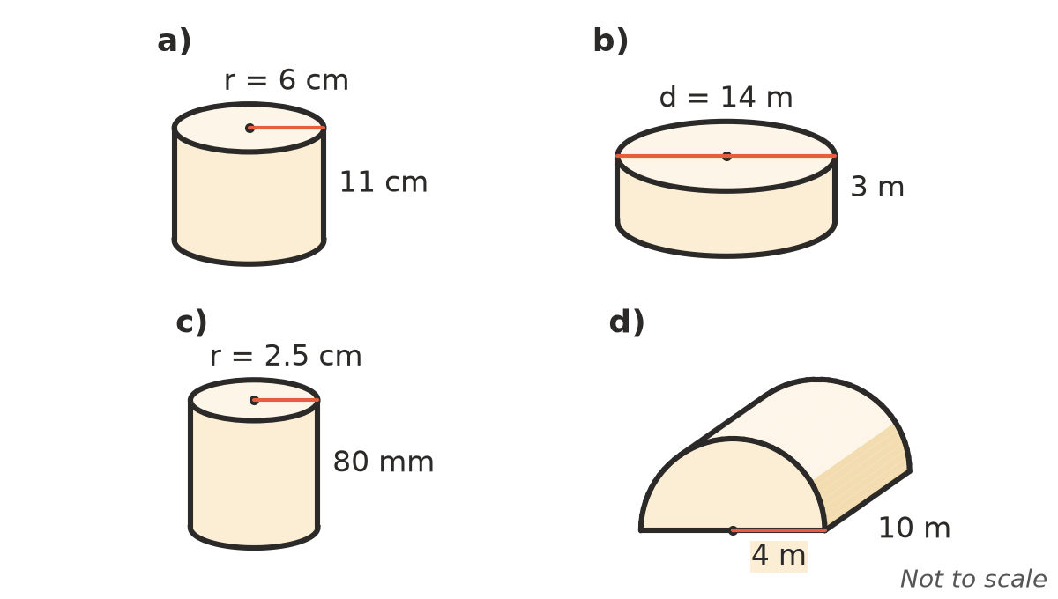

- A water tank has a diameter of 2.4 m and a height of 1.8 m. Find its capacity, to the nearest litre.

 Reasoning
- Work backwards.
  - A cylinder has a volume of 500 cm³ and a radius of 5 cm. Find its height, to 2 decimal places.
  - A cylinder has a volume of 1000 cm³ and a height of 10 cm. Find its radius, to 2 decimal places.
- What happens to the volume of a cylinder when:
  - the height is doubled?
  - the radius is doubled? Explain why the answers are different.
- Can A is tall and thin, with a radius of 3 cm and a height of 12 cm. Can B is short and wide, with a radius of 4.5 cm and a height of 5 cm. Which holds more? Show your working.

 Problem solving
- A rainwater tank has a radius of 1.2 m and a height of 2.1 m.
  - Find its capacity, to the nearest litre.
  - A family uses 180 L of water a day. How many full days would a full tank last?
- A concrete pipe is 2.5 m long. Its outer radius is 0.6 m and its inner radius is 0.5 m. Find the volume of concrete in the pipe, to 3 decimal places.
- A trophy is made of two cylinders. The base has a radius of 5 cm and a height of 2 cm. On top of it is a column with a radius of 2 cm and a height of 10 cm. Find the volume of the trophy, to 1 decimal place.
- A round above-ground pool has a radius of 3 m and is filled to a depth of 1.2 m.
  - How many litres of water are in it, to the nearest litre?
  - It is filled with a hose at 40 L per minute. How many hours does it take, to 1 decimal place?
- A candle maker has 2 L of melted wax. Each candle is a cylinder with a radius of 3.5 cm and a height of 10 cm. How many whole candles can she make?
- A full cylindrical jug with a radius of 6 cm and a height of 20 cm is poured into an empty rectangular tank with a base 30 cm by 20 cm. How deep is the water in the tank, to 2 decimal places?
- Six cans, each with a radius of 3.5 cm and a height of 12 cm, fit exactly in a box 21 cm long, 14 cm wide and 12 cm high.
  - Find the volume of empty space in your book, to 1 decimal place.
  - What percentage of the box is empty space, to 1 decimal place?

