9.07 Surface area of cylinders
Year 9 Maths · Worksheet · Level 3 · Challenge
Name: ____________________ Date: ______________
This worksheet challenges you with composite solids, working backwards from a surface area, exact answers and real costing problems. Tip: before you calculate, list the surfaces that are really there. Open ends, hidden faces and joins change the formula.

 Understanding
- A closed cylinder has radius r.
  - Show that if its height is 2r, its surface area is $6πr^{2}$. ______________
  - Find a formula for its surface area if its height equals its radius. ______________
  - A cylinder with height 2r has a surface area of $150π$ cm². Find r. ______________

 Fluency
- A cylinder of radius 3 cm and height 5 cm sits in the centre of a larger cylinder with a diameter of 12 cm and a height of 4 cm.
- 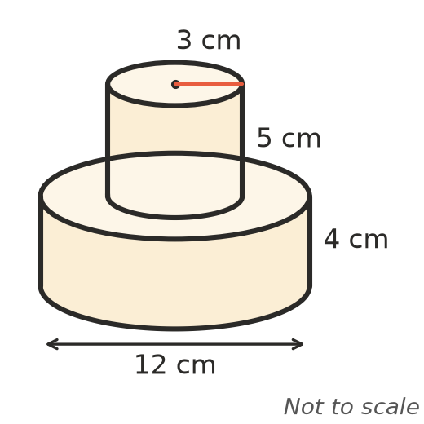
  - Find the exact surface area of the whole solid, including the base, in terms of $π$. ______________
  - Round your answer to 1 decimal place. ______________
- A water trough is a half cylinder with no top. Its radius is 0.3 m and it is 2 m long. Find the area of metal needed to make it, to 2 decimal places.
- 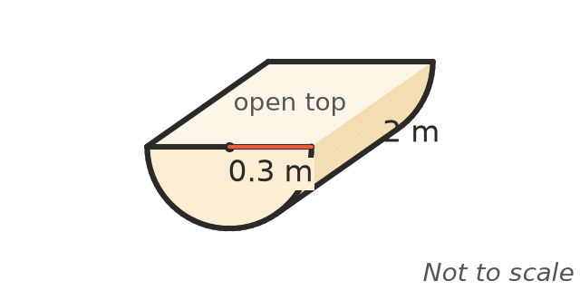

- A closed cylinder is 10 cm high and has a surface area of $528π$ cm². Show that $r^{2}+10r−264=0$, and solve it to find the radius.

- A cylinder with a base but no lid has a radius of 7 cm and a surface area of 600 cm². Find its height, to 2 decimal places.

 Reasoning
- The radius of a cylinder is doubled and its height is halved. What happens to its curved surface area? What happens to the area of each end? Explain.

- A cylinder fits exactly inside a cube with edges of 10 cm, so its diameter and height are both 10 cm.
  - Find the exact surface area of the cylinder and of the cube. ______________
  - Show that the cylinder’s surface area is exactly $\frac{π}{4}$ of the cube’s. ______________
- A rectangle of card 20 cm by 30 cm can be rolled into an open tube in two ways: with the 30 cm side going around, or with the 20 cm side going around.
  - Explain why both tubes have the same curved surface area. ______________
  - Each tube is closed with two circular ends. Find the total surface area of each closed cylinder, to 1 decimal place. ______________

 Problem solving
- A grain silo is a cylinder with a radius of 3 m and a height of 12 m. Its curved wall and its flat top are to get two coats of paint (the base sits on the ground). One litre covers 12 m², and paint comes in 10 L tins costing $139.
  - Find the area to be painted, to 2 decimal places. ______________
  - Find the number of tins needed and the cost. ______________
- A copper pipe is 3 m long. Its outside diameter is 2.2 cm and its inside diameter is 2.0 cm. Find its total surface area in cm², including the inside and the two ring-shaped ends, to 1 decimal place.

- A hot water pipe with a diameter of 6 cm and a length of 5 m is wrapped in a thin layer of foam. Find the area of foam needed, in m², to 2 decimal places.

- A paint roller has a radius of 2.5 cm and a length of 23 cm. It rolls 40 full turns across a wall. Find the area painted in cm², and in m² to 2 decimal places.

