9.07 Surface area of cylinders
Year 9 Maths · Worksheet · Level 2 · Core
Name: ____________________ Date: ______________
This worksheet practises finding the surface area of closed and open cylinders, half cylinders and pipes. Tip: a closed cylinder has SA = $2πr^{2}+2πrh$ (two circles plus the curved surface). Leave out a circle for each open end, and halve the parts of a half cylinder.

 Understanding
- A cylinder has radius r and height h.
  - Write a formula for the area of the curved surface. ______________
  - Write a formula for the surface area of the cylinder if it has a base but no lid. ______________
  - Write a formula for the surface area of a tube that is open at both ends. ______________

 Fluency
- Find the surface area of each closed cylinder, to 2 decimal places. In c), work in metres.
- 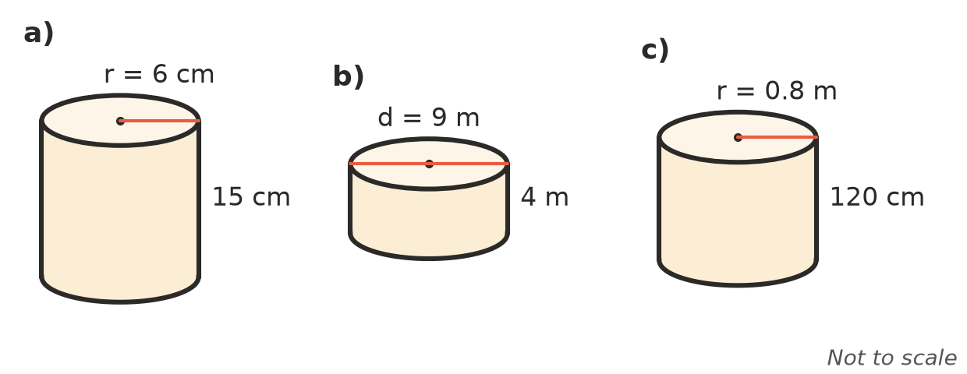
  - ______________
  - ______________
  - ______________
- A closed cylinder has a radius of 5 cm and a height of 7 cm. Find its exact surface area in terms of $π$. ______________
- Find each surface area, to 2 decimal places.
  - a bucket (no lid) with a radius of 10 cm and a height of 25 cm ______________
  - a cardboard tube, open at both ends, with a radius of 2 cm and a length of 30 cm ______________
- Find the total surface area of this closed half cylinder, to 2 decimal places. It has a curved surface, a flat rectangular base and two semicircular ends.
- 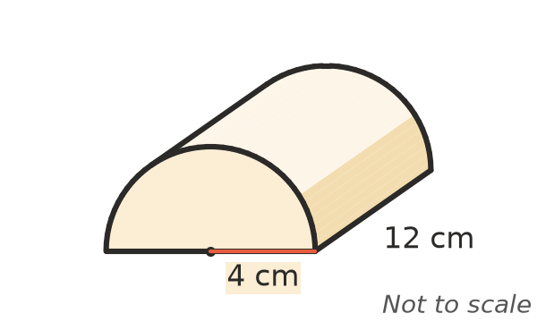

 Reasoning
- A closed cylinder has a radius of 5 cm and a surface area of 400 cm². Find its height, to 2 decimal places.

- Can A has a radius of 4 cm and a height of 10 cm. Can B has a radius of 5 cm and a height of 6.4 cm. Both are closed.
  - Find the exact surface area of each can in terms of $π$. ______________
  - Which can needs less metal? ______________
- Tom says the surface area of a closed can is $πr^{2}+2πrh$. Explain his mistake.

 Problem solving
- A can has a diameter of 7.5 cm and a height of 11 cm. Its paper label goes all the way around with a 1 cm overlap for the glue. Find the area of the label, to 1 decimal place.

- A closed steel water tank has a radius of 1.8 m and a height of 2.2 m. Steel costs $45 per m². Find the cost of the steel, to the nearest dollar.

- A garden roller is a cylinder with a radius of 0.25 m and a width of 0.9 m. Find the area of lawn it flattens in 20 full turns, to 1 decimal place.

- A concrete drain pipe is 2 m long. Its outer radius is 0.5 m and its inner radius is 0.4 m. Find its total surface area: the outside, the inside and the two ring-shaped ends. Give your answer to 2 decimal places.

- An above-ground pool is a cylinder with a radius of 2.5 m and a depth of 1.2 m, with no top. Find the area of the plastic liner that covers the floor and the inside wall, to 2 decimal places.

