9.07 Surface area of cylinders
Year 9 Maths · Worksheet · Level 1 · Warm-up
Name: ____________________ Date: ______________
If you cut the label off a can and flatten it, you get a rectangle. The net of a cylinder is two circles and one rectangle. The rectangle’s length is the circumference of the circle, $2πr$, so the curved surface has area $2πrh$. Tip: SA of a closed cylinder = $2πr^{2}+2πrh$.

 Understanding
- This is the net of a cylinder with a radius of 3 cm and a height of 10 cm.
- 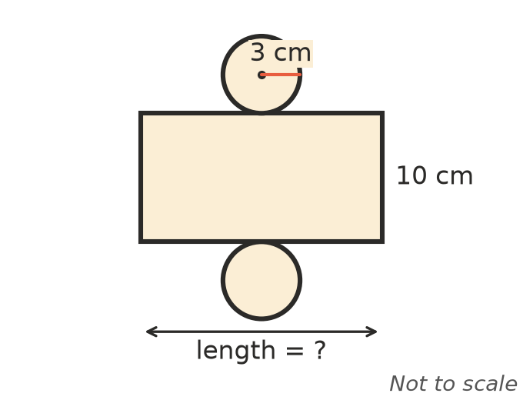
  - The rectangle wraps around the circle. What is the length of the rectangle, to 2 decimal places? ______________
  - Find the area of the rectangle, to 1 decimal place. ______________
  - Find the area of one circle, to 1 decimal place. ______________
  - Find the total surface area of the cylinder. ______________
- A circle has a radius of 5 cm. Find, to 2 decimal places:
  - its area, $πr^{2}$ ______________
  - its circumference, $2πr$ ______________

 Fluency
- Find the surface area of each closed cylinder, to 1 decimal place.
- 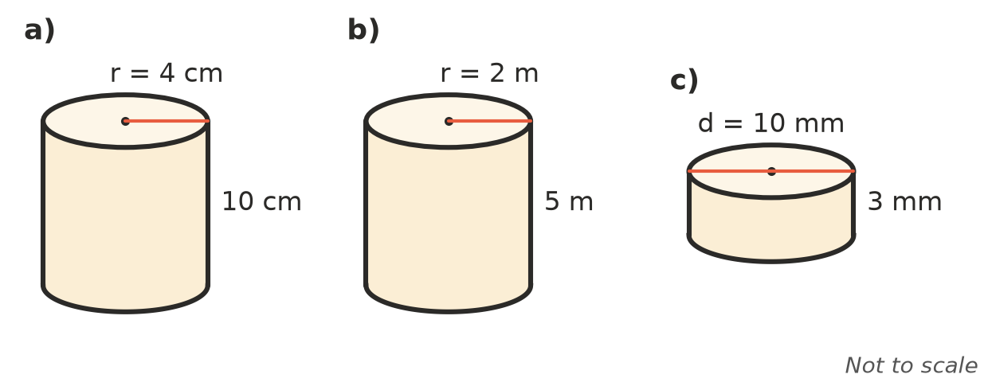
  - ______________
  - ______________
  - ______________
- Find the area of the curved surface only of a cylinder with a radius of 3 cm and a height of 8 cm, to 1 decimal place.

- A cup is a cylinder with a base but no lid. Its radius is 4 cm and its height is 9 cm. Find its outside surface area, to 1 decimal place.

 Reasoning
- Explain why the length of the rectangle in the net of a cylinder must equal the circumference of the circle.

- A cylinder has a diameter of 10 cm and a height of 4 cm. Kim finds its curved surface like this: 2 × $π$ × 10 × 4. Explain her mistake and find the correct curved surface area, to 1 decimal place.

 Problem solving
- A can of soup has a radius of 3.5 cm and a height of 11 cm. The paper label covers the curved surface. Find the area of the label, to 1 decimal place.

- A closed water tank is a cylinder with a radius of 1.5 m and a height of 2 m. Find the area to be painted on the outside, to 1 decimal place.

- A round concrete pillar has a radius of 0.3 m and a height of 4 m. Its curved surface is painted with two coats. One litre of paint covers 10 m².
  - Find the curved surface area, to 2 decimal places. ______________
  - How many whole litres of paint are needed? ______________
- A plastic pipe is 3 m long with a radius of 0.1 m. Find the area of its outside surface, to 2 decimal places.

