9.06 Accuracy of measurement
Year 9 Maths · A5 question sheet · Level 2 · Core
This worksheet practises limits of accuracy, absolute, relative and percentage error, and scientific notation for very large and very small measurements. Tip: a measurement can be out by up to half of the smallest unit used. Absolute error = |measured − actual|, relative error = absolute error ÷ actual, and percentage error = relative error × 100%.

 Understanding
- Read each scale.
- 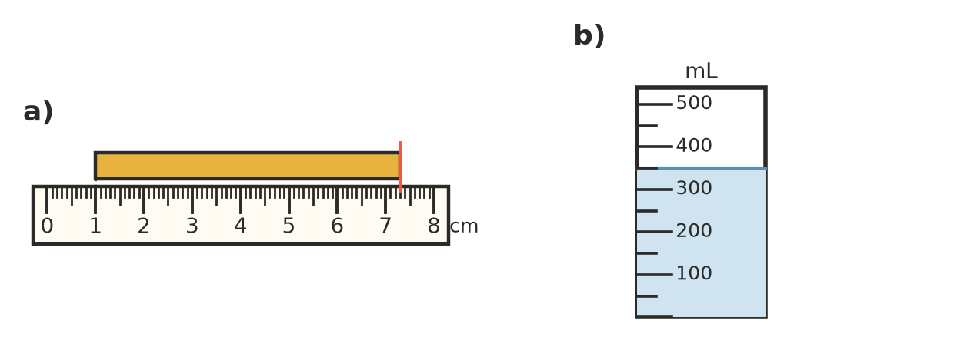
  - How long is the yellow bar? Between what limits must its real length lie?
  - How much water is in the jug, to the nearest 50 mL? Between what limits must the real amount lie?
- Write the limits of accuracy of each measurement.
  - 7.2 m, to the nearest 0.1 m
  - 450 g, to the nearest 10 g
  - 3.08 s, to the nearest 0.01 s
  - a crowd of 2400 people, to the nearest 100

 Fluency
- Copy and complete the table. Give the percentage error to the nearest whole percent.
Measured | Actual | Absolute error | Relative error
98 cm | 100 cm
5.2 kg | 5 kg
47 s | 50 s
0.81 L | 0.75 L

- Convert between scientific notation and ordinary numbers.
  - The width of a spider’s thread, 0.000 08 m
  - The distance from Earth to the Sun, 149 600 000 km
  - The mass of a dust particle, 7.5 × ${10}^{−10}$ kg
  - The radius of Earth, 6.4 × ${10}^{6}$ m

 Reasoning
- One measurement is written as 2.0 m and another as 2.00 m. Write the limits of accuracy for each. Which is more precise, and why?
- A rectangle is measured as 12 cm by 8 cm, each to the nearest centimetre.
  - Find the smallest and largest possible length and width.
  - Find the smallest and largest possible area.
  - The area is calculated as 12 × 8 = 96 cm². What is the greatest possible absolute error in this area?
  - Write this as a percentage error, to 1 decimal place.
- Find the smallest and largest possible perimeter of the rectangle in Question 6. By how much could the calculated perimeter, 40 cm, be wrong?
- Lucas uses 3.14 instead of $π$ to find the area of a circle with a radius of 10 cm. Find the absolute error (to 2 decimal places) and the percentage error (to 2 decimal places) caused by this.

 Problem solving
- Tama estimates the length of a paddock as 180 m by pacing it out. A tape measure shows it is 172.5 m. Find the absolute error and the percentage error of his estimate, to 1 decimal place.
- Kitchen scales show 1.25 kg for a bag of potatoes that has a mass of 1.2 kg. Find the percentage error, to 1 decimal place.
- A bacterium is 2 × ${10}^{−6}$ m long. How long would a line of 5000 of them be? Give your answer in scientific notation and in centimetres.
- A 10 kg test mass is put on three bathroom scales. They show 10.2 kg, 9.7 kg and 10.05 kg. Find the percentage error of each scale. Which is the most accurate?
- Two planks are each measured as 2.45 m, to the nearest centimetre. They are laid end to end. What are the limits of accuracy of their total length?

