9.05 Volume of prisms
Year 9 Maths · Worksheet · Level 3 · Challenge
Name: ____________________ Date: ______________
This worksheet challenges you with composite and hollow prisms, Pythagoras’ theorem, algebra, and real problems about water, concrete and metal. Tip: V = Ah for any right prism. For a hollow prism, take the area of the hole away from the area of the cross-section before you multiply by the length.

 Understanding
- Convert each measurement.
  - 0.0035 m³ = ______________ cm³ = ______________ L
  - 2 500 000 mm³ = ______________ L
  - 1 megalitre (1 ML = 1 000 000 L) = ______________ m³

 Fluency
- Find the volume of each prism. In b), a square hole 4 cm by 4 cm runs right through the block. In c), the trapezium is symmetrical with parallel sides of 10 m and 22 m.
- 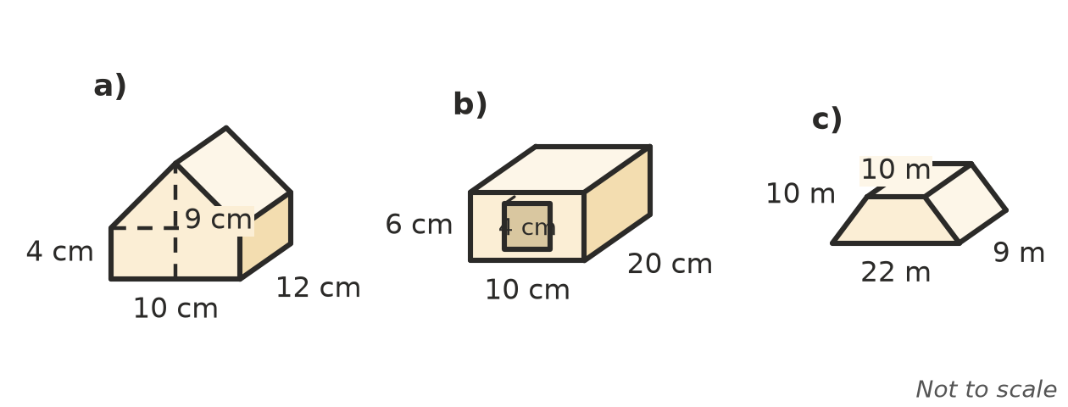
  - ______________
  - ______________
  - ______________
- A triangular prism is 30 cm long. Its cross-section is a right-angled triangle with a hypotenuse of 25 cm and one shorter side of 7 cm. Find its volume.

 Reasoning
- A rectangular prism is x cm long, 2x cm wide and 3x cm high. Its volume is 48 cm³. Find x and the dimensions of the prism.

- Every length of a prism is multiplied by 1.5. By what percentage does its volume increase? Explain.

- 6 L of water is poured into an empty tank with a rectangular base 30 cm by 25 cm. How deep is the water?

- A prism has a volume of 360 cm³. A second prism has a cross-section with 3 times the area, but is half as long. Find the volume of the second prism without finding any lengths.

 Problem solving
- A pool is 25 m long and 12 m wide. Its floor slopes evenly from 1.2 m deep to 2.4 m deep.
  - Find its capacity in litres. ______________
  - A garden hose delivers 30 L per minute. How many days would it take to fill the pool? ______________
- 22 mm of rain falls on a rectangular roof 9 m by 14 m. All of it runs into a tank with a rectangular base 2 m by 1.5 m.
  - How many litres of water run off the roof? ______________
  - By how many centimetres does the water level in the tank rise? ______________
- A drainage trench is 40 m long. Its cross-section is a triangle 1.2 m wide at the top and 0.9 m deep. A truck carries 6 m³ of soil. How many truckloads are needed to take away the soil?

- A rock is dropped into a fish tank with a base 40 cm by 25 cm, and the water level rises by 1.8 cm. Find the volume of the rock.

- A gold bar is a prism 12 cm long. Its cross-section is a trapezium with parallel sides of 4 cm and 6 cm, 3 cm apart. Gold has a mass of 19.3 g per cm³. Find the mass of the bar in kilograms.

- A rectangle of card 40 cm by 30 cm has a 5 cm square cut from each corner. The sides are folded up to make an open box. Find the capacity of the box in litres.

