9.05 Volume of prisms
Year 9 Maths · Worksheet · Level 1 · Warm-up
Name: ____________________ Date: ______________
Volume is the amount of space inside a solid, measured in cubic units such as cm³ or m³. For any prism, Volume = area of cross-section × length, or V = Ah. Tip: 1 cm³ holds exactly 1 mL, so 1000 cm³ = 1 L.

 Understanding
- Fill in the gaps.
  - 1 cm³ = ______________ mL
  - 1 L = ______________ mL = ______________ cm³
  - 1 m³ = ______________ L
  - 1 cm³ = ______________ mm³
- This rectangular prism is made of 1 cm cubes.
- 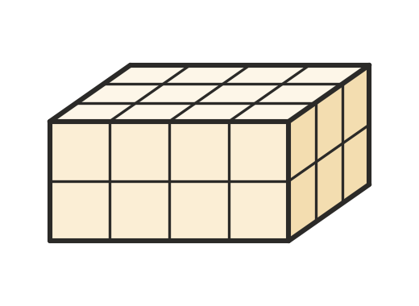
  - How many cubes are in the bottom layer? ______________
  - How many layers are there? ______________
  - What is the volume of the prism? ______________

 Fluency
- Find the volume of each rectangular prism.
  - 6 cm long, 5 cm wide, 4 cm high ______________
  - 10 m long, 3 m wide, 2 m high ______________
  - a cube with edges of 7 mm ______________
- Use V = Ah to find the volume of each prism.
  - cross-section area 15 cm², length 8 cm ______________
  - cross-section area 24 m², length 3.5 m ______________
- Find the volume of each prism.
- 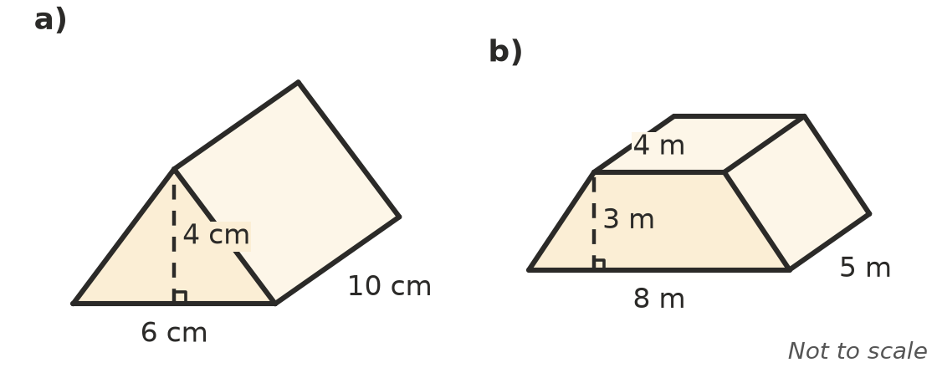
  - ______________
  - ______________
- A box is 20 cm long, 10 cm wide and 5 cm high. Find its volume in cm³, then its capacity in litres. ______________

 Reasoning
- Kai finds the volume of the triangular prism in Question 5 a) like this: 6 × 4 × 10 = 240 cm³. Explain his mistake.

- A rectangular prism has a volume of 96 cm³. It is 8 cm long and 4 cm wide. How high is it?

 Problem solving
- A fish tank is 50 cm long, 30 cm wide and 40 cm high. How many litres of water does it hold when full?

- A sandpit is 2 m long and 1.5 m wide. It is filled with sand to a depth of 0.3 m.
  - Find the volume of sand. ______________
  - Sand costs $60 per m³. Find the cost. ______________
- A water trough for cattle is a triangular prism 2 m long. Its cross-section is a triangle 0.6 m wide at the top and 0.4 m deep. How many litres does it hold?

