9.05 Volume of prisms
Year 9 Maths · A5 question sheet · Level 2 · Core
This worksheet practises finding the volume and capacity of right prisms. Tip: V = Ah, where A is the area of the cross-section and h is the length (or height) of the prism. Find A first with the right area formula, and make sure all the lengths are in the same unit.

 Understanding
- Convert each measurement.
  - 3.5 L = ______________ cm³
  - 2.4 m³ = ______________ L
  - 750 mL = ______________ cm³
  - 45 000 cm³ = ______________ m³
  - 0.6 cm³ = ______________ mm³

 Fluency
- Find the volume of each prism.
  - 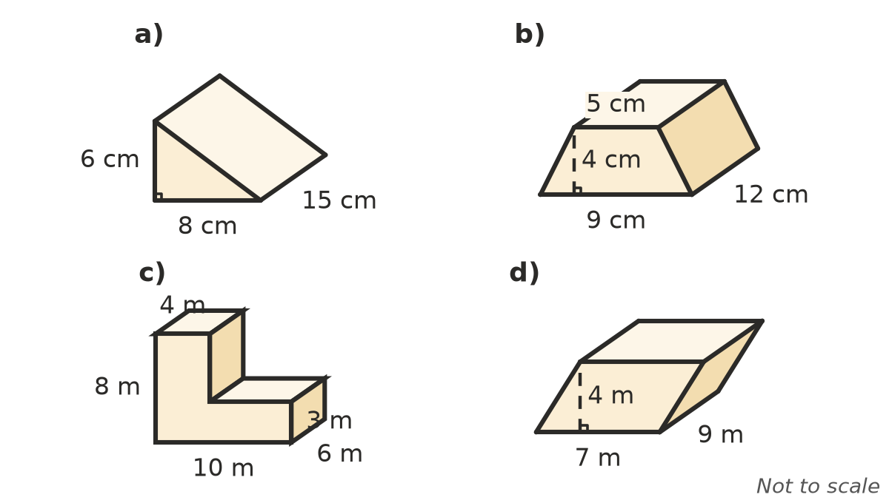

- A rectangular prism is 1.2 m long, 40 cm wide and 25 cm high.
  - Find its volume in cm³.
  - Find its capacity in litres.

 Reasoning
- Find the missing measurement.
  - A triangular prism has a volume of 540 cm³ and a cross-section area of 36 cm². How long is it?
  - A rectangular prism has a volume of 1.8 m³ and a base 1.5 m by 0.8 m. How high is it?
  - A cube has a volume of 729 cm³. How long are its edges?
- A cube has edges of 2 cm. Another cube has edges of 4 cm. Compare their volumes. What happens to the volume of a solid when every length is doubled?
- Jen says 2 m³ = 2000 cm³. Explain why she is wrong and give the correct value.

 Problem solving
- A swimming pool is 12 m long and 5 m wide, with a constant depth of 1.4 m.
  - How many litres of water does it hold?
  - A hose delivers 200 L per minute. How many hours does it take to fill the pool?
- A concrete path is 15 m long, 1.2 m wide and 10 cm thick. Concrete costs $250 per m³. Find the cost of the concrete.
- In a storm, 15 mm of rain falls on a flat shed roof with an area of 120 m². How many litres of water fall on the roof? (Hint: change 15 mm to metres.)
- A tent is a triangular prism 2.5 m long. Its ends are triangles with a base of 2.4 m and a height of 1.6 m. Find the volume of air inside the tent.
- A pool is 20 m long and 8 m wide. Its floor slopes evenly from 1 m deep at one end to 2 m deep at the other. Find how many litres it holds. (Hint: the side of the pool is a trapezium.)
- Sugar cubes with edges of 1.5 cm are packed into a box 12 cm long, 9 cm wide and 6 cm high. How many cubes fit in your book?

