9.04 Surface area of prisms
Year 9 Maths · Worksheet · Level 3 · Challenge
Name: ____________________ Date: ______________
This worksheet challenges you with prisms that need Pythagoras’ theorem, mixed units, working backwards from a surface area, and costing real jobs. Tip: SA = 2A + Pl, where A and P are the area and perimeter of the cross-section and l is the length of the prism. Sketch the net if you are not sure which faces are there.

 Understanding
- Explain why the surface area of any right prism is SA = 2A + Pl. Use the idea of a net in your answer.

 Fluency
- Find the surface area of each prism. In a), the cross-section is an isosceles triangle.
- 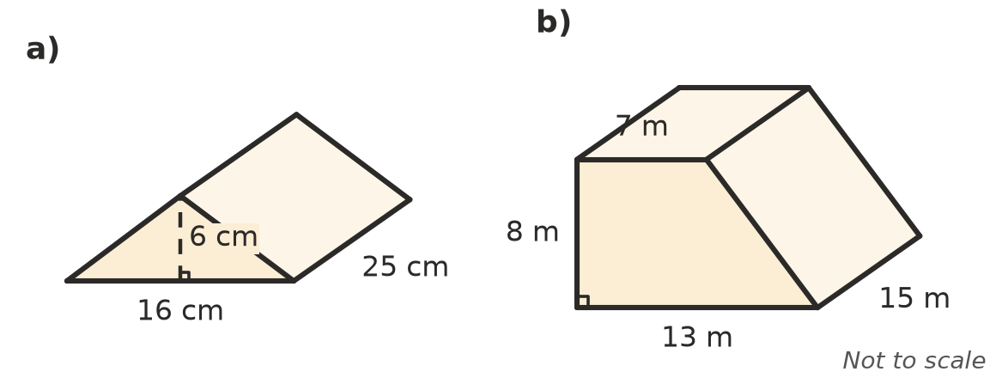
  - ______________
  - ______________
- A hay shed is shaped like a house: a rectangular prism with a triangular prism on top. The two sloping roof sections are the same size. Find the total surface area, including the floor.
- 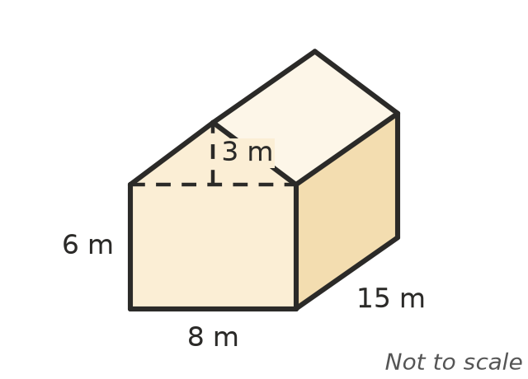

- A rectangular prism is 45 mm long, 3.2 cm wide and 2 cm high. Find its surface area in cm².

 Reasoning
- A rectangular prism is 10 cm long and 4 cm wide, and has a surface area of 248 cm². Find its height.

- A cube has a surface area of 486 cm².
  - Find the length of its edges. ______________
  - Every edge is made 3 times as long. What happens to the surface area? Explain. ______________
- Thirty-six 1 cm cubes are stacked into a solid rectangular prism. List every possible size of prism, and find the one with the smallest surface area.

- Two cubes with 5 cm edges are glued face to face to make one solid. Find its surface area. Explain why it is not double the surface area of one cube.

 Problem solving
- A swimming pool is 25 m long and 10 m wide. It is 1.2 m deep at the shallow end and 2.0 m deep at the deep end, with a flat sloping floor. The floor and the four walls inside are to be tiled.
- 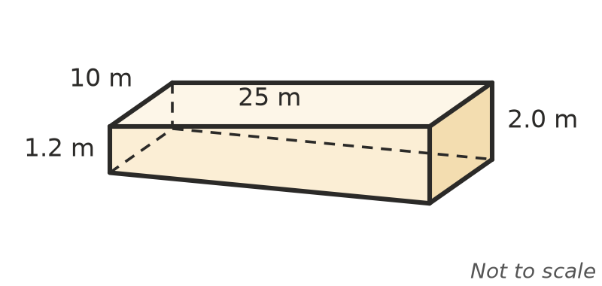
  - Use Pythagoras’ theorem to find the length of the sloping floor, to 2 decimal places. ______________
  - Find the area to be tiled, to 1 decimal place. ______________
  - Tiling costs $35 per m². Find the cost, to the nearest dollar. ______________
- A chocolate box is a triangular prism 20 cm long. Its ends are equilateral triangles with sides of 6 cm. Find the height of each triangle, then the surface area of the box, to 1 decimal place.

- A company makes boxes 20 cm × 15 cm × 8 cm. Each box needs an extra 10% of card for flaps. Card costs $4.50 per m².
  - Find the area of card for one box, including flaps. ______________
  - Find the cost of card for 10 000 boxes. ______________
- A steel beam is a hollow square tube 2 m long. The outside of its cross-section is a 10 cm square and the inside is an 8 cm square. Find its total surface area in cm², including the inside and the two ends.

- A rectangular prism has a square base. Its height is twice the length of the side of the base. Its surface area is 250 cm². Find its dimensions.

