9.04 Surface area of prisms
Year 9 Maths · A5 question sheet · Level 2 · Core
This worksheet practises finding the surface area of right prisms: rectangular, triangular, trapezoidal and L-shaped. Tip: for any right prism, SA = 2 × (area of cross-section) + (perimeter of cross-section) × length. The rectangles all have the prism’s length, so they join up into one long strip.

 Understanding
- This triangular prism has a right-angled triangle as its cross-section.
- 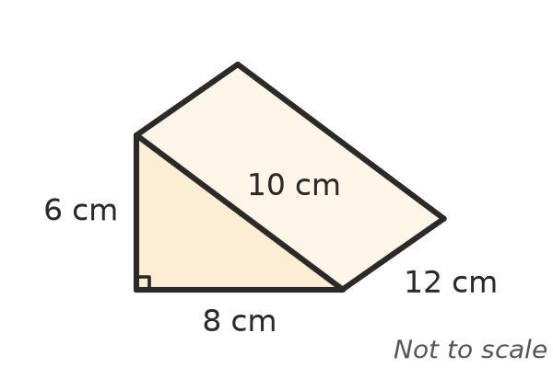
  - Find the area of one triangle.
  - Find the area of each of the three rectangles.
  - Find the total surface area.
- A prism has a cross-section with an area of 20 cm² and a perimeter of 18 cm. It is 10 cm long. Use SA = 2A + Pl to find its surface area.

 Fluency
- Find the surface area of each rectangular prism. In c), work in metres.
  - 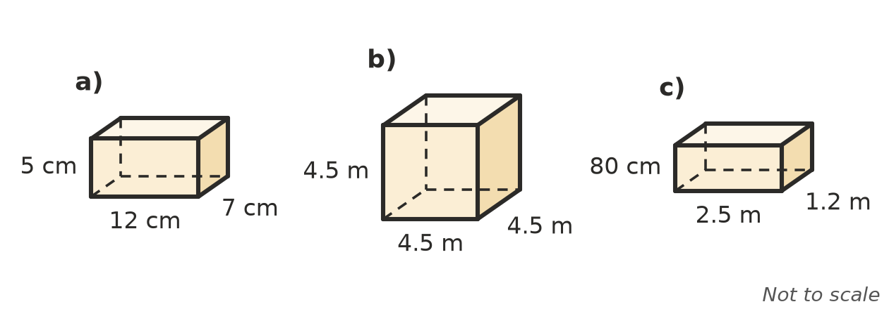

- Find the surface area of each prism. The trapezium in b) is symmetrical.
  - 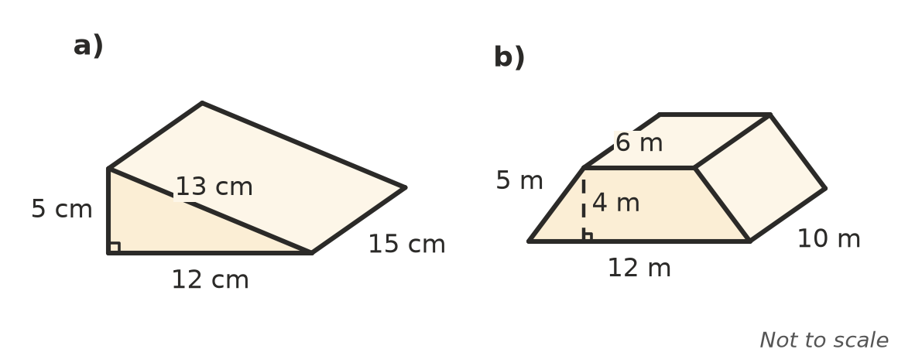

- The cross-section of this prism is an isosceles triangle. Use Pythagoras’ theorem to find the length of the sloping sides, then find the surface area.
- 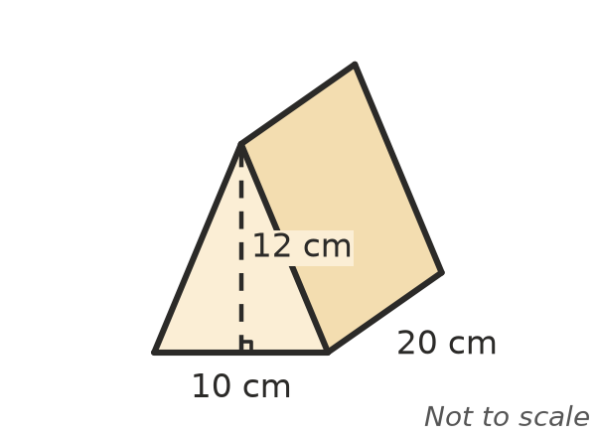
  - Sloping side:
  - Surface area:

 Reasoning
- A cube has edges of 2 cm. A second cube has edges of 4 cm.
  - Find the surface area of each cube.
  - The edge length doubled. What happened to the surface area?
- Two boxes both hold 64 cm³. Box A is 8 cm × 4 cm × 2 cm. Box B is a cube with 4 cm edges. Which box uses less cardboard? Show your working.
- Tom finds the surface area of a box 5 cm × 4 cm × 3 cm like this: 5 × 4 + 5 × 3 + 4 × 3 = 47 cm². Explain his mistake and give the correct answer.

 Problem solving
- A fish tank with no lid is made of glass. It is 60 cm long, 30 cm wide and 40 cm high. Find the area of glass in cm² and in m².
- A hiking tent is a triangular prism with a floor. The ends are isosceles triangles with a base of 2.4 m, a height of 1.6 m and sloping sides of 2 m. The tent is 2.5 m long. How much fabric is needed to make it?
- Find the surface area of this L-shaped prism.
- 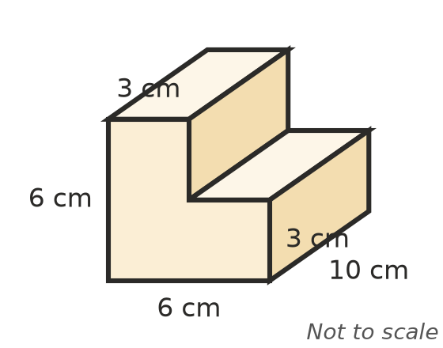
- A garden shed is a rectangular prism 3 m long, 2 m wide and 2.2 m high. The outside of the four walls and the flat roof are to get two coats of paint. The door, 0.8 m wide and 2 m high, is not painted. One litre of paint covers 8 m² and paint comes in 4 L tins costing $56.
  - Find the area to be painted (one coat).
  - How many tins are needed for two coats, and what do they cost?
- A cube has a surface area of 294 cm². Find the length of each edge.

