9.04 Surface area of prisms
Year 9 Maths · A5 question sheet · Level 1 · Warm-up
The surface area (SA) of a prism is the total area of all its faces. It is the area of its net. Tip: list every face, find each area, then add. In a rectangular prism the faces come in matching pairs, so SA = 2(lw + lh + wh).

 Understanding
- This is the net of a rectangular prism 6 cm long, 3 cm wide and 4 cm high.
- 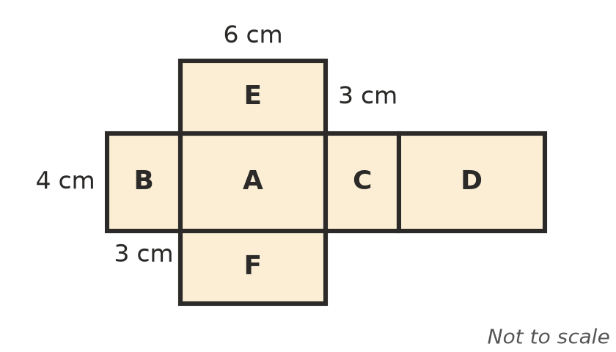
Face | Length × width
A
B
C
D
E
F
Total surface area

- Use SA = 2(lw + lh + wh) to find the surface area of each rectangular prism.
  - length 5 cm, width 4 cm, height 2 cm
  - a cube with edges of 6 cm

 Fluency
- Find the surface area of each prism.
  - 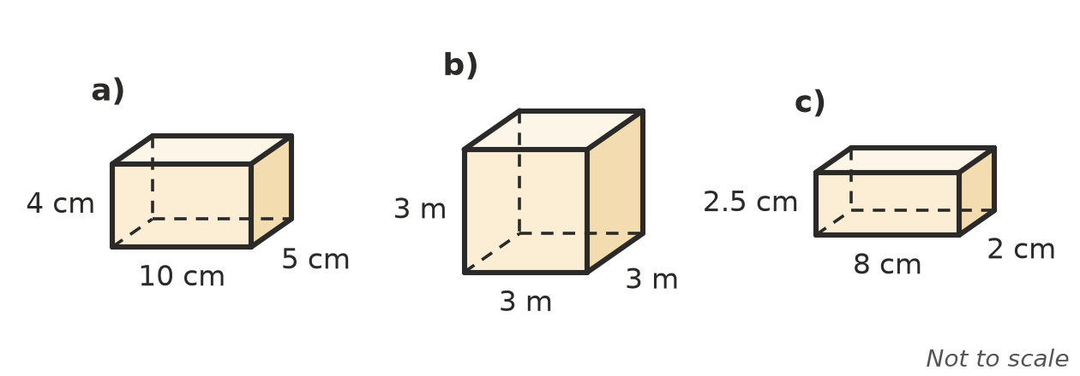

- Find the surface area of each triangular prism. First find the area of one triangle, then the area of each rectangle.
  - 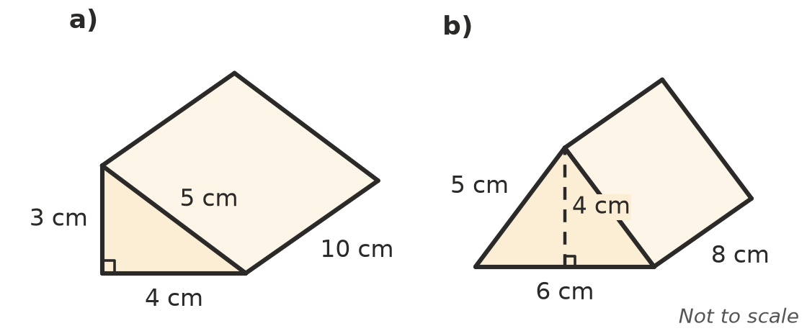

 Reasoning
- Explain why surface area is measured in square units, such as cm², and not in cm³.
- Lily says the surface area of a cube with edges of 2 cm is 8 cm². Explain what she has worked out by mistake, and find the correct surface area.

 Problem solving
- A present is in a box 30 cm long, 20 cm wide and 10 cm high. What is the least amount of wrapping paper needed to cover it exactly?
- A storage box has no lid. It is 40 cm long, 30 cm wide and 20 cm high. Find its outside surface area.
- A shipping container used as a farm shed is 6 m long, 2.4 m wide and 2.6 m high. Every outside face except the floor is to be painted.
  - Find the area to be painted.
  - One litre of paint covers 10 m². How many whole litres are needed?
- A cube has a surface area of 150 cm². How long is each edge?

