9.03 Nets of prisms
Year 9 Maths · Worksheet · Level 3 · Challenge
Name: ____________________ Date: ______________
This worksheet challenges you to picture how nets fold, to find missing lengths from a net, and to reason about faces, edges and vertices. Tip: imagine one face as the base and fold the others up around it, one at a time. Two faces that would land in the same place mean the net doesn’t work.

 Understanding
- A prism has an n-sided cross-section.
  - Write rules for its number of faces, edges and vertices in terms of n. ______________
  - A prism has 50 vertices. How many faces and edges does it have? ______________
  - Can a prism have exactly 40 edges? Explain. ______________
  - Can a prism have exactly 20 faces? If so, how many edges does it have? ______________

 Fluency
- Which of these nets will fold up to make a cube? Write Yes or No.
- 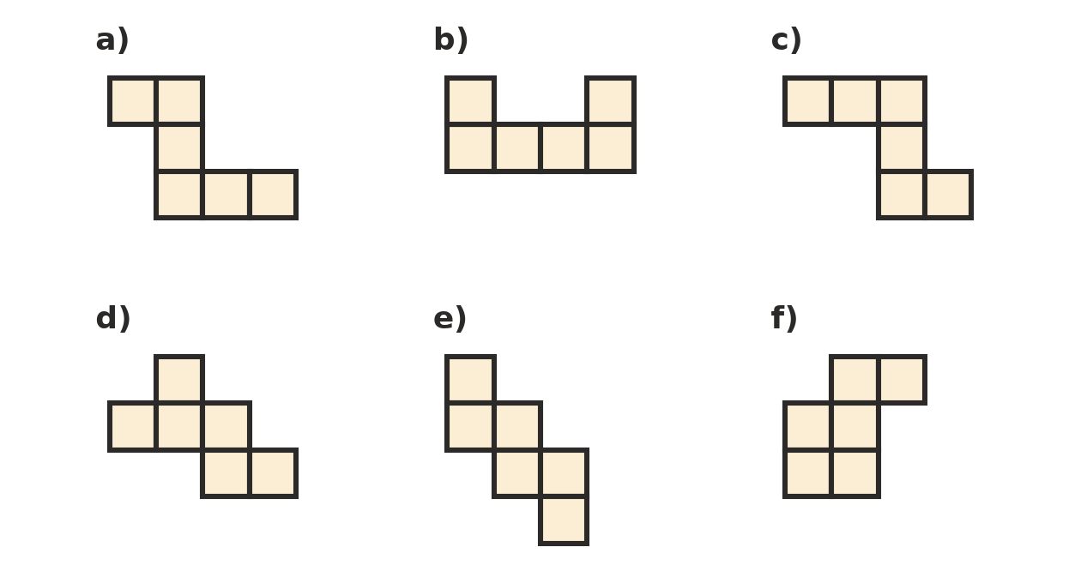
  - ______________
  - ______________
  - ______________
  - ______________
  - ______________
  - ______________
- This net folds up to make a cube.
- 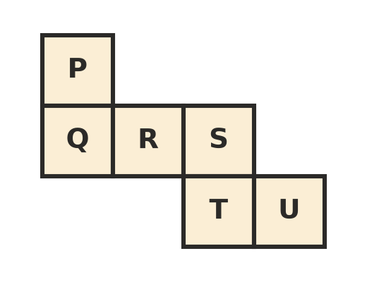
  - Write the three pairs of opposite faces. ______________
  - Which faces share an edge with face P? ______________
- This is the net of a rectangular prism. The whole net is 26 cm long and 18 cm tall.
- 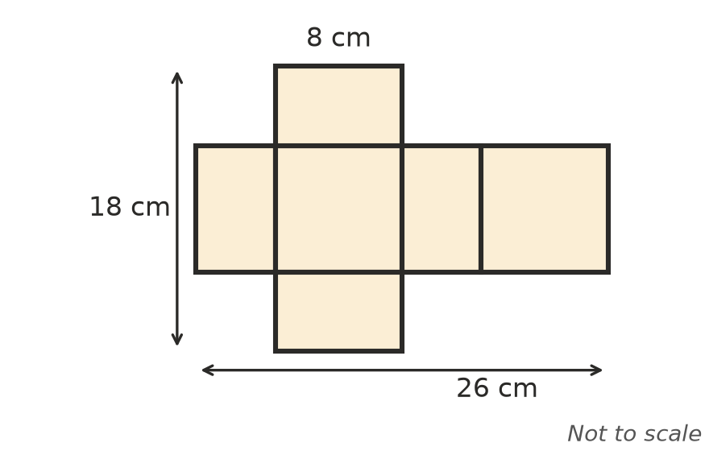
- Find the length, width and height of the prism.

- Draw a net of this triangular prism. Its cross-section is an isosceles triangle. Use Pythagoras’ theorem to find any missing lengths, and label every edge of your net.
- 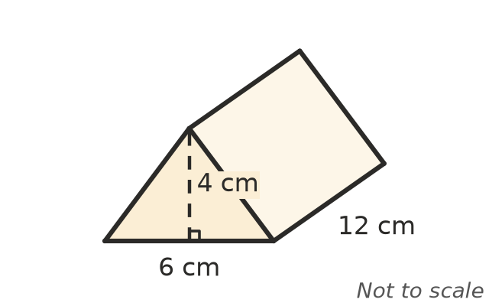

- This net folds up to make a prism with an L-shaped cross-section.
- 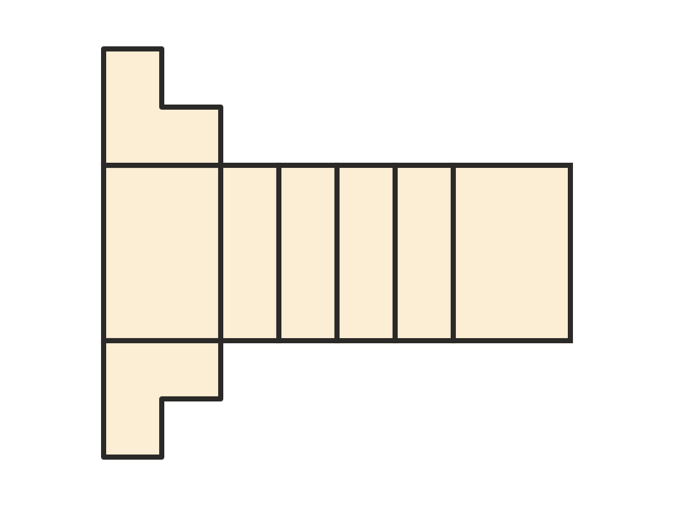
  - How many faces, edges and vertices does the prism have? ______________
  - Check your answer with Euler’s rule, Faces + Vertices − Edges = 2. ______________
  - Sam says, “This is a hexagonal prism.” Is Sam right? Explain. ______________
- Which of these are nets of a triangular prism? For any that are not, explain what goes wrong when you fold it.
- 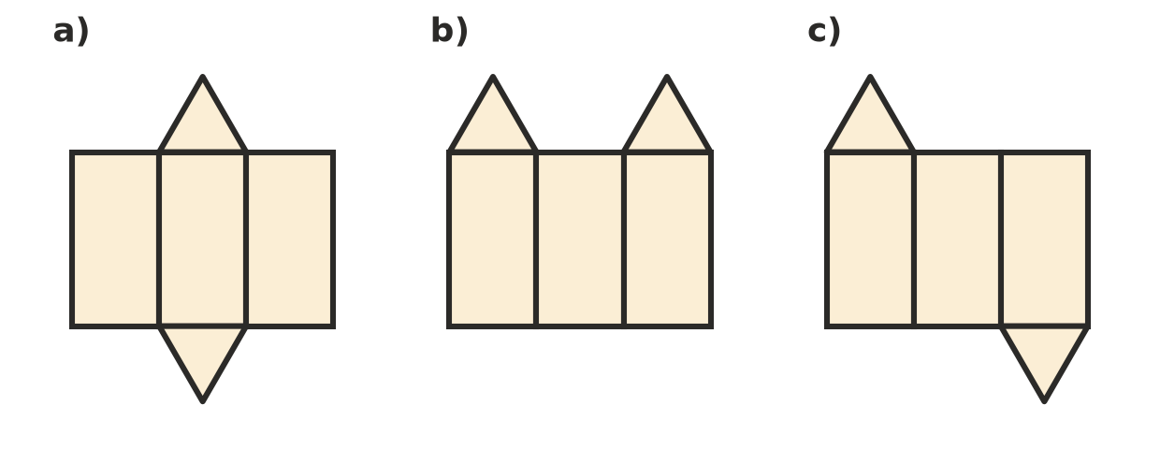
  - ______________
  - ______________
  - ______________

 Reasoning
- Explain why a net made of a row of four squares, with two more squares both attached to the same side of the row (like net b in Question 2), can never fold into a cube.

- To make a prism from a net, you fold along the lines where two faces meet, then tape the other edges together.
  - A net of a prism with an n-sided cross-section has n + 2 faces joined by n + 1 folds. Explain why the number of edges that must be taped is 2n − 1. ______________
  - Check the rule for a cube and for a triangular prism. ______________
- A square of card has sides of 30 cm. A 5 cm square is cut from each corner and the sides are folded up to make an open box.
  - What are the length, width and height of the box? ______________
  - Find the area of card in the net. ______________

 Problem solving
- A tent is a triangular prism with a floor. Its ends are isosceles triangles with a base of 2.4 m and a height of 1.6 m. The tent is 3 m long.
  - Find the length of each sloping side of the ends. ______________
  - Sketch a net of the tent with every edge labelled, and find the total area of fabric needed. ______________

- A chocolate box is a prism with a regular hexagon as its cross-section. Each side of the hexagon is 3 cm and the box is 15 cm long.
  - Describe the faces in the net of the box. ______________
  - Find the total area of the rectangles in the net. ______________

