9.03 Nets of prisms
Year 9 Maths · Worksheet · Level 1 · Warm-up
Name: ____________________ Date: ______________
A prism is a solid with two identical, parallel ends (the cross-section) joined by rectangles. A net is the flat shape you would cut out and fold to make the solid. Tip: a prism is named after its cross-section, and its net always has two copies of the cross-section.

 Understanding
- Complete the table.
Prism | Shape of cross-section | Faces | Edges | Vertices (corners)
Triangular prism
Rectangular prism
Pentagonal prism
Hexagonal prism

- Is each solid a prism? If it is, write its name.
- 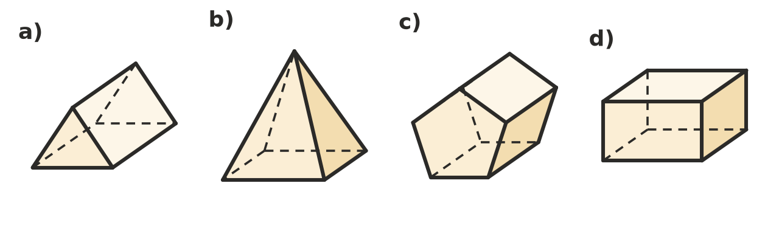
  - ______________
  - ______________
  - ______________
  - ______________

 Fluency
- Which of these nets will fold up to make a cube? Write Yes or No.
- 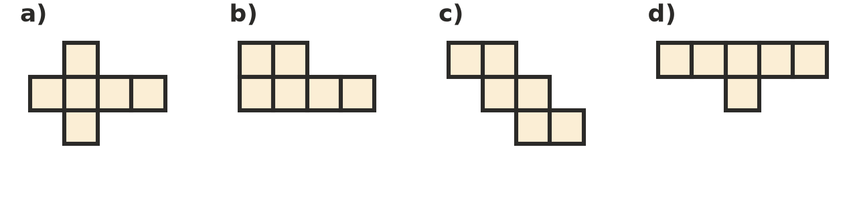
  - ______________
  - ______________
  - ______________
  - ______________
- This is the net of a rectangular prism.
- 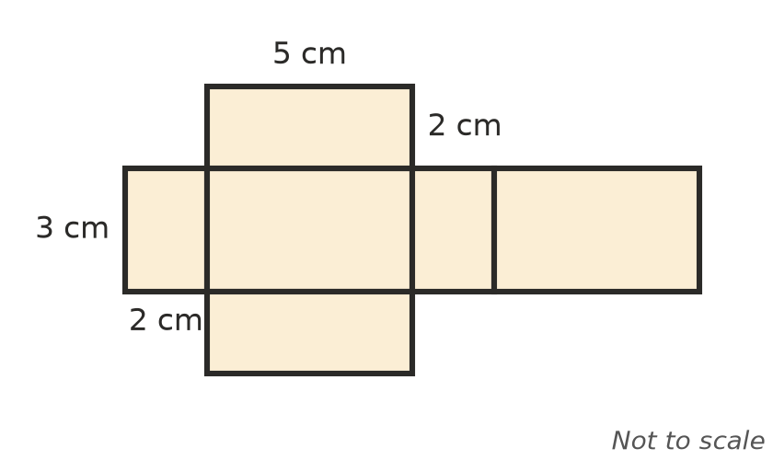
  - How many faces does the prism have? ______________
  - What are the length, width and height of the prism? ______________
  - How many rectangles are there of each size? ______________
- Name the solid that each net makes.
- 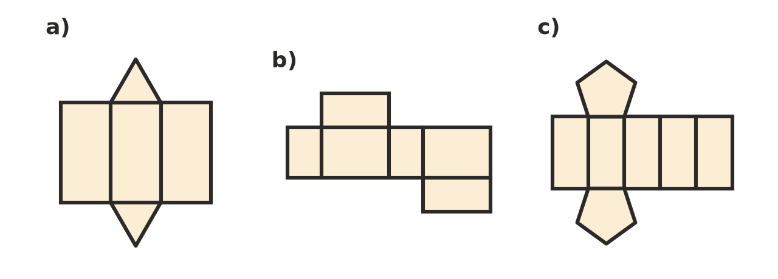
  - ______________
  - ______________
  - ______________
- Draw a net of a cube with edges 3 cm long on this grid. Each grid square is 1 cm by 1 cm.
- 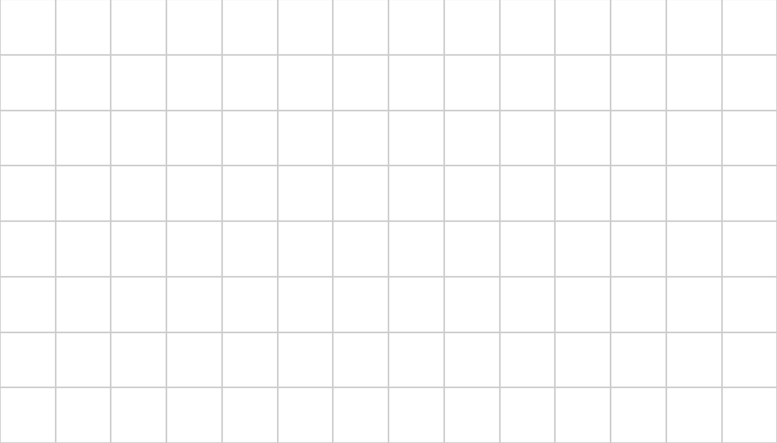
- On a dice, the numbers on opposite faces always add to 7. This is the net of a dice. Find the numbers that go in A, B and C.
- 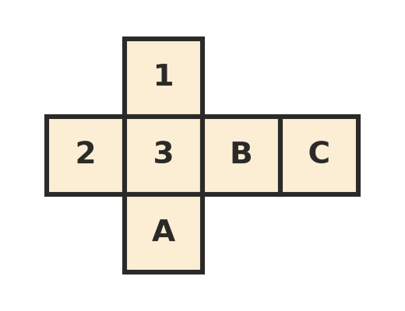
  - A = ______________
  - B = ______________
  - C = ______________

 Reasoning
- Euler’s rule says that for a prism, Faces + Vertices − Edges = 2. Check that the rule works for a triangular prism and a rectangular prism. Use your table from Question 1.

- A cylinder has two identical, parallel circles for ends. Explain why it is not a prism.

 Problem solving
- A box with no lid is 20 cm long, 10 cm wide and 8 cm high.
  - How many faces does its net have? ______________
  - Sketch a net of the box and label the length of every edge.

- A prism has 12 vertices.
  - What shape is its cross-section? ______________
  - How many faces and edges does it have? ______________

