9.03 Nets of prisms
Year 9 Maths · A5 question sheet · Level 2 · Core
This worksheet practises recognising prisms and their nets, and drawing nets with the right measurements. Tip: when two faces of a net fold together, the edges that meet must be the same length. Use this to check a net and to find missing lengths.

 Understanding
- Copy and complete the table. In the last row, the cross-section has n sides.
Prism | Faces | Edges
Triangular prism
Pentagonal prism
Octagonal prism
Prism with an n-sided cross-section

 Fluency
- Which of these nets will fold up to make a cube? Write Yes or No.
  - 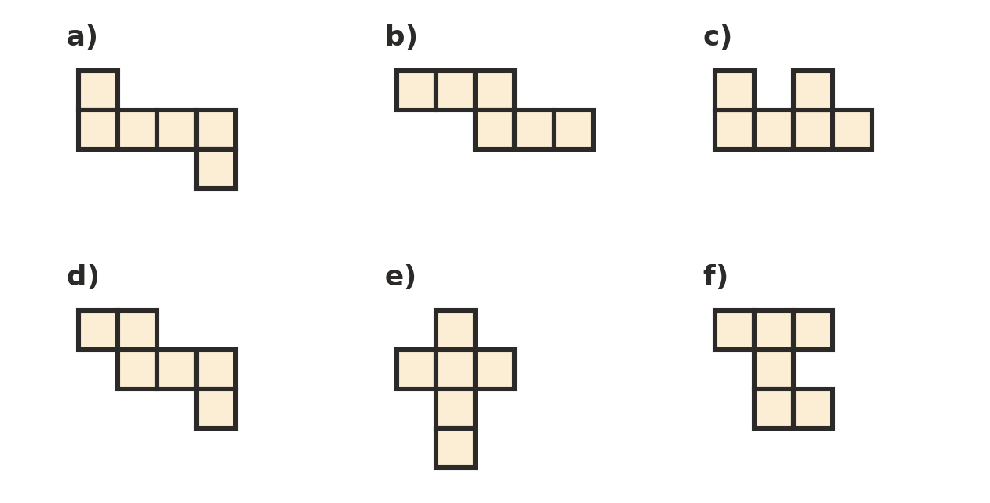

- This is the net of a rectangular prism.
- 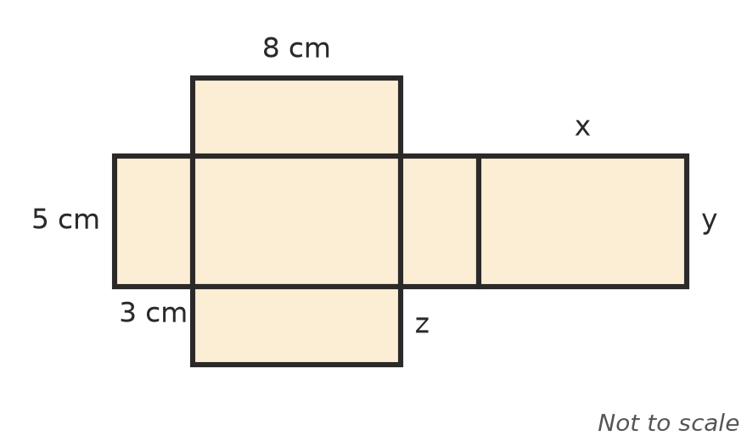
  - Find x, y and z.
  - Write the length, width and height of the prism.
  - How long is the whole strip of four rectangles in the middle of the net?
- Draw a net of this triangular prism. Label the length of every edge on your net.
- 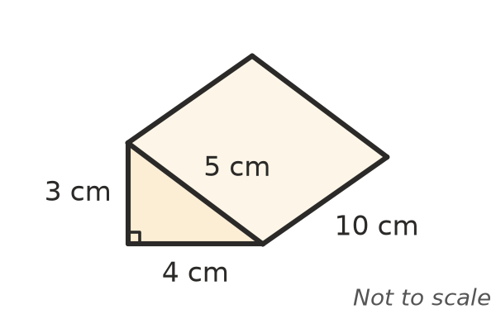
- This net folds up to make a cube. Which face is opposite each face?
- 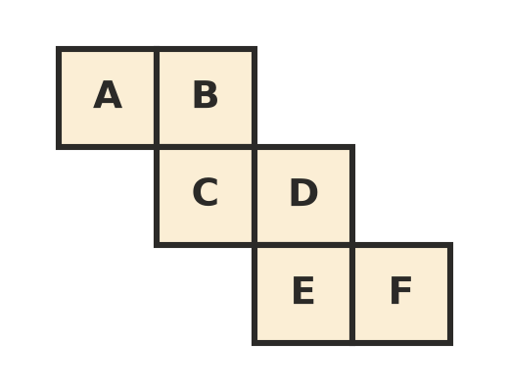
  - A is opposite
  - B is opposite
  - C is opposite
- Name the solid that each net makes.
  - 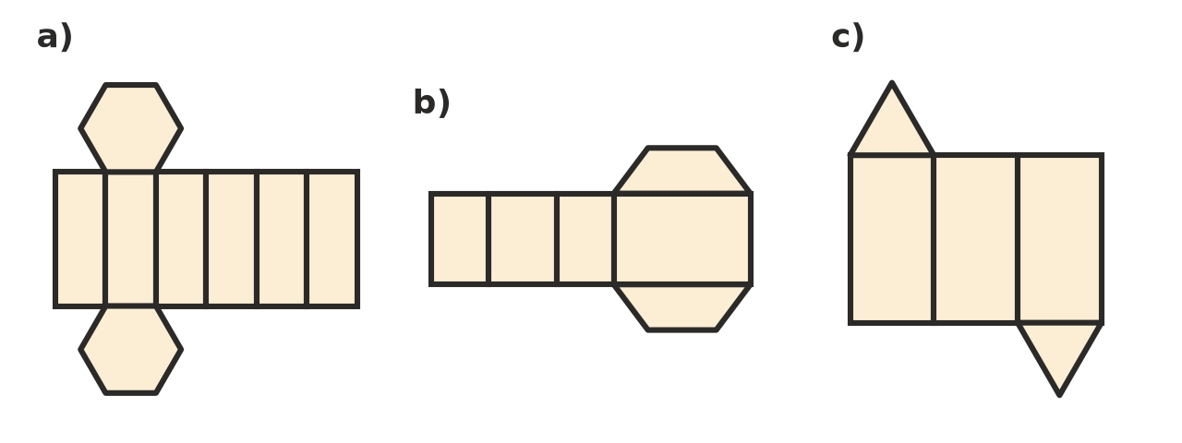

 Reasoning
- A prism has 30 edges.
  - How many sides does its cross-section have?
  - How many faces and vertices does it have?
  - Check your answers with Euler’s rule, Faces + Vertices − Edges = 2.
- Ahmed drew this net for a box 6 cm long, 3 cm wide and 4 cm high. Explain why it will not fold in your book, and how to fix it.
- 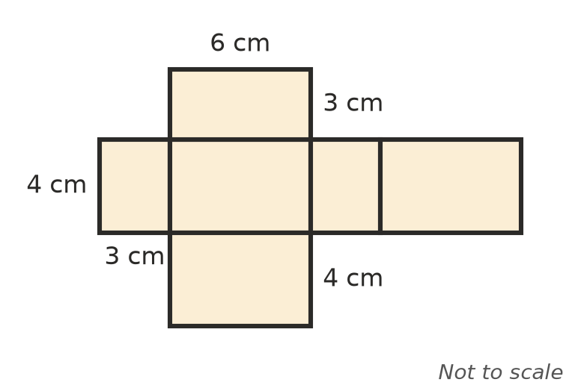
- Explain why the net of any prism has exactly two faces that are not rectangles. How many rectangles does the net of a prism with an n-sided cross-section have?

 Problem solving
- A cereal box is 20 cm wide, 6 cm deep and 30 cm tall.
  - Sketch a net of the box (ignore the flaps). Label every edge.
  - Your net is cut from a rectangle of card. What size rectangle does your net need?
- A gift box is a triangular prism. Its ends are equilateral triangles with sides of 4 cm, and it is 20 cm long.
  - Sketch a net of the box and label every edge.
  - The net is folded along the lines where two faces meet. How many edges of the box are folds, and how many must be taped?
- A cube net is made of six squares, each with sides of 5 cm. What is the total area of card in the net?

