9.02 Area of composite shapes
Year 9 Maths · Worksheet · Level 3 · Challenge
Name: ____________________ Date: ______________
This worksheet challenges you with composite shapes built from rectangles, triangles, sectors and circles, exact answers in terms of $π$, and real design problems. Tip: a sector with angle $θ$ has area $\frac{θ}{360}$ × $πr^{2}$. Draw extra lines on the diagram to show how you split it up.

 Understanding
- Answer each question about sectors. Give exact answers in terms of $π$.
  - Find the area of a sector with radius 6 cm and angle 40°. ______________
  - Find the area of a sector with radius 10 m and angle 216°. ______________
  - A sector of radius 6 cm has an area of $15π$ cm². Find its angle. ______________

 Fluency
- Find the area of each composite shape, to 1 decimal place where needed. In a), a semicircle has been cut out of the right-hand end.
- 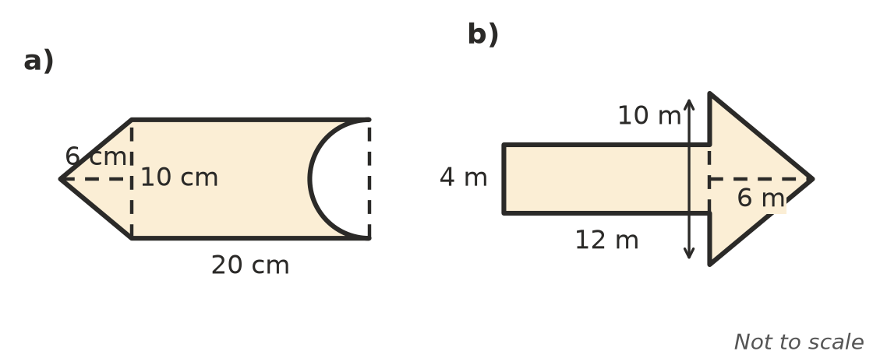
  - ______________
  - ______________
- The shaded shape is a semicircle of diameter 12 cm with two smaller semicircles cut out.
- 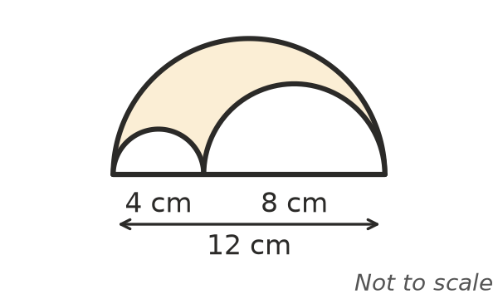
  - Find the exact shaded area. ______________
  - Round your answer to 1 decimal place. ______________
- A pipe has an outside diameter of 10 cm and an inside diameter of 8 cm. Find the exact area of the ring-shaped end of the pipe, then round it to 2 decimal places.

 Reasoning
- A quarter circle with a radius of 5 cm is cut from each corner of a square with sides of 10 cm.
- 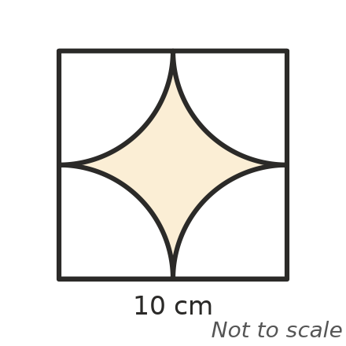
  - Find the exact shaded area. ______________
  - What percentage of the square is shaded, to 1 decimal place? ______________
- Two quarter circles of radius 4 cm are drawn inside a square with sides of 4 cm. Each one is centred on a corner of the square. Show that the shaded leaf has an area of (8$π$ − 16) cm².
- 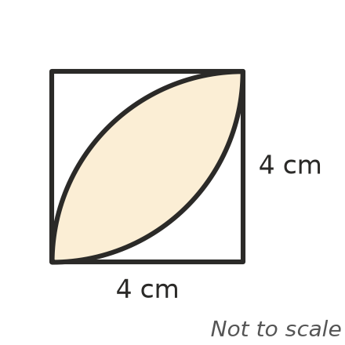

- Every length in a composite shape is doubled. Explain what happens to its area, and why.

- A semicircle is drawn on each side of a right-angled triangle with sides 6 cm, 8 cm and 10 cm.
- 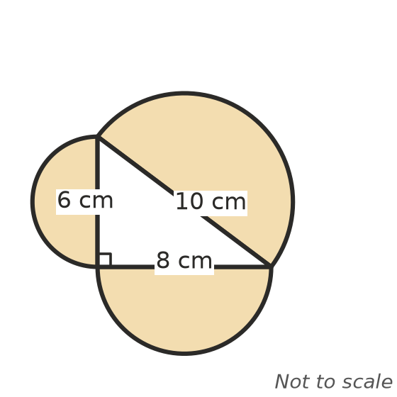
  - Find the exact area of each semicircle. ______________
  - What do you notice? Explain how this links to Pythagoras’ theorem.

 Problem solving
- One lane of a running track is 1 m wide. It has two straights 100 m long. On each bend the inside edge of the lane is a semicircle with radius 36 m, and the outside edge is a semicircle with radius 37 m. Find the area of the lane, to 1 decimal place.

- A garden bed is a rectangle x metres long and 4 m wide, with a semicircle on one of its 4 m ends.
  - Show that its area is A = 4x + 2$π$. ______________
  - The bed must have an area of 40 m². Find x, to 2 decimal places. ______________
- A window is a rectangle with a semicircle on top. The window is 1.6 m wide and 2.5 m tall at its highest point. Glass costs $180 per m².
  - Find the area of glass, to 2 decimal places. ______________
  - Find the cost of the glass, to the nearest dollar. ______________
- A garden sprinkler waters a sector with a radius of 6 m and an angle of 270°.
  - Find the area it waters, to 1 decimal place. ______________
  - A lawn has an area of 400 m². What is the least number of these sprinklers that could water it all? Explain why the real number might be higher.

- A circular pond with a radius of 3 m is surrounded by a path 1.5 m wide. Pavers for the path cost $48 per m². Find the area of the path to 2 decimal places, and the cost of the pavers.

