9.02 Area of composite shapes
Year 9 Maths · Worksheet · Level 1 · Warm-up
Name: ____________________ Date: ______________
A composite shape is made of simpler shapes joined together, or with a piece cut out. Tip: split the shape into parts you know, find each area, then add them. If a piece is missing, find the area of the whole shape and subtract the missing piece.

 Understanding
- This shape has been split into two rectangles, A and B.
- 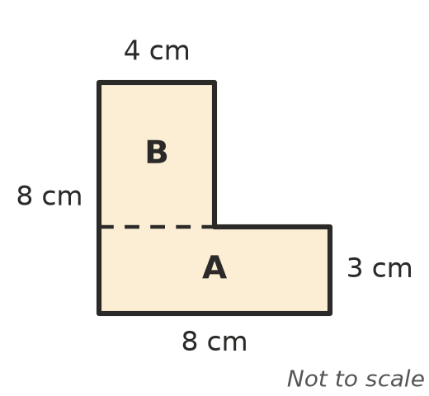
  - Find the area of rectangle A. ______________
  - Rectangle B is 4 cm wide. How tall is it? Find its area. ______________
  - Find the total area of the shape. ______________
- A semicircle is half a circle and a quadrant is a quarter of a circle. Find each area, to 1 decimal place.
  - a semicircle with radius 4 cm ______________
  - a quadrant with radius 10 m ______________

 Fluency
- Find the area of each composite shape. Round to 1 decimal place where needed.
- 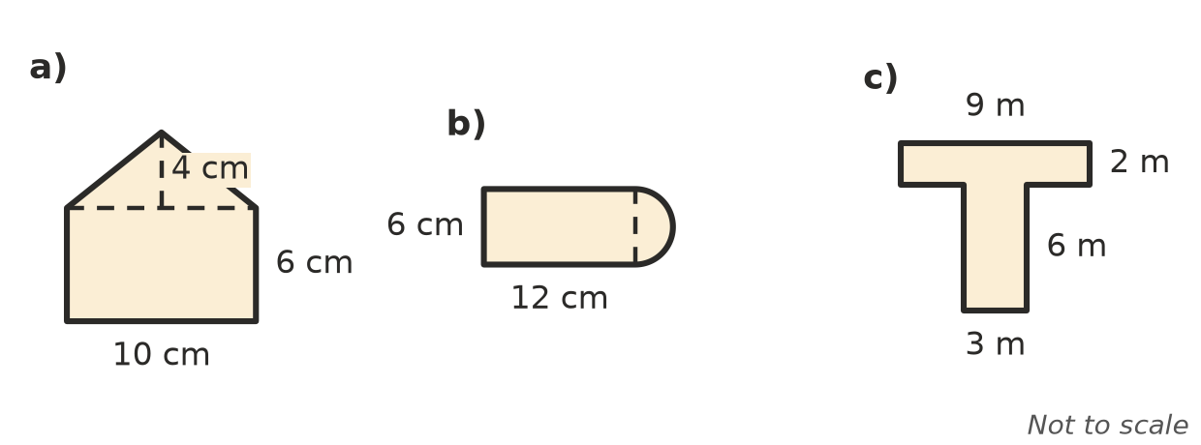
  - ______________
  - ______________
  - ______________
- Find the area of each shaded region. In a), the hole is a square with sides of 3 cm. Round to 1 decimal place where needed.
- 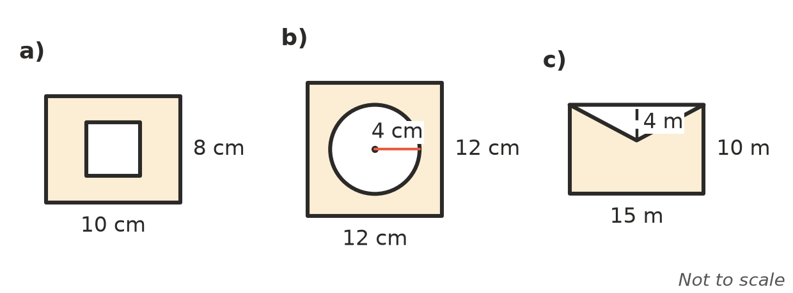
  - ______________
  - ______________
  - ______________

 Reasoning
- Look again at the shape in Question 1. Ari splits it with a vertical line instead, into a left part 4 cm wide and 8 cm tall, and a right part 4 cm wide and 3 cm tall. Find the area Ari’s way. Do you get the same answer as Question 1?

- A rectangle 10 cm by 7 cm has a 4 cm by 3 cm rectangle cut from one corner. Explain why it is quicker to subtract than to add here, and find the area.

 Problem solving
- A lawn is a rectangle 12 m by 9 m with a round pond of radius 2 m in the middle. Find the area of grass, to 1 decimal place.

- A window is a rectangle 1.2 m wide and 1.5 m tall with a semicircle on top. The semicircle’s diameter is the top of the rectangle. Find the area of glass, to 2 decimal places.

- The grass inside a running track is a rectangle 80 m long and 50 m wide with a semicircle on each end. Each semicircle has a diameter of 50 m. Find the area of grass, to 1 decimal place.

- A picture frame is 40 cm by 30 cm on the outside and 32 cm by 22 cm on the inside. Find the area of the frame.

- A wall is 5 m wide and 2.6 m high. It has a door 0.9 m wide and 2.1 m high.
  - Find the area of wall to be painted. ______________
  - One litre of paint covers 4 m². How many 1 L tins are needed? ______________

