9.02 Area of composite shapes
Year 9 Maths · A5 question sheet · Level 2 · Core
This worksheet practises finding the area of composite shapes by adding and subtracting simpler shapes, including parts of circles. Tip: a sector with angle $θ$ is $\frac{θ}{360}$ of a whole circle, so its area is $\frac{θ}{360}$ × $πr^{2}$.

 Understanding
- What fraction of a whole circle is each sector?
  - a semicircle (180°)
  - a quadrant (90°)
  - a sector with an angle of 60°
  - a sector with an angle of 270°

 Fluency
- Find the area of each composite shape. Round to 1 decimal place where needed.
  - 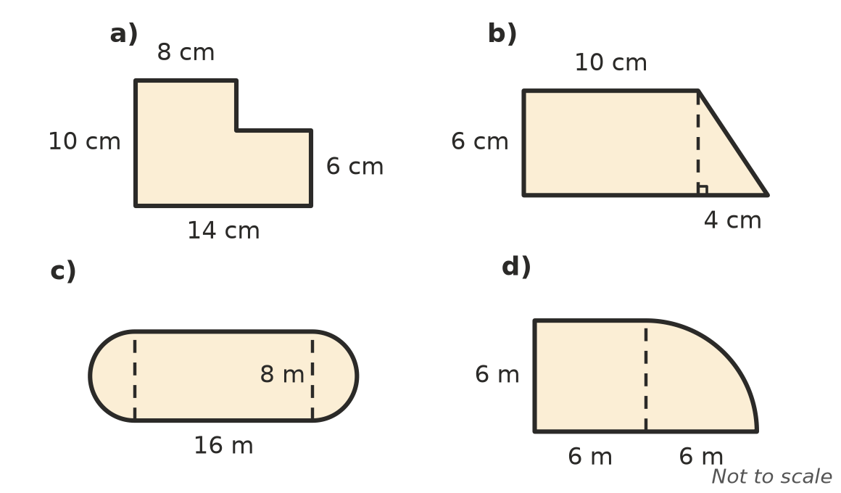

- Find the area of each shaded region. In a), each circle has a radius of 3 cm. Round to 1 decimal place.
  - 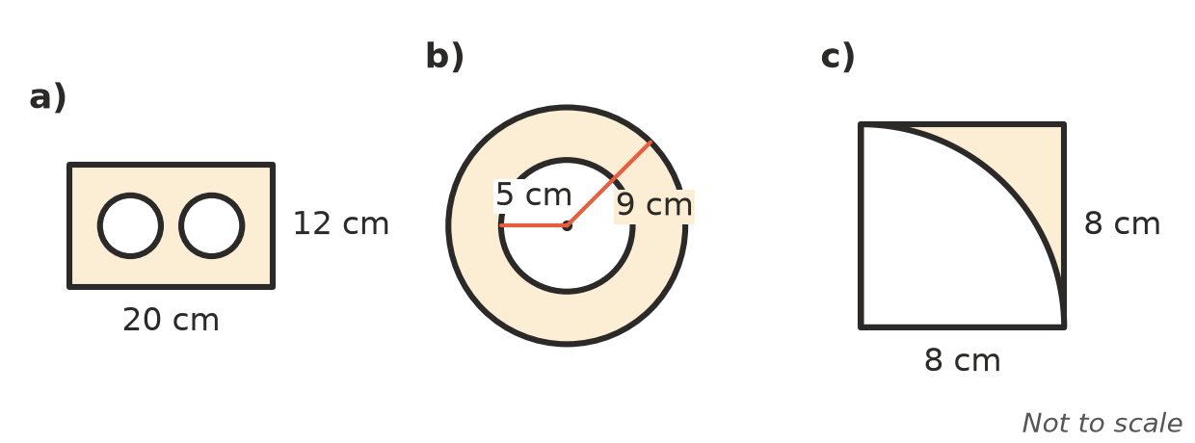

- Find the area of each sector, to 1 decimal place.
  - 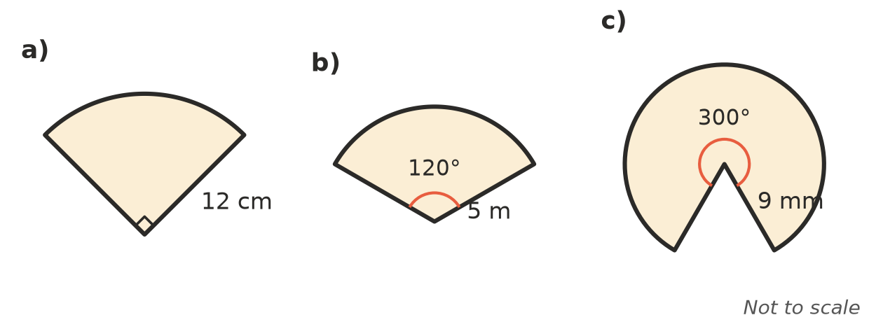

 Reasoning
- Mia finds the shaded area in Question 3 b) like this: $π$ × $(9−5)^{2}$ = $16π$ cm². Explain her mistake and give the correct exact answer.
- Look at shape a) in Question 2. Show two different ways to find its area: one by adding and one by subtracting.
- A square with sides of 4 cm has a semicircle on one side. The diameter of the semicircle is a side of the square. Find the exact area of the shape, in terms of $π$.

 Problem solving
- The infield of an athletics oval is a rectangle 90 m long and 60 m wide with a semicircle on each end. Find the area of the infield, to the nearest square metre.
- A courtyard is a rectangle 8 m by 6 m with a 3 m by 2 m garden bed cut out of one corner. Paving costs $55 per m². Find the cost of paving the courtyard.
- An arched doorway is a rectangle 1.0 m wide and 2.0 m tall with a semicircle on top. Find the area of the doorway, to 2 decimal places.
- A target has three rings with radii 2 cm, 4 cm and 6 cm, all with the same centre.
  - Find the exact area of the outer ring (between the 4 cm and 6 cm circles).
  - What fraction of the whole target is the outer ring?
- A tent floor at church camp is a rectangle 4 m by 3 m. A semicircular porch with a diameter of 3 m is joined to one of the 3 m sides. Find the total floor area, to 2 decimal places.
- A 35 cm pizza (the diameter) is cut into 8 equal slices. Find the area of one slice, to 1 decimal place.

