9.01 Area
Year 9 Maths · Worksheet · Level 3 · Challenge
Name: ____________________ Date: ______________
This worksheet stretches your skills with area: tricky diagrams, unit conversions, working backwards from an area, and building a rule to model a cost. Tip: check which length is the perpendicular height before you use a formula, and keep full calculator values until the last step.

 Understanding
- Convert each area.
  - 0.035 km² = ______________ m²
  - 4.2 m² = ______________ mm²
  - 125 000 mm² = ______________ m²
  - 7 500 000 cm² = ______________ ha

 Fluency
- Find the area of each shape. Watch out for lengths you don’t need.
- 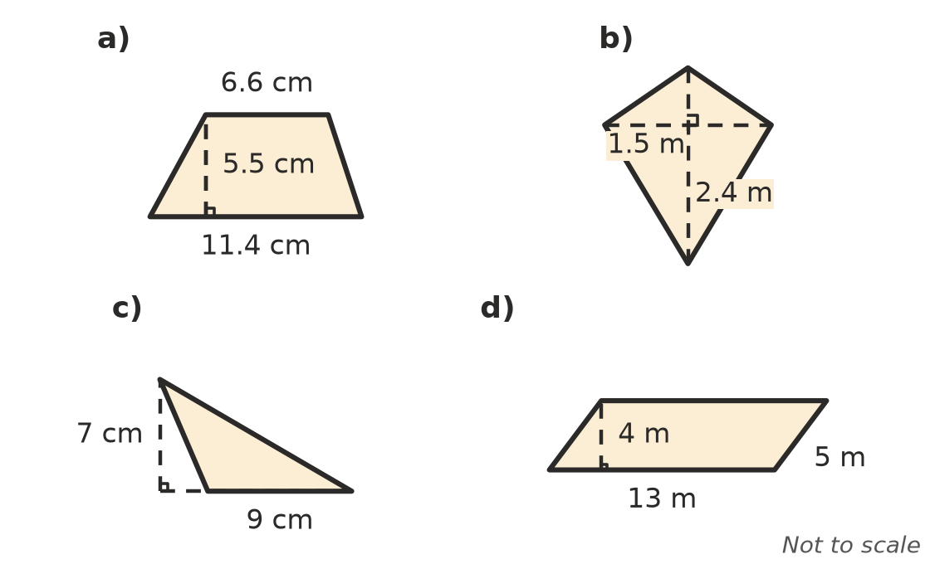
  - ______________
  - ______________
  - ______________
  - ______________
- Find the area of each circle.
  - radius 9 cm, as an exact answer in terms of $π$ ______________
  - diameter 3.6 m, to 2 decimal places ______________
  - circumference 44 cm, to 1 decimal place (find the radius first) ______________

 Reasoning
- Two copies of the same trapezium, one turned upside down, fit together to make a parallelogram. Use this idea to explain why the area of a trapezium is $\frac{1}{2}$(a + b)h.

- Find the missing lengths.
  - A rhombus has an area of 96 cm² and one diagonal of 16 cm. Find the other diagonal, then the length of each side. ______________
  - A circle has an area of 1000 m². Find its radius, to 2 decimal places. ______________
  - A trapezium has an area of 135 m², a height of 9 m and one parallel side of 11 m. Find the other parallel side. ______________
- A square and a circle both have an area of 100 cm². Which shape has the longer perimeter? Show your working.

- The radius of a circle is increased by 50%. By what percentage does its area increase?

- A kite has an area of 54 cm². Its diagonals are in the ratio 3 : 4. Find the length of each diagonal.

 Problem solving
- A paddock is shaped like a trapezium. Its parallel sides are 180 m and 240 m long, and they are 150 m apart. One 25 kg bag of fertiliser covers 400 m² and costs $42.
  - Find the area of the paddock in hectares. ______________
  - How many bags are needed, and what will they cost? ______________
- A family wants a round rug that covers at least 6 m² of floor. Rugs come in diameters of 2.4 m, 2.8 m and 3.0 m. Which is the smallest rug that will do? Show your working.

- A concreting company charges $65 per square metre plus a $350 call-out fee.
  - Write a rule for the cost, C dollars, of concreting an area of A square metres. ______________
  - Find the cost of a driveway 12 m long and 3.5 m wide. ______________
  - A family has $5000 to spend. What is the largest area they can afford, to 1 decimal place? ______________
- A square is drawn inside a circle of radius 5 cm so that its four corners touch the circle. The diagonal of the square is a diameter of the circle.
  - Find the area of the square. (Hint: a square is a rhombus.) ______________
  - What percentage of the circle does the square cover, to 1 decimal place? ______________
- A farmer sells a rectangular block of land 0.8 km long and 650 m wide for $12 500 per hectare. How much does the farmer receive?

