9.01 Area
Year 9 Maths · A5 question sheet · Level 2 · Core
This worksheet revises the area of the main two-dimensional shapes and converting between units of area. Tip: to change square units, square the length conversion. 1 m = 100 cm, so 1 m² = 100 × 100 = 10 000 cm².

 Understanding
- Write the area formula for each shape, using the letters given.
Shape | Letters
Triangle | base b, perpendicular height h
Parallelogram | base b, perpendicular height h
Trapezium | parallel sides a and b, height h
Rhombus or kite | diagonals x and y
Circle | radius r

- Copy and fill in the gaps.
  - 1 cm² = ______________ mm²
  - 1 m² = ______________ cm²
  - 1 ha = ______________ m²
  - 1 km² = ______________ ha

 Fluency
- Find the area of each shape.
  - 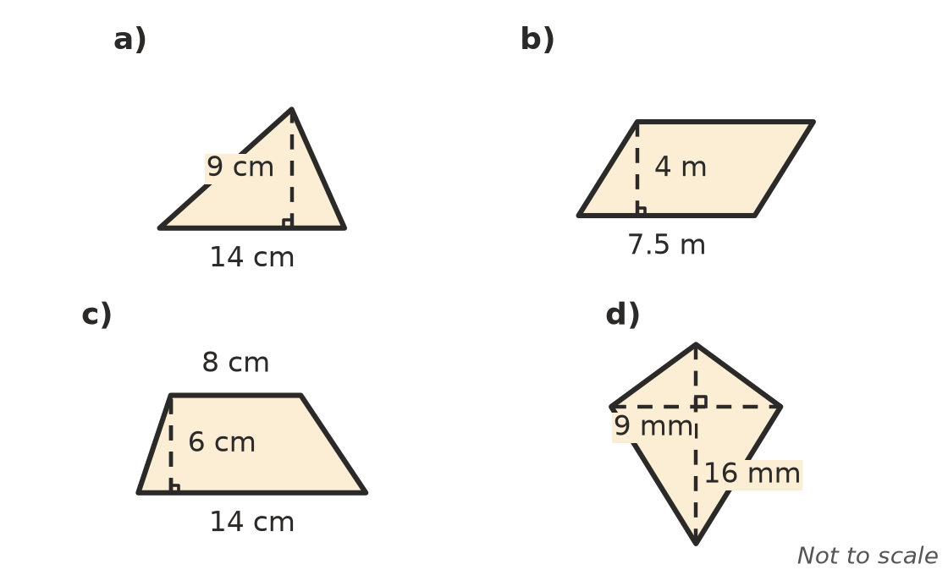

- Find the area of each circle.
  - radius 7 cm, to 2 decimal places
  - diameter 15 m, to 2 decimal places
  - radius 2.4 mm, to 2 decimal places
  - radius 6 cm, as an exact answer in terms of $π$
- Convert each area.
  - 2.7 m² = ______________ cm²
  - 8400 cm² = ______________ m²
  - 65 mm² = ______________ cm²
  - 3.2 ha = ______________ m²
  - 450 000 m² = ______________ ha

 Reasoning
- Jo says a square with sides of 1 m has an area of 100 cm². Explain why she is wrong, and give the correct area in cm².
- Find the missing length in each shape.
  - A parallelogram has an area of 84 cm² and a base of 12 cm. Find its height.
  - A triangle has an area of 45 m² and a height of 9 m. Find its base.
  - A trapezium has an area of 60 cm² and parallel sides of 7 cm and 13 cm. Find its height.
  - A circle has an area of 50.27 cm². Find its radius, to the nearest centimetre.
- The base and the height of a triangle are both doubled. What happens to its area? Use an example to explain.

 Problem solving
- A paddock is a rectangle 450 m long and 320 m wide.
  - Find its area in m².
  - Find its area in hectares.
- A pizza shop sells a 30 cm pizza for $18 and a 20 cm pizza for $9 (the sizes are diameters). Work out the cost per cm² of each pizza. Which is better value?
- A bathroom floor is 3.6 m long and 2.4 m wide. It is covered with square tiles that measure 30 cm by 30 cm. How many tiles are needed? (No tiles need to be cut.)
- The council wants a circular garden with an area of 200 m².
  - Find its radius, to 1 decimal place.
  - Find the length of edging needed around it, to the nearest metre. Use C = $2πr$.

