9.01 Area
Year 9 Maths · A5 question sheet · Level 1 · Warm-up
This worksheet revises the area formulas you met in earlier years. Tip: the height of a triangle, parallelogram or trapezium is always measured at right angles to the base, and area is always in square units such as cm² or m².

 Understanding
- Write the area formula for each shape.
Shape
Rectangle
Triangle
Parallelogram
Trapezium
Rhombus or kite
Circle

- Copy and fill in the gaps.
  - 1 cm = 10 mm, so 1 cm² = ______________ mm²
  - 1 m = 100 cm, so 1 m² = ______________ cm²
  - 1 hectare (ha) is a square 100 m by 100 m, so 1 ha = ______________ m²

 Fluency
- Find the area of each shape.
  - 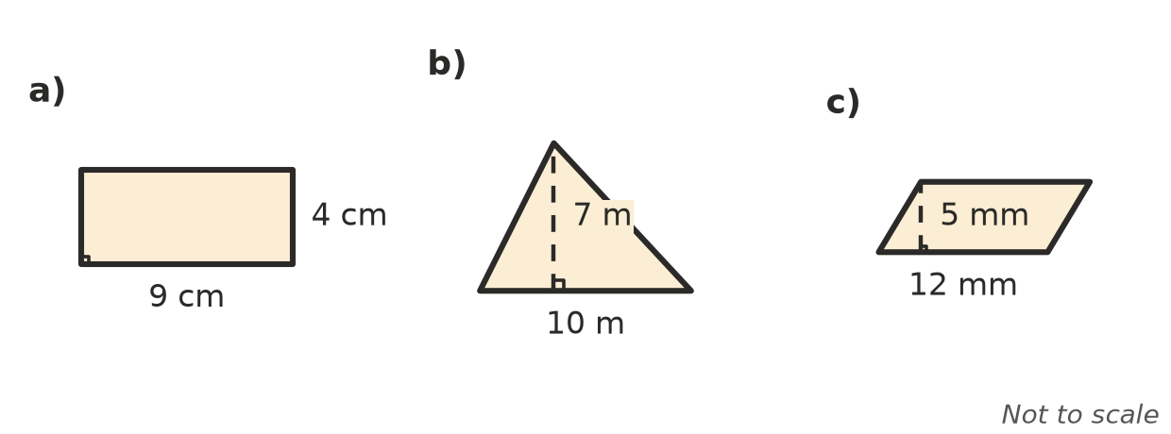

- Find the area of each shape.
  - 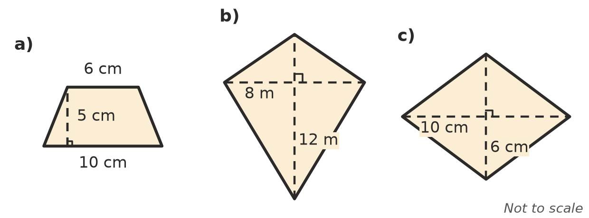

- Use A = $πr^{2}$ to find the area of each circle. Round to 1 decimal place.
  - radius 5 cm
  - radius 3 m
  - diameter 12 mm (halve the diameter first)
- Convert each area.
  - 4 m² = ______________ cm²
  - 350 mm² = ______________ cm²
  - 25 000 m² = ______________ ha

 Reasoning
- Kim says the area of a triangle with a base of 8 cm and a height of 6 cm is 48 cm². Explain her mistake and find the correct area.
- A rectangle has an area of 72 cm² and a length of 9 cm. How wide is it?

 Problem solving
- A backyard lawn is a rectangle 12 m long and 8 m wide. New turf costs $15 per m².
  - Find the area of the lawn.
  - Find the cost of the turf.
- A round trampoline has a diameter of 4 m. Find the area of its mat, to 1 decimal place.
- A triangular garden bed has a base of 5 m and an area of 20 m². Find its height.

