Linear relationships: Practice test 3
Year 9 Maths · Test · Test 3
Name: ____________________ Date: ______________
Time: 45 minutes
Total: 40 marks
Show your working in the boxes. Then write each final answer on the answer sheet on the last page. Write gradients as whole numbers or fractions in simplest form, and write equations of lines in the form $y=mx+c$ unless the question says otherwise.

 Section A: No calculator
- Answer each part.
  - Find the midpoint of the interval joining (−8, 5) and (2, −9). (1 mark)

  - M(−1, 3) is the midpoint of the interval CD. D is the point (4, 10). Find the coordinates of C. (2 marks)

- Triangle ABC is drawn on the number plane.
- 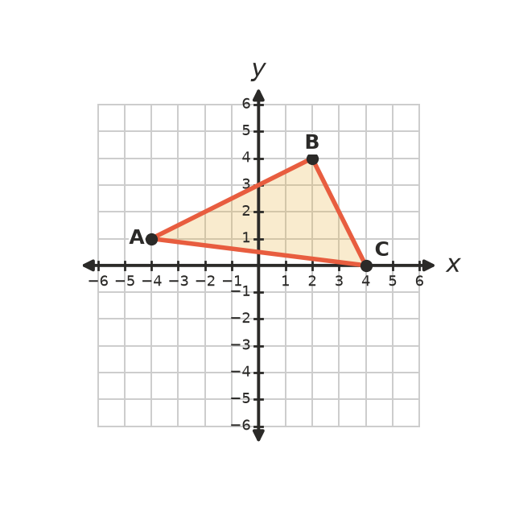
  - Find the gradient of AB. (1 mark)

  - Find the gradient of BC. (1 mark)

  - Use your answers to explain why angle ABC is a right angle. (1 mark)

- Answer each part.
  - Find the distance between the points (−2, −5) and (10, 0). (2 marks)

  - The distance from $(1,k)$ to (4, 2) is 5 units. Find the two possible values of $k$. (1 mark)

- Answer each part.
  - Which of these lines has a gradient of −2 and a y-intercept of 3? Answer: ______________ (1 mark)
  - $y=3x−2$
  - $2x+y=3$
  - $y=−2x−3$
  - $2y=−4x+3$
  - Find the gradient and the y-intercept of the line $5x−3y=15$. (2 marks)

- The table of values comes from a straight line.
$x$ | −1 | 0 | 1 | 2 | 3 | 4
$y$ | −7 | −4 |  | 2 |  | 8

  - Write the two missing values. (1 mark)

  - Write the equation of the line. (1 mark)

- This question is about the lines $2x−5y=10$ and $y=x+1$.
- 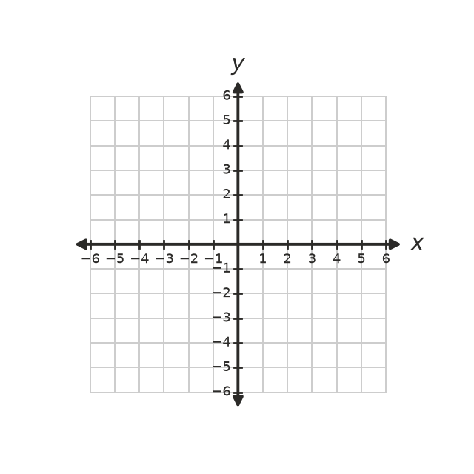
  - Find the x-intercept and the y-intercept of $2x−5y=10$. (1 mark)

  - Draw both lines on the number plane. Write the coordinates of the point where they meet. (1 mark)

- The line ℓ passes through (0, −2) and (6, 1).
  - Find the equation of the line that is perpendicular to ℓ and passes through (1, 5). (2 marks)

  - Find the equation of the line that is parallel to ℓ and has an x-intercept of −6. (2 marks)

- Find the equation of the straight line that passes through (−5, 4) and (5, −2). (2 marks)

- Answer each part.
  - Solve $−2x+9<3$. (1 mark)

  - Solve $\frac{2x+1}{5}≤x−4$. (2 marks)

  - Write the inequality shown on this number line. (1 mark)
- 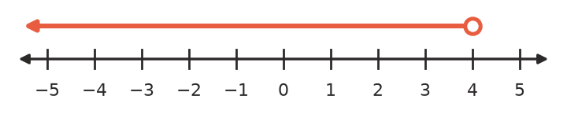

- A(1, 2), B(7, 4) and C(5, 8) are three corners of the parallelogram ABCD. The diagonals of a parallelogram cut each other in half, so AC and BD have the same midpoint. Find the coordinates of D. (2 marks)

 Section B: Calculator allowed
- The graph shows the cost of cheese at the deli counter.
- 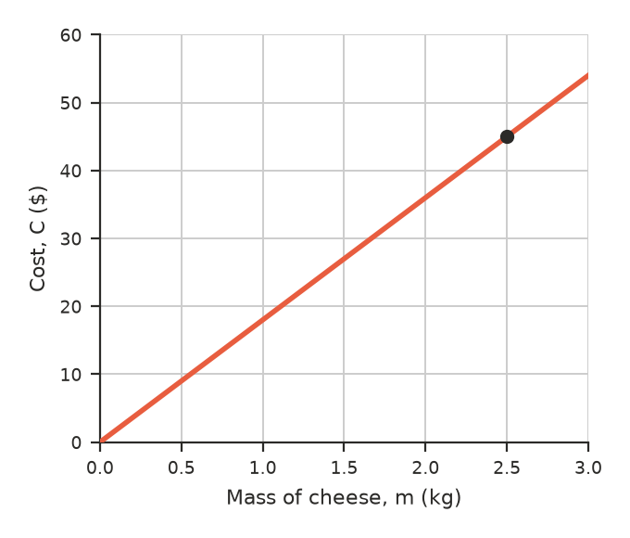
  - Explain how the graph shows that the cost is directly proportional to the mass. (1 mark)

  - Use the marked point to find the cost per kilogram. Write a formula for $C$ in terms of $m$. (1 mark)

  - Find the cost of 1.35 kg of cheese. (1 mark)

- For a one-day car hire, Company X charges $65 plus $0.28 for each kilometre driven. Company Y charges $110 with no charge per kilometre.
  - Write a formula for the cost, $C$ dollars, of driving $d$ km with Company X. (1 mark)

  - Find the cost of driving 140 km with Company X. (1 mark)

  - Write and solve an inequality to find the distances for which Company Y is cheaper. Give your answer to one decimal place. (2 marks)

- A coach marks positions on a footy oval using a grid in metres. A player kicks the ball from P(−18, 12) to a teammate at Q(25, −9).
  - How far does the ball travel, correct to two decimal places? (2 marks)

  - A third player stands exactly halfway between P and Q. Find this player’s position. (1 mark)

- The formula $F=1.8C+32$ changes a temperature in degrees Celsius ($C$) into degrees Fahrenheit ($F$).
  - What does the number 1.8 tell you about the two temperature scales? (1 mark)

  - At one temperature, the Celsius and Fahrenheit readings are the same number. Find this temperature. (1 mark)

 Answer sheet
Name: ____________________
Write your final answer for each question in the table.
Question | Answer | Marks | Question | Answer | Marks
1a |  | /1 | 8 |  | /2
1b |  | /2 | 9a |  | /1
2a |  | /1 | 9b |  | /2
2b |  | /1 | 9c |  | /1
2c |  | /1 | 10 |  | /2
3a |  | /2 | 11a |  | /1
3b |  | /1 | 11b |  | /1
4a |  | /1 | 11c |  | /1
4b |  | /2 | 12a |  | /1
5a |  | /1 | 12b |  | /1
5b |  | /1 | 12c |  | /2
6a |  | /1 | 13a |  | /2
6b |  | /1 | 13b |  | /1
7a |  | /2 | 14a |  | /1
7b |  | /2 | 14b |  | /1
 |  |  |  | Total | /40

