Linear relationships: Practice test 2
Year 9 Maths · Test · Test 2
Name: ____________________ Date: ______________
Time: 45 minutes
Total: 40 marks
Show your working in the boxes. Then write each final answer on the answer sheet on the last page. Write gradients as whole numbers or fractions in simplest form, and write equations of lines in the form $y=mx+c$ unless the question says otherwise.

 Section A: No calculator
- Answer each part.
  - Find the midpoint of the interval joining (−7, −2) and (3, 8). (1 mark)

  - The midpoint of the interval joining $(k,1)$ and (9, −7) is (4, −3). Find the value of $k$. (1 mark)

- The interval AB is drawn on the number plane.
- 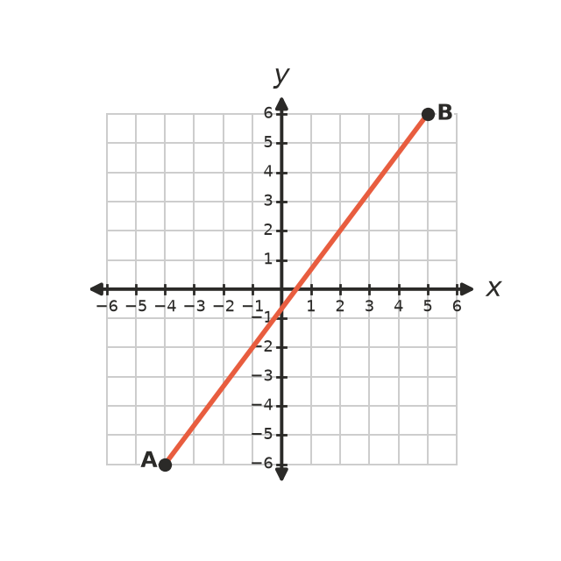
  - Find the gradient of AB. (1 mark)

  - Find the length of AB. (2 marks)

  - Find the midpoint of AB. (1 mark)

- Answer each part.
  - Find the gradient of the line through (−2, 6) and (4, −3). (1 mark)

  - The line through $(1,p)$ and (4, 11) has a gradient of 2. Find the value of $p$. (2 marks)

- This question is about the line $3x+4y=20$.
  - Rearrange the equation into the form $y=mx+c$. (1 mark)

  - Write the gradient and the y-intercept of the line. (1 mark)

- Use the gradient and the y-intercept to draw the lines $y=−\frac{1}{2}x+2$ and $y=2x−3$ on this number plane.
- 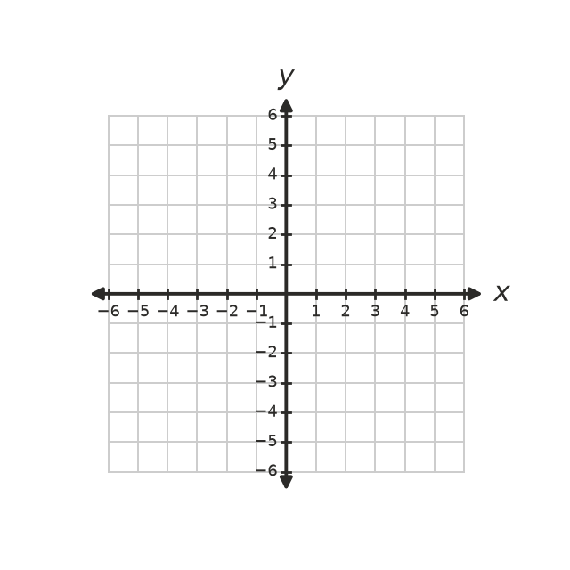
  - Write the coordinates of the point where the two lines meet. (1 mark)

  - Are the two lines perpendicular? Show how you know. (1 mark)

- Write the equation of each line.
- 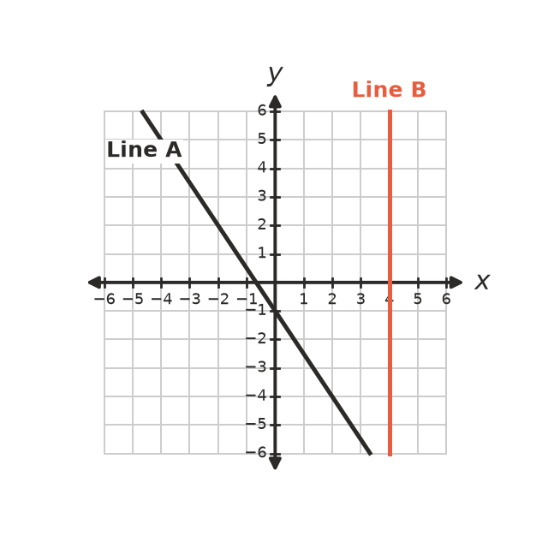
  - Line A (1 mark)

  - Line B (1 mark)

- Answer each part.
  - Find the equation of the line that is parallel to $2x−y=7$ and passes through (−3, 1). (2 marks)

  - Find the equation of the line that is perpendicular to $y=−\frac{1}{3}x+2$ and passes through (2, 4). (2 marks)

- Find the equation of the straight line that passes through (−3, 10) and (6, −2). (2 marks)

- Answer each part.
  - Solve $3(x−4)<5x+6$. (2 marks)

  - Solve $\frac{5−2x}{3}≥−1$. (2 marks)

  - Write the inequality shown on this number line. (1 mark)
- 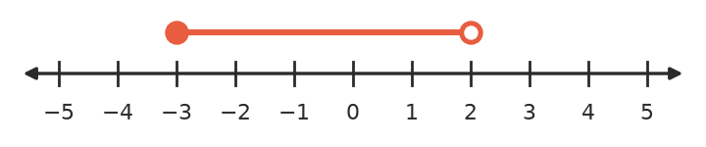

- Explain why the lines $2y=3x+8$ and $y=1.5x−4$ never meet. (2 marks)

 Section B: Calculator allowed
- The table shows what Ella is paid for different numbers of hours of work at a bakery.
Hours worked, $h$ | 4 | 6 | 9 | 15
Pay, $P$ ($) | 106.00 | 159.00 | 238.50 | 397.50

  - Show that pay is directly proportional to the hours worked. (1 mark)

  - Write a formula for $P$ in terms of $h$. (1 mark)

  - How much is Ella paid for 37.5 hours of work? (1 mark)

- A farm water tank holds 4500 L. A pipe empties it at a steady 180 L per minute.
  - Write a formula for the volume of water, $V$ litres, left in the tank after $t$ minutes. (1 mark)

  - How long does it take to empty the tank? (1 mark)

  - What does the gradient of your formula tell you about the tank? (1 mark)

  - Write and solve an inequality to find when there will be less than 1000 L left in the tank. Give your answer to one decimal place. (2 marks)

- On a map with a grid in kilometres, a school is at S(−3.5, 2) and a church is at C(4, −2.5). Find the straight-line distance between them, correct to two decimal places. (2 marks)

- On a site plan, a straight road passes through the points (1.2, 3.4) and (2.8, 0.2).
  - Find the gradient of the road. (1 mark)

  - A new footpath will meet the road at right angles. Find the gradient of the footpath. (1 mark)

 Answer sheet
Name: ____________________
Write your final answer for each question in the table.
Question | Answer | Marks | Question | Answer | Marks
1a |  | /1 | 8 |  | /2
1b |  | /1 | 9a |  | /2
2a |  | /1 | 9b |  | /2
2b |  | /2 | 9c |  | /1
2c |  | /1 | 10 |  | /2
3a |  | /1 | 11a |  | /1
3b |  | /2 | 11b |  | /1
4a |  | /1 | 11c |  | /1
4b |  | /1 | 12a |  | /1
5a |  | /1 | 12b |  | /1
5b |  | /1 | 12c |  | /1
6a |  | /1 | 12d |  | /2
6b |  | /1 | 13 |  | /2
7a |  | /2 | 14a |  | /1
7b |  | /2 | 14b |  | /1
 |  |  |  | Total | /40

