Linear relationships: Practice test 1
Year 9 Maths · Test · Test 1
Name: ____________________ Date: ______________
Time: 45 minutes
Total: 40 marks
Show your working in the boxes. Then write each final answer on the answer sheet on the last page. Write gradients as whole numbers or fractions in simplest form, and write equations of lines in the form $y=mx+c$ unless the question says otherwise.

 Section A: No calculator
- Answer each part.
  - Find the midpoint of the interval joining J(−6, 3) and K(2, −7). (1 mark)

  - M(1, −2) is the midpoint of the interval AB. A is the point (5, 4). Find the coordinates of B. (2 marks)

- Find the gradient of the line through each pair of points.
  - (−1, −4) and (3, 8) (1 mark)

  - (2, 5) and (8, 1) (1 mark)

  - (−3, 4) and (5, 4) (1 mark)

- The interval AB is drawn on the number plane.
- 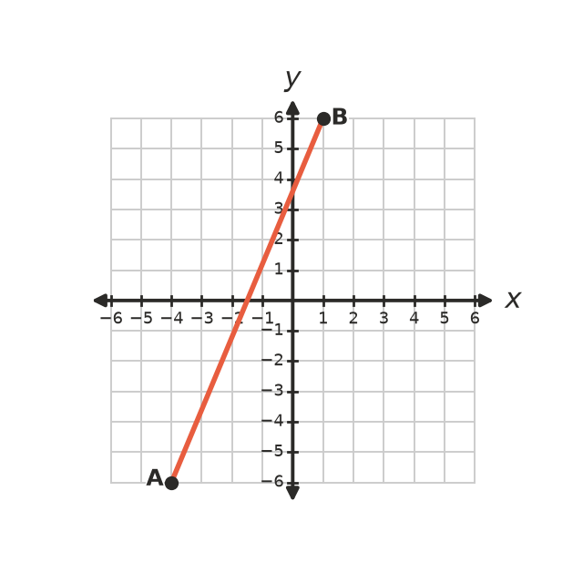
  - Find the gradient of AB. (1 mark)

  - Find the length of AB. (2 marks)

- Answer each part.
  - Write the gradient and the y-intercept of the line $y=7−3x$. (1 mark)

  - Rearrange $2y−6x=8$ into the form $y=mx+c$. (1 mark)

  - Write the equation of the line with gradient $−\frac{1}{2}$ and y-intercept 3. (1 mark)

- Write the equation of each line.
- 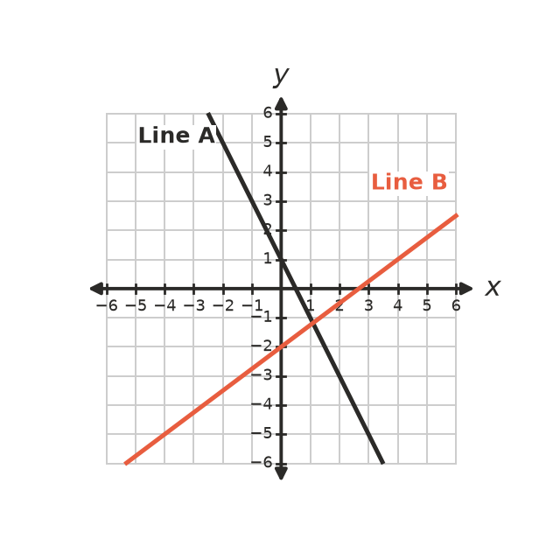
  - Line A (1 mark)

  - Line B (1 mark)

- This question is about the lines $x+2y=6$ and $y=x−3$.
- 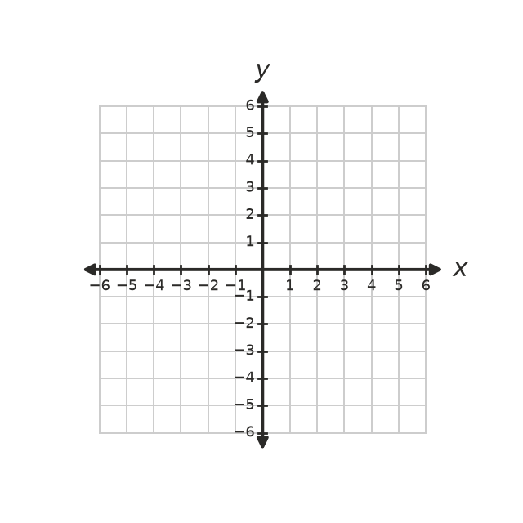
  - Find the x-intercept and the y-intercept of $x+2y=6$. (1 mark)

  - Draw both lines on the number plane. Write the coordinates of the point where they meet. (1 mark)

- Answer each part.
  - Are the lines $y=3x+2$ and $6x−2y=5$ parallel? Show how you know. (1 mark)

  - Write the gradient of a line that is perpendicular to $y=−4x+1$. (1 mark)

  - Find the equation of the line that passes through (−2, 5) and is perpendicular to $y=\frac{1}{2}x−3$. (2 marks)

- Find the equation of the straight line that passes through (−4, −1) and (2, 8). (2 marks)

- Answer each part.
  - Solve $4x+7>−9$. (1 mark)

  - Solve $2−5x≥27$. (2 marks)

  - Write the inequality shown on this number line. (1 mark)
- 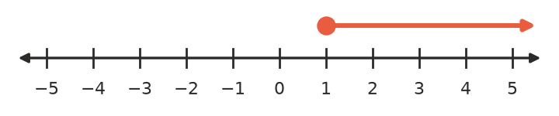

- Sam says that the line through (2, 1) and (2, 6) has a gradient of 0. Explain why Sam is wrong, and describe the line. (2 marks)

 Section B: Calculator allowed
- The mass of a stack of identical paving tiles is directly proportional to the number of tiles. A stack of 24 tiles has a mass of 50.4 kg.
  - Find the constant of proportionality, $k$ (the mass of one tile). (1 mark)

  - Write a formula for the mass, $M$ kg, of $n$ tiles. (1 mark)

  - A garden trolley can carry at most 180 kg. What is the greatest number of tiles it can carry? (1 mark)

- A taxi charges a flag fall of $4.20 plus $2.35 for each kilometre travelled.
  - Write a formula for the cost, $C$ dollars, of a trip of $d$ km. (1 mark)

  - Find the cost of an 18 km trip. (1 mark)

  - A trip cost $56.84. How far was the trip? (1 mark)

  - A rideshare service charges $2.95 per kilometre with no flag fall. Write and solve an inequality to find the trip lengths for which the taxi is cheaper. (2 marks)

- On a map with a grid in kilometres, a fishing boat is at S(−12, 5) and a lighthouse is at L(9, −3). Find the straight-line distance from the boat to the lighthouse, correct to two decimal places. (2 marks)

- A wheelchair ramp rises 0.45 m over a horizontal distance of 3.6 m.
  - Find the gradient of the ramp as a decimal. (1 mark)

  - A building rule says the gradient of a ramp must be no more than $\frac{1}{14}$. Does this ramp meet the rule? Show how you know. (1 mark)

 Answer sheet
Name: ____________________
Write your final answer for each question in the table.
Question | Answer | Marks | Question | Answer | Marks
1a |  | /1 | 7c |  | /2
1b |  | /2 | 8 |  | /2
2a |  | /1 | 9a |  | /1
2b |  | /1 | 9b |  | /2
2c |  | /1 | 9c |  | /1
3a |  | /1 | 10 |  | /2
3b |  | /2 | 11a |  | /1
4a |  | /1 | 11b |  | /1
4b |  | /1 | 11c |  | /1
4c |  | /1 | 12a |  | /1
5a |  | /1 | 12b |  | /1
5b |  | /1 | 12c |  | /1
6a |  | /1 | 12d |  | /2
6b |  | /1 | 13 |  | /2
7a |  | /1 | 14a |  | /1
7b |  | /1 | 14b |  | /1
 |  |  |  | Total | /40

