4.10 Linear inequalities
Year 9 Maths · Worksheet · Level 3 · Challenge
Name: ____________________ Date: ______________
This worksheet practises harder inequalities with fractions and brackets, double inequalities, and real problems where the answer must be rounded sensibly. Tip: in a double inequality like $−5<3x+1≤10$, do the same thing to all three parts at once.

 Understanding
- Solve each inequality.
  - $\frac{3x−2}{4}≤\frac{x+5}{2}$ ______________
  - $5−3(2x−1)>2x$ ______________
  - $\frac{x}{3}−\frac{x}{4}≥2$ ______________
  - $−2(x+4)≥3(2−x)$ ______________

 Fluency
- Solve each double inequality, then show the answer on the number line.
  - $−5<3x+1≤10$ ______________
  - $1≤7−2x<9$ ______________
- 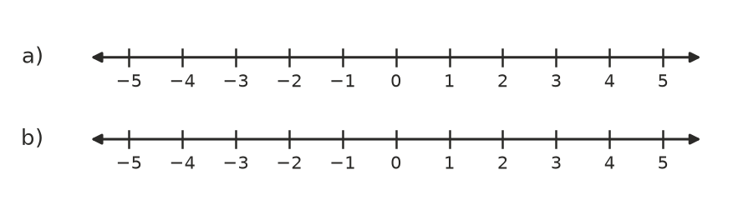
- Write the inequality shown on each number line.
- 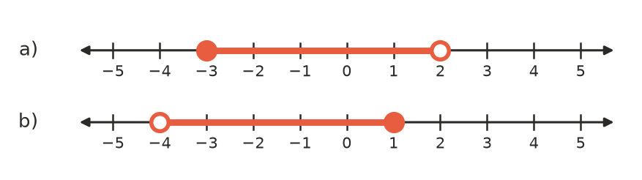
  - ______________
  - ______________

 Reasoning
- Find the smallest integer $n$ that satisfies $4n−7>2n+6$. ______________
- For what value of $k$ does the inequality $3x+k>5$ have the solution $x>2$? ______________
- Explain why $2(x+3)>2x+1$ is true for every value of $x$, but $2(x+3)<2x+1$ has no solution.

 Problem solving
- Plan A costs $25 a month plus $8 per GB of data. Plan B costs $59 a month for unlimited data. Write and solve an inequality to find when plan A is cheaper. ______________
- A rectangle’s length is 3 cm more than twice its width, and its perimeter is at most 60 cm.
  - Write and solve an inequality for the width, $w$ cm. ______________
  - If the width is a whole number of centimetres, find the largest possible area. ______________
- For a bake sale, the youth group spends $45 on equipment plus 80 cents per cupcake, and sells each cupcake for $3. How many cupcakes must they make and sell to make a profit of at least $200? ______________
- A vaccine must be stored between 2 °C and 8 °C (inclusive). Use $F=1.8C+32$ to write this range as a double inequality in degrees Fahrenheit. ______________
- Three consecutive even numbers add to less than 100. Find the largest possible set of three numbers. ______________

