4.10 Linear inequalities
Year 9 Maths · Worksheet · Level 2 · Core
Name: ____________________ Date: ______________
This worksheet practises solving linear inequalities, including ones with brackets, fractions and negative coefficients, and using them to solve problems. Tip: reverse the inequality sign whenever you multiply or divide both sides by a negative number. Check your answer by testing a number from your solution.

 Understanding
- Write the inequality shown on each number line.
- 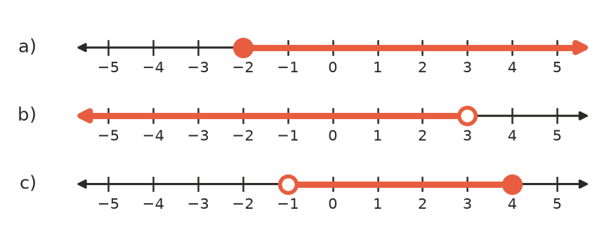
  - ______________
  - ______________
  - ______________

 Fluency
- Solve each inequality.
  - $3x−7>8$ ______________
  - $5+2x≤−9$ ______________
  - $\frac{x}{4}+3≥1$ ______________
  - $4(x−2)<12$ ______________
  - $\frac{2x+1}{3}>5$ ______________
  - $6x+1≥2x+13$ ______________
- Solve each inequality.
  - $−4x>20$ ______________
  - $7−3x≤1$ ______________
  - $−\frac{x}{2}≥3$ ______________
  - $2(3−x)<10$ ______________
- Solve each inequality, then show the answer on the number line.
  - $5x−2≥3x+4$ ______________
  - $9−2x>3$ ______________
- 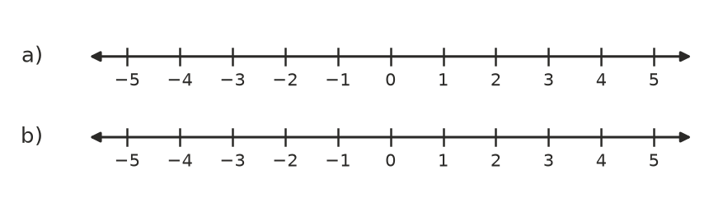

 Reasoning
- Noah solved $4−2x>10$ like this:
- $−2x>6$, so $x>−3$
- Find his mistake and give the correct solution.

- Use the true statement 2 < 5 to explain why multiplying both sides of an inequality by −1 reverses the sign.

- List all the integers that satisfy $−3≤2x+1<7$. ______________

 Problem solving
- Emily has $30. She must keep $6 for the bus, and wants to spend the rest on sausage rolls at $4.50 each. Write and solve an inequality to find the greatest number of sausage rolls she can buy. ______________
- Kai’s first three test scores are 72, 85 and 68. What score does he need on the fourth test to have an average of at least 75? ______________
- A gym charges $18 per visit, or $55 a month plus $4 per visit for members. Write and solve an inequality to find how many visits a month make membership the cheaper option. ______________
- A goods lift can carry at most 1000 kg. The operator weighs 80 kg and each box weighs 35 kg. Find the greatest number of boxes the lift can carry with the operator. ______________

