4.10 Linear inequalities
Year 9 Maths · A5 question sheet · Level 1 · Warm-up
This worksheet practises solving inequalities and showing the answers on a number line. Tip: solve an inequality just like an equation, but if you multiply or divide both sides by a negative number, reverse the inequality sign. On a number line, an open circle means the number is not included (< or >) and a filled circle means it is (≤ or ≥).

 Understanding
- Write the inequality shown on each number line.
  - 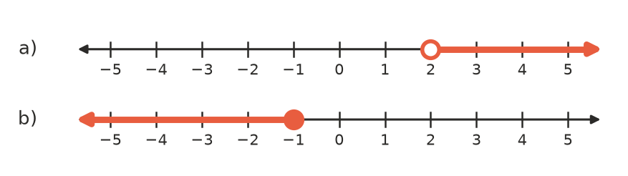

- Is each inequality true or false when $x=3$?
  - $x+4>6$
  - $2x≤5$
  - $10−x≥7$
  - $3x−1<8$

 Fluency
- Solve each inequality.
  - $x+5>9$
  - $x−3≤2$
  - $4x≥20$
  - $\frac{x}{3}<2$
  - $2x+1>7$
  - $3x−4≤11$
- Solve each inequality, then show the answer on a grid in your book.
  - $2x−3<5$
  - $5x+2≥−8$
- Solve each inequality. Remember to reverse the sign if you divide by a negative number.
  - $−3x≥12$
  - $5−x>2$

 Reasoning
- To solve $−2x<6$, Ava divides both sides by −2 and gets $x>−3$.
  - Test $x=0$ in $−2x<6$. Is it true?
  - Test $x=−4$ in $−2x<6$. Is it true?
  - Do your tests agree with Ava’s answer?
- Write an inequality for each statement.
  - Your age, $a$, is at least 18.
  - Your speed, $s$ km/h, is less than 40.
  - The number of people in the lift, $p$, is no more than 12.

 Problem solving
- Concert tickets cost $35 each. Tom has $200.
  - Write an inequality for the number of tickets, $n$, he can buy.
  - What is the greatest number of tickets he can buy?
- A phone plan costs $20 a month plus $5 for each GB of data. Mia’s budget is $50 a month. Write and solve an inequality to find the most data she can use.
- Find the largest whole number $x$ that makes $3x+2<20$ true.

