4.09 Model linear equations
Year 9 Maths · Worksheet · Level 2 · Core
Name: ____________________ Date: ______________
This worksheet practises building linear models from words, tables and graphs, using them to answer questions, and deciding how far a model can be trusted. Tip: when two linear models are compared, the point where their graphs cross is where they give the same value. Find it by making the two rules equal. You may use a calculator.

 Understanding
- Write a linear model for each situation. Say what each variable stands for.
  - A plumber charges an $85 call-out fee plus $70 per hour. ______________
  - A pool already holds 45 000 L and is being filled at 1500 L per hour. ______________
  - A ute bought for $28 000 loses $3500 of value each year. ______________
- A hall hire company charges for chairs like this.
Number of chairs, $n$ | 10 | 20 | 30 | 40
Cost, $C$ ($) | 650 | 1050 | 1450 | 1850

  - Find a rule for the cost. ______________
  - What could the number on its own in your rule stand for? ______________
  - Find the cost of 75 chairs. ______________

 Fluency
- The graph shows the charges of two electricians, A and B.
- 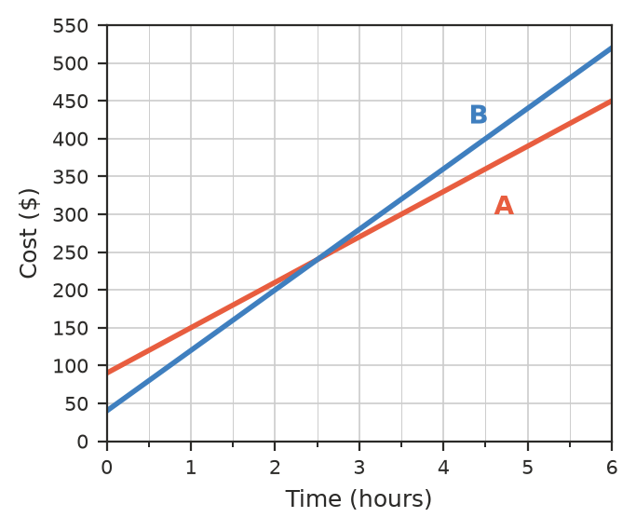
  - Write a rule for each electrician’s charge, $C$ dollars, for $h$ hours. ______________
  - Which electrician is cheaper for a 4-hour job? ______________
  - Use algebra to find the job length for which they charge the same. Check it on the graph. ______________
- Grace invests $5000 at 4% per year simple interest, so she earns the same amount of interest every year.
  - How much interest does she earn each year? ______________
  - Write a rule for the value of her investment, $A$ dollars, after $t$ years. ______________
  - How much will it be worth after 6 years? ______________
  - After how many years will it be worth $7000? ______________

 Reasoning
- A ute’s value is modelled by $V=28 000−3500t$, where $t$ is the number of years since it was bought.
  - Find its value after 5 years. ______________
  - When does the model say the ute is worth nothing? ______________
  - Is this a good model for the ute’s value over 10 years? Give one reason.

- Hikers record the temperature at different heights on a mountain on the same morning.
Height above sea level (m) | 0 | 500 | 1000 | 1500
Temperature (°C) | 24 | 20.75 | 17.5 | 14.25

  - Write a rule for the temperature, $T$ °C, at a height of $a$ metres. ______________
  - Use your rule to predict the temperature at the top of Mt Kosciuszko (2228 m), to 1 decimal place. ______________
  - Give one reason why the prediction might not match the real temperature.

 Problem solving
- A church camp hires a venue for $1200, and food and activities cost $45 per camper. The camp charges each camper $85.
  - Write rules for the total cost, $C$, and the total income, $I$, for $n$ campers. ______________
  - How many campers are needed to break even? ______________
  - What is the profit if 42 campers come? ______________
- Tank A holds 600 L and is draining at 25 L per minute. At the same time, Tank B holds 150 L and is filling at 20 L per minute. When will the two tanks hold the same amount, and how much will that be?

- Mia has $180 and saves $15 each week. Leo has $420 and spends $25 of it each week. After how many weeks will they have the same amount, and how much will each have?

- A candle burns at a steady rate. After 1 hour it is 21.5 cm tall, and after 4 hours it is 14 cm tall.
  - Write a rule for its height, $h$ cm, after $t$ hours. ______________
  - How tall was it when it was lit? ______________
  - How long will it burn for altogether? Give your answer in hours and minutes. ______________

