4.09 Model linear equations
Year 9 Maths · A5 question sheet · Level 1 · Warm-up
This worksheet practises writing linear rules for real situations and using them to answer questions. Tip: in a rule like $C=12w+40$, the number multiplying the variable is the rate (the amount added each time) and the number on its own is the starting amount.

 Understanding
- A gym charges a $40 joining fee plus $12 per week.
  - Write a rule for the total cost, $C$ dollars, after $w$ weeks.
  - Find the cost for 10 weeks.
  - In your rule, what does the 12 mean, and what does the 40 mean?
- The table shows the cost of hiring a bobcat.
Hours, $h$ | 0 | 1 | 2 | 3 | 4
Cost, $C$ ($) | 30 | 75 | 120 | 165 | 210

  - By how much does the cost go up each hour?
  - Write a rule for the cost.
  - Find the cost of hiring it for 7 hours.

 Fluency
- Josh has $120 saved, and saves $25 each week.
  - Write a rule for his savings, $S$ dollars, after $w$ weeks.
  - How much will he have after 8 weeks?
  - How many weeks until he has $470?
- A water tank holds 2000 L. Water is used at 80 L per hour.
  - Write a rule for the water left, $V$ litres, after $t$ hours.
  - How much water is left after 6 hours?
  - When will the tank be empty?
- The graph shows what a plumber charges.
- 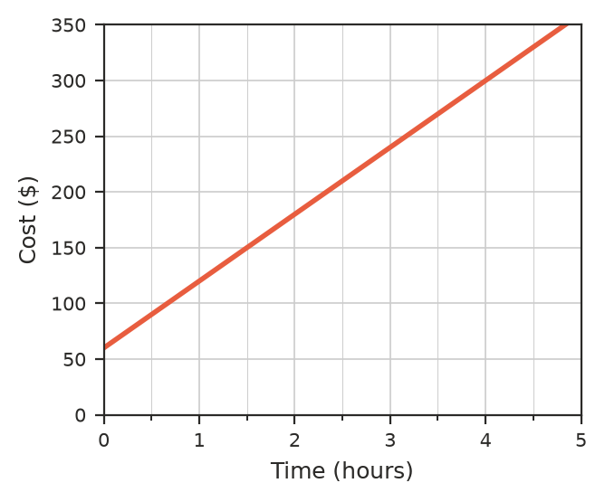
  - What is the call-out fee (the charge for 0 hours)?
  - How much does the plumber charge for each hour?
  - Write a rule for the charge, $C$ dollars, for $h$ hours.
  - Find the charge for a 2.5-hour job.

 Reasoning
- Bike Hire A charges $20 plus $8 per hour. Bike Hire B charges $12 per hour.
  - Copy and complete the table.
Hours | 1 | 3 | 5 | 8
Cost at A ($)
Cost at B ($)

  - Which company is cheaper for 3 hours? For 8 hours?
  - For how many hours do they cost the same?
- A baby is 50 cm long at birth and grows about 6 cm a year in early childhood. Explain why the rule “length = 50 + 6 × age” can’t be used for adults.

 Problem solving
- At a sausage sizzle fundraiser, the gas and barbecue hire cost $60. Each sausage costs $1 to buy and sells for $3.
  - Show that the profit, $P$ dollars, from selling $n$ sausages is $P=2n−60$.
  - How many sausages must be sold to break even (make $0 profit)?
  - What is the profit if 100 sausages are sold?
- Bec drives from Perth to Albany, a distance of 420 km, at an average speed of 90 km/h.
  - Write a rule for the distance still to go, $D$ km, after $t$ hours.
  - How far is left after 2 hours?
  - How long does the whole trip take, in hours and minutes?
  - Give one reason why the real trip might take longer.
- A club orders T-shirts for a fun run. The cost is $C=15n+200$ dollars for $n$ shirts.
  - What does the 200 stand for?
  - Find the cost of 40 shirts.
  - How many shirts can the club get for $1100?

