4.08 Direct proportion
Year 9 Maths · Worksheet · Level 2 · Core
Name: ____________________ Date: ______________
This worksheet practises recognising direct proportion from tables, graphs and situations, finding the constant of proportionality, and using $y=kx$ to solve problems. Tip: $k=\frac{y}{x}$ is the gradient of the graph, and it is the amount of $y$ for each 1 unit of $x$.

 Understanding
- Which tables show direct proportion? For each one that does, write the rule $y=kx$.
Table | Values of $x$ | Values of $y$ | Proportional? Rule?
a | 2, 4, 6, 8 | 7, 14, 21, 28
b | 1, 2, 3, 4 | 3, 5, 7, 9
c | 5, 10, 15, 20 | 2, 4, 6, 8
d | 1, 2, 4, 8 | 2, 4, 8, 16

- The graph shows the distance travelled by a car on a highway at a steady speed.
- 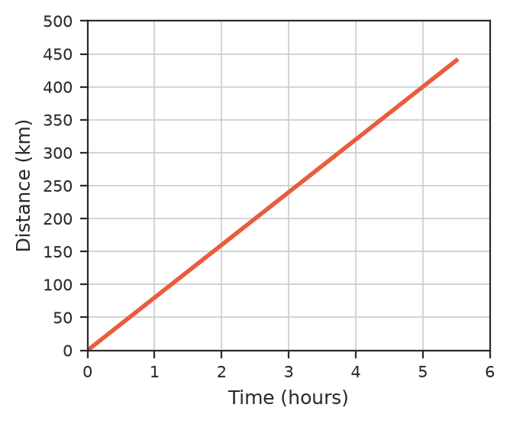
  - Find the constant of proportionality, $k$. ______________
  - Write a rule for the distance, $d$ km, after $t$ hours. ______________
  - What does $k$ mean in this situation? ______________

 Fluency
- $y$ is directly proportional to $x$.
  - $y=18$ when $x=4$. Write the rule and find $y$ when $x=10$. ______________
  - $y=7.5$ when $x=2.5$. Write the rule and find $x$ when $y=24$. ______________
  - $y=6$ when $x=15$. Write the rule and find $y$ when $x=40$. ______________
- $y$ is directly proportional to $x$. Complete the table.
$x$ | 3 | 5 |  | 12
$y$ | 10.5 |  | 28 |  | 63

 Reasoning
- Explain why the graph of a direct proportion must pass through the origin.

- Ava says this table shows direct proportion because $y$ goes up by 4 each time. Is she right? Explain.
$x$ | 2 | 4 | 6
$y$ | 5 | 9 | 13

- $y$ is directly proportional to $x$. What happens to $y$ when:
  - $x$ is tripled? ______________
  - $x$ is halved? ______________

 Problem solving
- A car uses 6.8 L of petrol for every 100 km.
  - Write a rule for the petrol used, $F$ litres, on a trip of $d$ km. ______________
  - How much petrol is used on a 450 km trip? ______________
  - How far can the car go on 52 L, to the nearest km? ______________
- On one day, 250 Australian dollars (AUD) could be exchanged for 272.50 New Zealand dollars (NZD).
  - Write a rule for the number of NZD, $N$, you get for $A$ AUD. ______________
  - How many NZD would you get for 640 AUD? ______________
  - How many AUD would you need to get 1308 NZD? ______________
- The stretch of a spring is directly proportional to the mass hanging on it. A 300 g mass stretches the spring 4.5 cm.
  - Find the stretch for each gram. ______________
  - How far will a 750 g mass stretch the spring? ______________
  - The spring breaks if it stretches more than 18 cm. What is the largest mass it can hold? ______________
- Amy and Ben ride their bikes along the same bike path, starting at the same time and place.
- 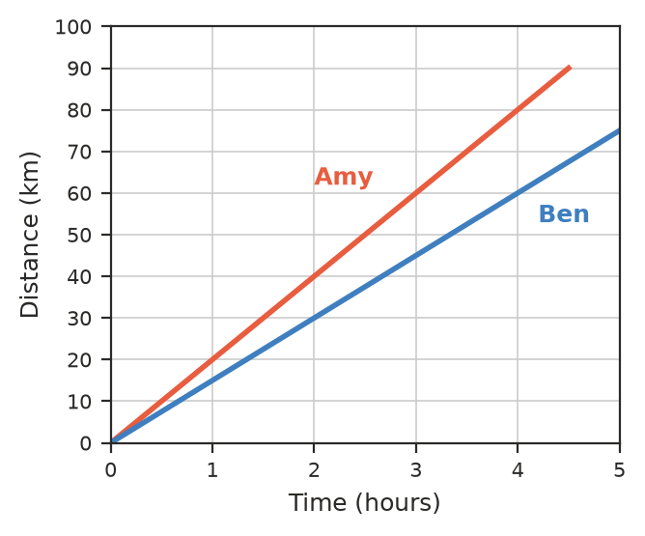
  - Find each rider’s speed. ______________
  - Write a rule for the distance each rider has gone after $t$ hours. ______________
  - How far apart are they after 2 hours? ______________

