4.08 Direct proportion
Year 9 Maths · Worksheet · Level 1 · Warm-up
Name: ____________________ Date: ______________
This worksheet practises recognising direct proportion and using the rule $y=kx$. Tip: two quantities are directly proportional if $y÷x$ is always the same number, $k$. The graph is a straight line through the origin.

 Understanding
- Does each table show direct proportion? If it does, write the value of $k=y÷x$.
$x$ | 1 | 2 | 3 | 4
$y$ | 3 | 6 | 9 | 12

- Answer: ______________
$x$ | 1 | 2 | 3 | 4
$y$ | 4 | 6 | 8 | 10

- Answer: ______________
$x$ | 1 | 2 | 3 | 4
$y$ | 5 | 10 | 15 | 20

- Answer: ______________
- Which of these graphs show direct proportion? Explain how you can tell.
- 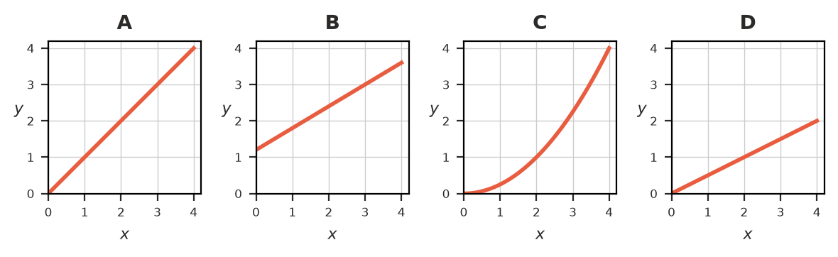

 Fluency
- $y$ is directly proportional to $x$. Find $k$, then write the rule $y=kx$.
  - $y=12$ when $x=3$ ______________
  - $y=35$ when $x=7$ ______________
  - $y=9$ when $x=18$ ______________
- $y$ is directly proportional to $x$, and $y=20$ when $x=4$.
  - Find $k$. ______________
  - Find $y$ when $x=9$. ______________
  - Find $x$ when $y=60$. ______________
- Petrol costs the same amount per litre. 5 L of petrol costs $10.50. Complete the table.
Litres | 1 | 5 | 10 | 40
Cost ($) |  | 10.50

 Reasoning
- A taxi charges a $4 flagfall plus $2 per km. Explain why the cost is not directly proportional to the distance.

- Apples cost $4.50 per kg. Is the cost directly proportional to the mass of apples? If so, write the rule. ______________

 Problem solving
- 3 cups of flour make 12 muffins.
  - Write a rule for the number of muffins, $m$, made from $f$ cups of flour. ______________
  - How much flour is needed for 30 muffins? ______________
- Sophie earns $162 for working 9 hours at the canteen.
  - What is her hourly rate? ______________
  - Write a rule for her pay, $P$ dollars, for $h$ hours. ______________
  - How much does she earn for 25 hours? ______________
- On a map, 2 cm stands for 15 km.
  - How far is it in real life between two towns that are 7 cm apart on the map? ______________
  - Two towns are 120 km apart. How far apart are they on the map? ______________

