4.08 Direct proportion
Year 9 Maths · A5 question sheet · Level 3 · Challenge
This worksheet practises testing for direct proportion, proving facts about proportional quantities, and judging when a real situation is (or isn’t) directly proportional. Tip: if $y$ is directly proportional to $x$, then $\frac{y_{1}}{x_{1}}=\frac{y_{2}}{x_{2}}$ for any two pairs of values. You may use a calculator.

 Understanding
- Does each set of data show direct proportion? Show your working.
  - $x$: 1.5, 4, 6.5 and $y$: 5.4, 14.4, 23.4
  - $x$: 2, 5, 9 and $y$: 3.2, 8, 14.6
- $y$ is directly proportional to $x$, and $y=28$ when $x=0.8$.
  - Find $k$ and write the rule.
  - Find $y$ when $x=2.4$.
  - Find $x$ when $y=7$.

 Fluency
- $y$ is directly proportional to $x$, and $y=13.5$ when $x=6$. Use $\frac{y_{1}}{x_{1}}=\frac{y_{2}}{x_{2}}$ to find $y$ when $x=22$.
- Which of these equations show that $y$ is directly proportional to $x$?
  - $y=7x$
  - $y=\frac{x}{4}$
  - $y=3x+1$
  - $y=2(x+3)$
  - $y=\frac{5}{x}$
  - $3y=2x$

 Reasoning
- $y=kx$. Prove that if $x$ is doubled, then $y$ is doubled.
- $a$ is directly proportional to $b$, and $b$ is directly proportional to $c$. Prove that $a$ is directly proportional to $c$.
- Is the perimeter of a square directly proportional to its side length? Is its area? Explain.

 Problem solving
- A 2.4 kW heater uses 2.4 kWh of electricity each hour. Electricity costs 31 cents per kWh.
  - Write a rule for the cost, $C$ dollars, of running the heater for $h$ hours.
  - The heater runs 6 hours a day for 90 days of winter. Find the total cost.
- Sound travels about 343 m each second, so the distance to a lightning strike is directly proportional to the time until you hear the thunder.
  - Thunder is heard 4.5 seconds after the lightning. How far away was the strike, in km to 1 decimal place?
  - A storm is 5 km away. How long after the lightning will the thunder be heard, to the nearest tenth of a second?
- A bank exchanges Australian dollars (AUD) for US dollars (USD). It first takes an $8 fee from the AUD, then converts the rest at 0.66 USD for each AUD.
  - Write a rule for the USD, $U$, you get for $A$ AUD.
  - How many USD do you get for 500 AUD?
  - Is $U$ directly proportional to $A$? Explain, and say what would need to change to make it proportional.
- The graph shows the cost of two brands of coffee beans.
- 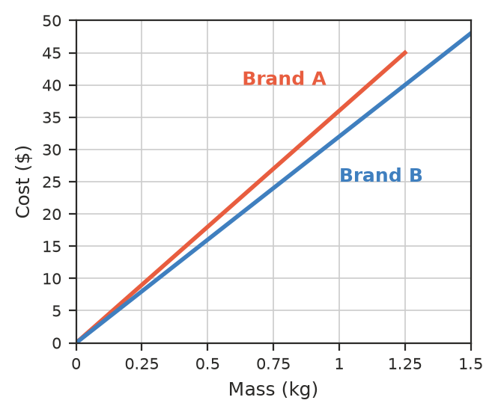
  - Find the cost per kilogram of each brand.
  - How much would you save by buying 3 kg of the cheaper brand instead of the dearer one?

