4.07 Equation of a straight line
Year 9 Maths · Worksheet · Level 1 · Warm-up
Name: ____________________ Date: ______________
This worksheet practises writing the equation of a line when you know its gradient and one point, or two points on it. Tip: write $y=mx+c$ with the gradient in place of $m$, substitute the point’s $x$ and $y$, and solve for $c$.

 Understanding
- The line has gradient 2 and passes through (1, 3).
- 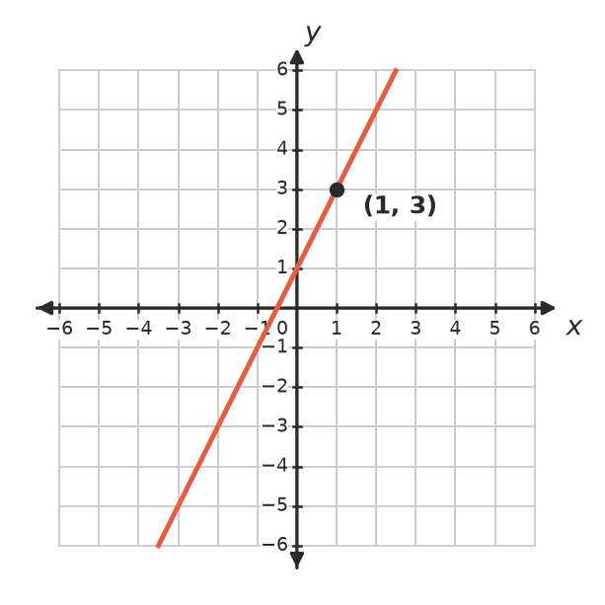
  - Read the $y$-intercept from the graph. ______________
  - Write the equation of the line. ______________
- Fill in the gaps to find the equation of the line with gradient 3 through (2, 7).
- $y=3x+c$
- Substitute $x=2$ and $y=7$: 7 = 3 × …… + $c$
- So 7 = …… + $c$, which gives $c$ = ……
- The equation is $y$ = ______________

 Fluency
- Find the equation of the line with the given gradient that passes through the given point.
  - gradient 2, through (1, 5) ______________
  - gradient −1, through (3, 4) ______________
  - gradient 4, through (−1, 2) ______________
  - gradient −3, through (2, −1) ______________
- Find the equation of the line through each pair of points. First find the gradient, then find $c$.
  - (1, 3) and (3, 7) ______________
  - (0, −2) and (4, 6) ______________
  - (−1, 5) and (2, −1) ______________
- Write the equation of each line.
- 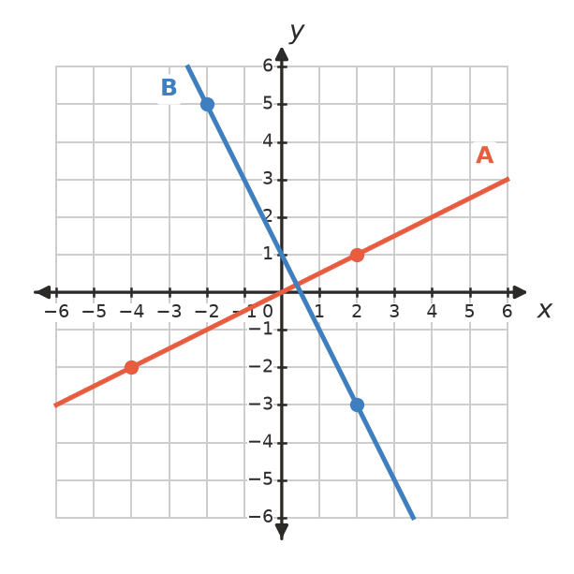
  - Line A ______________
  - Line B ______________

 Reasoning
- Does the line through (1, 2) and (3, 8) also pass through (5, 14)? Show your working.

- Liam says the line with gradient 2 through (3, 1) is $y=2x+1$. Check his answer by substituting the point. Is he right? If not, find the correct equation.

 Problem solving
- A taxi ride of 4 km costs $14 and a ride of 10 km costs $26. The cost rises at a steady rate.
  - Find the cost per kilometre. ______________
  - Write a rule for the cost, $C$ dollars, of a $d$ km ride. ______________
  - Find the cost of a 15 km ride. ______________
- A candle burns down at a steady rate. After 2 hours it is 16 cm tall, and after 5 hours it is 10 cm tall.
  - Write a rule for its height, $h$ cm, after $t$ hours. ______________
  - How tall was the candle before it was lit? ______________
- Write the equation of:
  - the horizontal line through (3, −4) ______________
  - the vertical line through (3, −4) ______________

