4.07 Equation of a straight line
Year 9 Maths · A5 question sheet · Level 2 · Core
This worksheet practises finding the equation of a line from a point and a gradient, or from two points, and writing it in general form. Tip: you can use the point-gradient formula $y−y_{1}=m(x−x_{1})$, then expand and rearrange into $y=mx+c$.

 Understanding
- A line has gradient $m$ and passes through the point $(x_{1},y_{1})$. Let $(x,y)$ be any other point on the line. Use the gradient formula to explain why $y−y_{1}=m(x−x_{1})$.

 Fluency
- Find the equation of each line in the form $y=mx+c$.
  - gradient 3, through (2, −1)
  - gradient −2, through (−3, 4)
  - gradient $\frac{1}{2}$, through (4, 1)
  - gradient $−\frac{2}{3}$, through (6, −2)
  - gradient 0, through (5, −3)
- Find the equation of the line through each pair of points.
  - (2, 5) and (4, 11)
  - (−1, 6) and (3, −2)
  - (−4, −1) and (2, 2)
  - (−3, 4) and (5, 4)
  - (2, −1) and (2, 6)
- Write each equation in general form, $ax+by+c=0$, with whole numbers and $a$ positive.
  - $y=\frac{1}{2}x+1$
  - $y=−\frac{2}{3}x+2$
- The line passes through the two marked points.
- 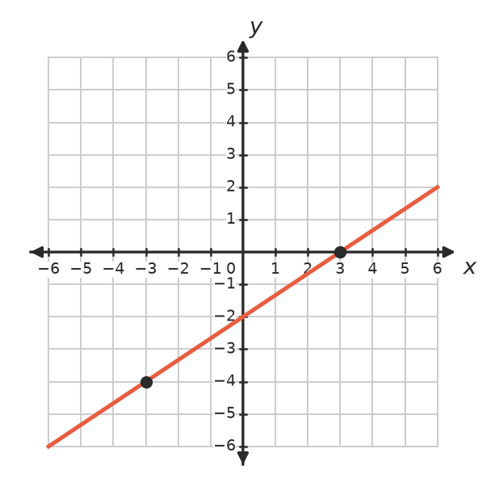
  - Write its equation in the form $y=mx+c$.
  - Write it in general form.

 Reasoning
- Does the point (8, 9) lie on the line through (−2, −6) and (2, 0)? Show your working.
- Zoe found the equation of the line through (1, 4) and (3, 10). She found the gradient was 3, then wrote $y=3x+4$. Find her mistake and correct it.

 Problem solving
- A phone company charges $35 a month for 5 GB of data and $56 a month for 12 GB. The cost is a linear function of the data.
  - Write a rule for the monthly cost, $C$ dollars, for $g$ GB.
  - What do the gradient and the $C$-intercept mean?
  - Find the cost of 20 GB.
- A lift travels down at a steady speed. After 4 seconds it is 42 m above the ground, and after 10 seconds it is 18 m above the ground.
  - Write a rule for its height, $h$ m, after $t$ seconds.
  - How high was the lift when it started?
  - When will it reach the ground?
- Find the equation of the line through (−2, 3) that is:
  - parallel to $y=4x−1$
  - perpendicular to $y=4x−1$
- A triangle has corners A(0, 2), B(6, 5) and C(4, −1). Find the equation of:
  - side AB
  - side BC

