4.06 Parallel and perpendicular lines
Year 9 Maths · Worksheet · Level 2 · Core
Name: ____________________ Date: ______________
This worksheet practises using gradients to decide whether lines are parallel or perpendicular, and writing equations of parallel and perpendicular lines. Tip: lines are perpendicular when $m_{1}×m_{2}=−1$, so the perpendicular gradient is $m_{2}=−\frac{1}{m_{1}}$. Rearrange equations into $y=mx+c$ first to see the gradient.

 Understanding
- Look at the four lines.
- 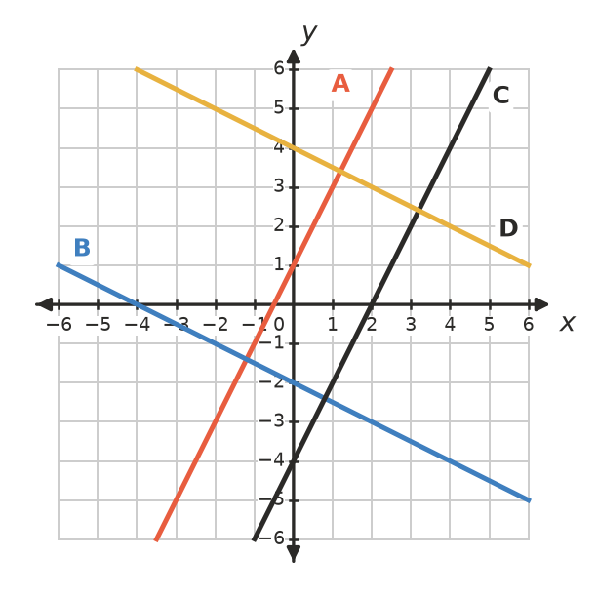
  - Find the gradient of each line. ______________
  - Which pairs of lines are parallel? ______________
  - Which pairs of lines are perpendicular? ______________

 Fluency
- Write the gradient of a line perpendicular to a line with gradient:
  - 5 ______________
  - $−\frac{2}{3}$ ______________
  - 0.25 ______________
  - −1 ______________
  - $\frac{3}{4}$ ______________
- Are the lines in each pair parallel, perpendicular or neither? Show the gradients.
  - $y=3x−2$ and $6x−2y=5$ ______________
  - $y=−4x+1$ and $x−4y=8$ ______________
  - $2x+3y=6$ and $3x−2y=4$ ______________
  - $y=\frac{1}{2}x+1$ and $y=2x−1$ ______________
- Write the equation of the line that is:
  - parallel to $y=−3x+2$ with $y$-intercept 5 ______________
  - perpendicular to $y=4x−1$ and passes through (0, −2) ______________
  - parallel to $2x+y=7$ and passes through the origin ______________

 Reasoning
- A horizontal line and a vertical line are perpendicular, but you can’t use $m_{1}×m_{2}=−1$ to show it. Explain why.

- Use gradients to show that the triangle with corners A(−2, 1), B(2, 3) and C(4, −1) has a right angle. Where is it?

- Find the value of $k$ so that:
  - $y=(k−1)x+4$ is parallel to $y=5x−2$ ______________
  - $y=kx−1$ is perpendicular to $2x−5y=10$ ______________

 Problem solving
- On a town map, Main Street follows the line $y=2x+1$. A new street will cross Main Street at right angles at the point (2, 5). Find the equation of the new street.

- ABCD has corners A(−3, 2), B(1, 4), C(3, 0) and D(−1, −2).
  - Use gradients to show that ABCD is a rectangle.

  - Is ABCD also a square? Explain. ______________
- Line L passes through (0, 4) and (2, 0). Find the equation of the line that is perpendicular to L and passes through the origin. ______________

