4.06 Parallel and perpendicular lines
Year 9 Maths · Worksheet · Level 1 · Warm-up
Name: ____________________ Date: ______________
This worksheet practises using gradients to spot parallel and perpendicular lines. Tip: parallel lines have the same gradient. Perpendicular lines (at right angles) have gradients that multiply to −1. To find a perpendicular gradient, flip the fraction and change the sign: 2 becomes $−\frac{1}{2}$.

 Understanding
- The graph shows two parallel lines.
- 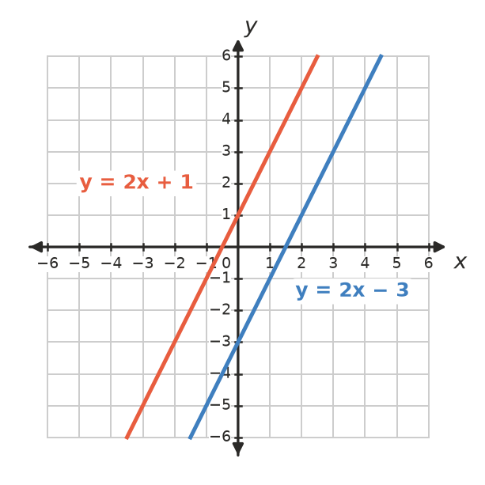
  - Write the gradient of each line. ______________
  - What do you notice? ______________
- The graph shows two perpendicular lines.
- 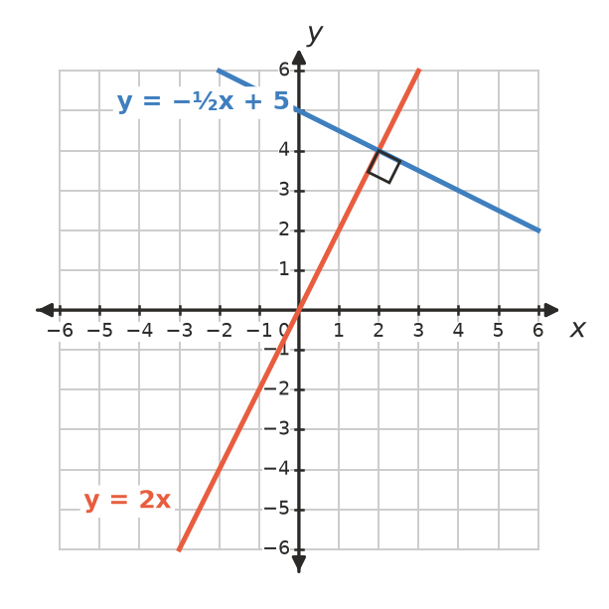
  - Write the gradient of each line. ______________
  - Multiply the two gradients. What do you get? ______________

 Fluency
- Write the gradient of a line that is parallel to:
  - $y=3x+7$ ______________
  - $y=−2x+1$ ______________
  - $y=\frac{1}{2}x−4$ ______________
  - $y=5$ ______________
- Write the gradient of a line that is perpendicular to a line with gradient:
  - 2 ______________
  - −3 ______________
  - $\frac{1}{2}$ ______________
  - $−\frac{1}{4}$ ______________
  - 1 ______________
- Are the lines in each pair parallel, perpendicular or neither?
Lines | Gradients | Parallel, perpendicular or neither
$y=4x+1$ and $y=4x−6$
$y=3x+2$ and $y=−\frac{1}{3}x+5$
$y=2x$ and $y=−2x$
$y=−x+3$ and $y=x−1$

 Reasoning
- Tom says $y=3x+1$ and $y=−3x+1$ are perpendicular because one gradient is negative. Is he right? Explain.

- Write the equation of a line that is parallel to $y=2x+5$ and has $y$-intercept −1. ______________

 Problem solving
- Write the equation of a line that is perpendicular to $y=−\frac{1}{2}x+2$ and has $y$-intercept 3. ______________
- On a map, two fences follow the lines $y=0.5x+2$ and $y=0.5x−1$. If the fences kept going, would they ever meet? Explain. ______________

- ABCD has corners A(0, 0), B(4, 2), C(3, 4) and D(−1, 2).
  - Find the gradient of AB. ______________
  - Find the gradient of BC. ______________
  - Are AB and BC perpendicular? ______________
  - Find the gradients of CD and DA. Is ABCD a rectangle? ______________

