4.06 Parallel and perpendicular lines
Year 9 Maths · A5 question sheet · Level 1 · Warm-up
This worksheet practises using gradients to spot parallel and perpendicular lines. Tip: parallel lines have the same gradient. Perpendicular lines (at right angles) have gradients that multiply to −1. To find a perpendicular gradient, flip the fraction and change the sign: 2 becomes $−\frac{1}{2}$.

 Understanding
- The graph shows two parallel lines.
- 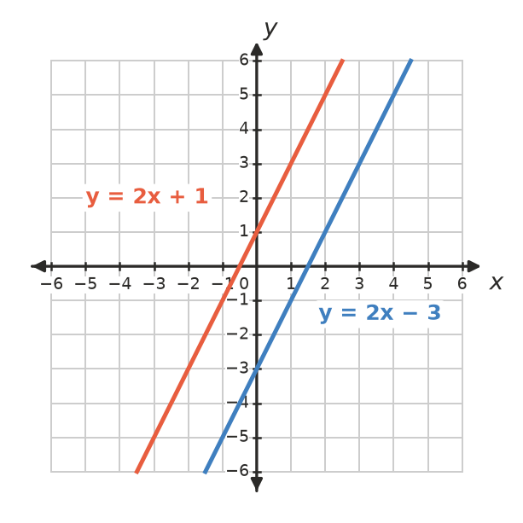
  - Write the gradient of each line.
  - What do you notice?
- The graph shows two perpendicular lines.
- 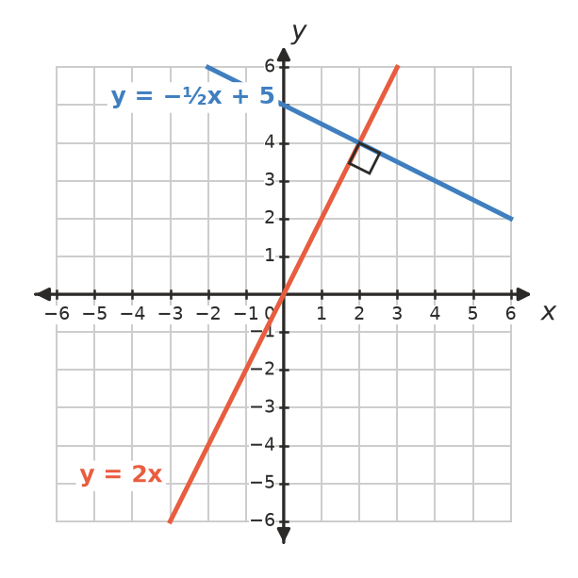
  - Write the gradient of each line.
  - Multiply the two gradients. What do you get?

 Fluency
- Write the gradient of a line that is parallel to:
  - $y=3x+7$
  - $y=−2x+1$
  - $y=\frac{1}{2}x−4$
  - $y=5$
- Write the gradient of a line that is perpendicular to a line with gradient:
  - 2
  - −3
  - $\frac{1}{2}$
  - $−\frac{1}{4}$
  - 1
- Are the lines in each pair parallel, perpendicular or neither?
Lines | Gradients
$y=4x+1$ and $y=4x−6$
$y=3x+2$ and $y=−\frac{1}{3}x+5$
$y=2x$ and $y=−2x$
$y=−x+3$ and $y=x−1$

 Reasoning
- Tom says $y=3x+1$ and $y=−3x+1$ are perpendicular because one gradient is negative. Is he right? Explain.
- Write the equation of a line that is parallel to $y=2x+5$ and has $y$-intercept −1.

 Problem solving
- Write the equation of a line that is perpendicular to $y=−\frac{1}{2}x+2$ and has $y$-intercept 3.
- On a map, two fences follow the lines $y=0.5x+2$ and $y=0.5x−1$. If the fences kept going, would they ever meet? Explain.
- ABCD has corners A(0, 0), B(4, 2), C(3, 4) and D(−1, 2).
  - Find the gradient of AB.
  - Find the gradient of BC.
  - Are AB and BC perpendicular?
  - Find the gradients of CD and DA. Is ABCD a rectangle?

