4.05 Linear graphs
Year 9 Maths · Worksheet · Level 3 · Challenge
Name: ____________________ Date: ______________
This worksheet practises intercepts with fractions and decimals, choosing the best way to sketch a line, finding equations from intercepts, and using linear graphs to model and solve problems. Tip: if a line passes through the origin, both intercepts are 0, so you need a second point to draw it.

 Understanding
- Find the $x$-intercept and the $y$-intercept of each line.
  - $3x+4y=6$ ______________
  - $5x−2y=15$ ______________
  - $y=\frac{2}{3}x−4$ ______________
  - $\frac{x}{3}+\frac{y}{5}=1$ ______________
  - $0.4x−0.5y=2$ ______________
- Explain why you can’t sketch $y=3x$ using only its intercepts, and what you could do instead.

 Fluency
- Sketch these three lines on the grid. Choose the best method for each, and label each line.
  - $2x−3y=6$
  - $y=−\frac{3}{2}x+4$
  - $y=−2x$
- 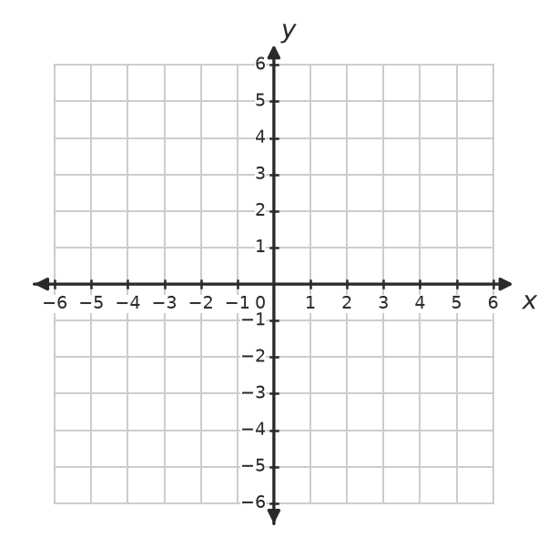
- Find the equation of each line in the form $y=mx+c$.
  - $x$-intercept 4, $y$-intercept −6 ______________
  - $x$-intercept −3, $y$-intercept 2 ______________
  - passes through the origin and (2, −5) ______________

 Reasoning

  - Show that the line $\frac{x}{a}+\frac{y}{b}=1$ has $x$-intercept $a$ and $y$-intercept $b$.

b) Use this to write the equation of the line with $x$-intercept 5 and $y$-intercept −2, then write it with no fractions. ______________
- For what value of $k$ does the line $kx+3y=12$ have an $x$-intercept of −6? ______________
- Find where each pair of lines meet.
  - $x=3$ and $2x−y=1$ ______________
  - $y=−4$ and $3x+2y=7$ ______________

 Problem solving
- The graph shows the water temperature in a hot water system as it heats up.
- 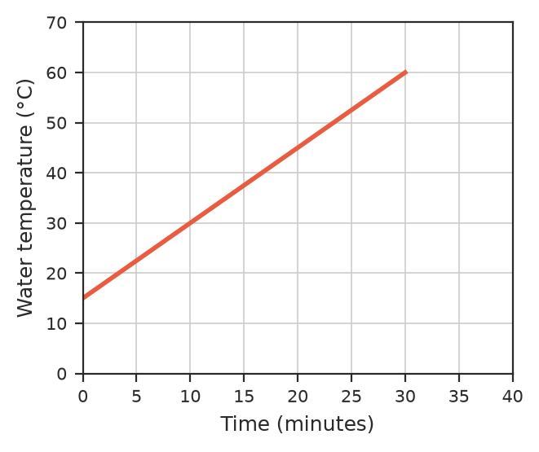
  - Find the gradient and say what it means. ______________
  - Write a rule for the temperature, $T$ °C, after $t$ minutes. ______________
  - The heater switches off at 65 °C. After how long does this happen? Give your answer in minutes and seconds. ______________
  - Why can’t this rule be used to predict the temperature after 2 hours? ______________
- Sketch $y=x+2$ and $y=−2x+8$ on the grid.
  - Find, using algebra, where the two lines meet. ______________
  - Find the area of the triangle formed by the two lines and the $x$-axis. ______________
- A line has gradient −3 and $x$-intercept 4. Find its $y$-intercept and its equation. ______________

