4.05 Linear graphs
Year 9 Maths · Worksheet · Level 2 · Core
Name: ____________________ Date: ______________
This worksheet practises sketching straight lines using the intercepts or the gradient and $y$-intercept, horizontal and vertical lines, and reading graphs of real situations. Tip: the intercept method is quickest for equations like $3x+2y=6$; the gradient-intercept method is quickest for equations like $y=−3x+1$.

 Understanding
- The graph shows the line $3x−2y=6$.
- 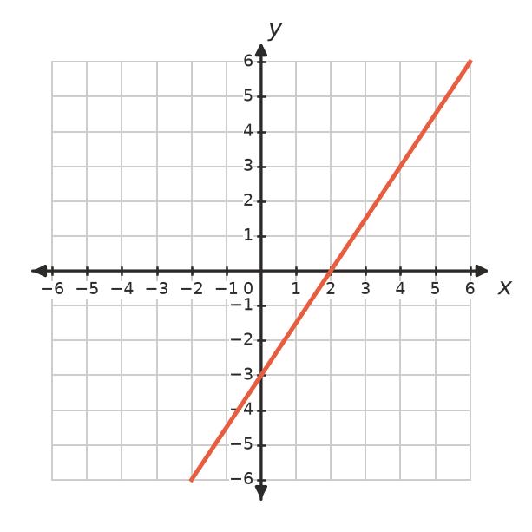
  - Read the $x$-intercept and the $y$-intercept from the graph. ______________
  - Check both intercepts using the equation. ______________
  - Find the gradient and write the equation in the form $y=mx+c$. ______________

 Fluency
- Find the $x$-intercept and the $y$-intercept of each line.
  - $y=3x+12$ ______________
  - $4x+5y=20$ ______________
  - $3x−y=9$ ______________
  - $y=−\frac{1}{2}x+3$ ______________
  - $2x−7y=14$ ______________
- Use the intercepts to sketch both lines on this grid. Label each line.
  - $3x+2y=6$
  - $x−2y=4$
- 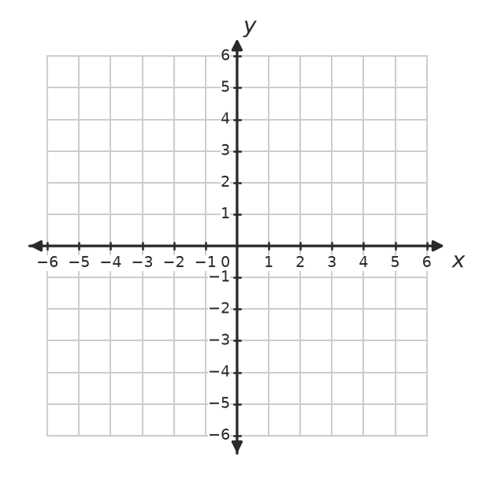
- Use the gradient and the $y$-intercept to sketch both lines on this grid. Label each line.
  - $y=\frac{1}{2}x−3$
  - $y=−3x+1$
- Write the equation of:
  - the horizontal line through (3, −5) ______________
  - the vertical line through (−2, 7) ______________
  - the $x$-axis ______________
  - the line parallel to the $y$-axis through (4, 1) ______________

 Reasoning
- Mia says the line $2x+3y=12$ crosses the $x$-axis at (0, 4). Explain her mistake and give the correct $x$-intercept.

- Which of these lines pass through (2, −1)? Answer: ______________
  - $y=3x−7$
  - $2x+y=3$
  - $x−2y=5$
  - $y=−1$
- The line $y=mx+2$ crosses the $x$-axis at (4, 0). Find $m$. ______________

 Problem solving
- The graph shows the petrol in a car’s tank on a long drive.
- 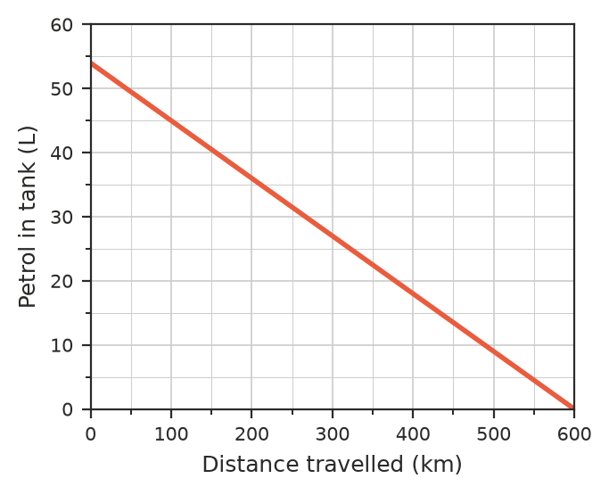
  - Write the intercepts and explain what each one means. ______________
  - Find the gradient and explain what it means. ______________
  - Write a rule for the petrol, $V$ litres, after $d$ km. ______________
  - How much petrol is left after 250 km? ______________
- A gym charges a $60 joining fee plus $15 a week.
  - Write a rule for the total cost, $C$ dollars, after $w$ weeks. ______________
  - Complete the table.
Weeks, $w$ | 0 | 4 | 8 | 12
Cost, $C$ ($)

  - Draw the graph on these axes.
- 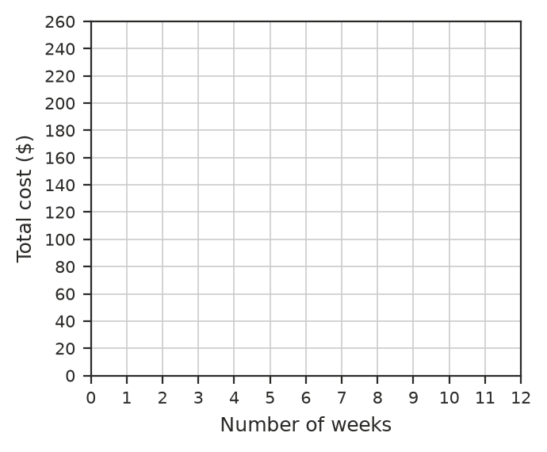
  - Use your graph to find how many weeks a total of $195 pays for. ______________
- Find the area of the triangle formed by the line $2x+3y=12$ and the two axes. ______________

