4.05 Linear graphs
Year 9 Maths · Worksheet · Level 1 · Warm-up
Name: ____________________ Date: ______________
This worksheet practises drawing straight-line graphs from a table, from the intercepts, and from the gradient and $y$-intercept. Tip: to find the $x$-intercept put $y=0$; to find the $y$-intercept put $x=0$. Use a ruler and extend your lines to the edge of the grid.

 Understanding
- The rule is $y=2x−1$.
$x$ | −2 | −1 | 0 | 1 | 2
$y$

  - Complete the table.
  - Plot the points on the grid and join them with a ruler.
- 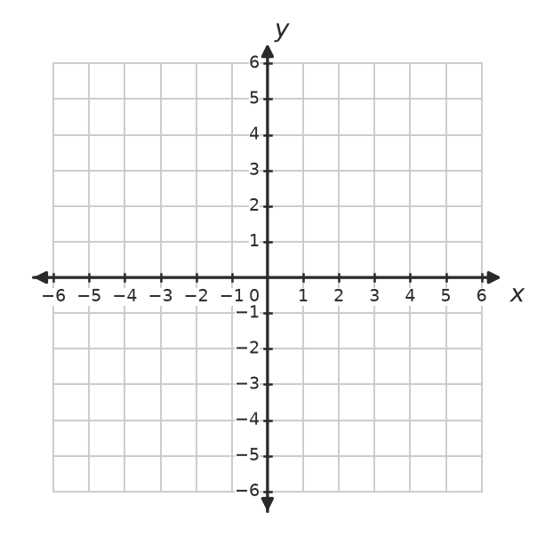
- Look at this line.
- 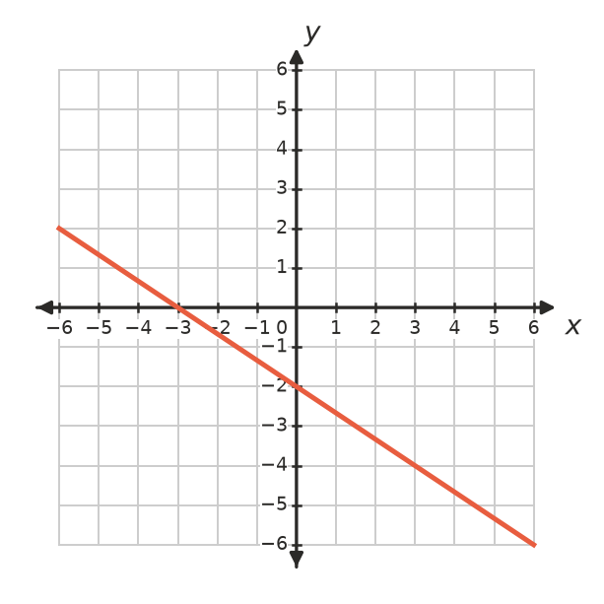
  - What is the $x$-intercept? ______________
  - What is the $y$-intercept? ______________

 Fluency
- Find the $x$-intercept and the $y$-intercept of each line.
  - $y=x+4$ ______________
  - $y=2x−6$ ______________
  - $x+y=5$ ______________
  - $2x+3y=12$ ______________
- Draw both lines on this grid.
  - Find the intercepts of $2x+y=6$, plot them and join them with a ruler. ______________
  - Draw $y=2x−2$: start at the $y$-intercept, then go 1 right and 2 up, again and again. Join the points with a ruler.
- Use your graph from Question 4. Where do the two lines cross? ______________

 Reasoning
- Write the equation of each line.
- 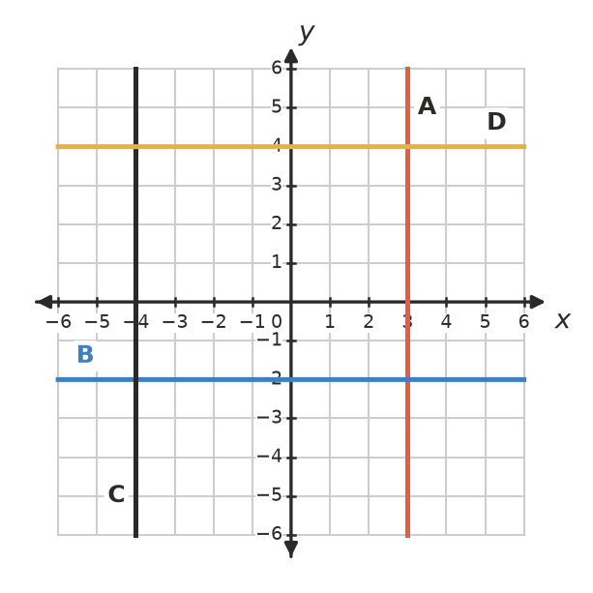
Line | A | B | C | D
Equation

- Does each point lie on the line $3x−y=1$? Show your working.
  - (2, 5) ______________
  - (−1, −3) ______________
- Where does every line of the form $y=mx$ cross the $y$-axis? Explain. ______________

 Problem solving
- The graph shows the cost of a taxi ride.
- 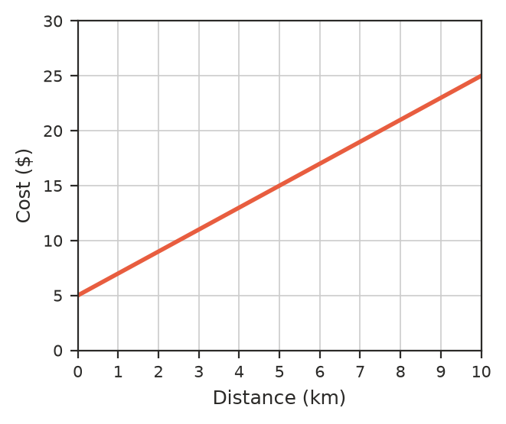
  - What is the cost before the taxi moves (the flagfall)? ______________
  - How much does each extra kilometre cost? ______________
  - Find the cost of a 7 km ride. ______________
  - Write a rule for the cost, $C$ dollars, of a $d$ km ride. ______________
- Where do the lines $y=4$ and $x=−1$ meet? ______________

