4.04 Gradient-intercept form
Year 9 Maths · Worksheet · Level 3 · Challenge
Name: ____________________ Date: ______________
This worksheet practises rearranging harder equations into the form $y=mx+c$, finding equations from given facts, and interpreting $m$ and $c$ in real models. Tip: clear brackets and fractions first, then get $y$ on its own.

 Understanding
- Rearrange each equation into the form $y=mx+c$.
  - $5x−2y=8$ ______________
  - $\frac{y}{3}−x=2$ ______________
  - $3(y−2)=2(x+6)$ ______________
  - $\frac{x}{4}+\frac{y}{2}=1$ ______________
  - $ax+by=d$, where $b≠0$ ______________
- The line below passes exactly through grid corners at two points. Find its equation in the form $y=mx+c$.
- 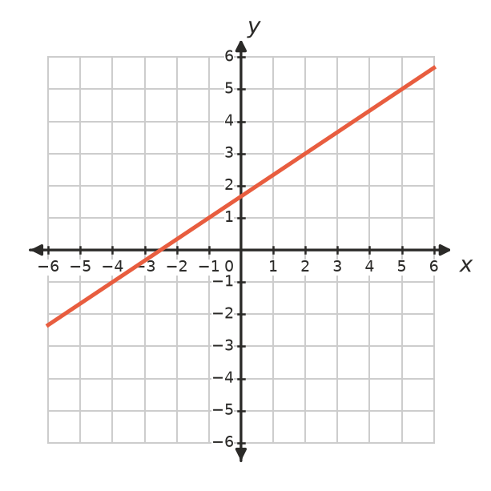

 Fluency
- Find the equation of each line in the form $y=mx+c$.
  - gradient −3, passing through (2, 1) ______________
  - passing through (0, 4) and (6, 1) ______________
  - passing through (−2, 9) and (4, −3) ______________
  - same gradient as $y=4x−1$, and same $y$-intercept as $3x+2y=10$ ______________
- Write the equation of each line.
- 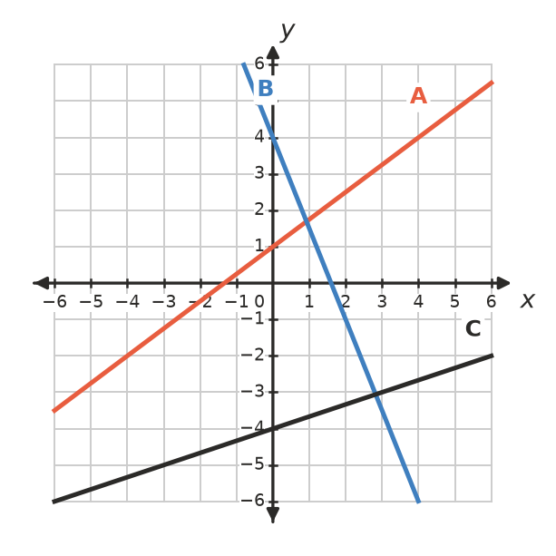
Line | A | B | C
Equation

 Reasoning
- For what value of $k$ does the line $kx+2y=6$ have a gradient of 4? ______________
- A line has gradient $m$ and passes through the point $(p,q)$. Show that its $y$-intercept is $q−mp$.

- Kai says the graph of $y=2(x−3)$ crosses the $y$-axis at −3. Is he right? Explain.

 Problem solving
- Two companies hire out trailers. Company A charges $C=45h+60$ dollars for $h$ hours. Company B’s cost graph is a straight line through (0, 100) and (4, 260).
  - Write the equation for Company B. ______________
  - Which company is cheaper for a 6-hour hire? ______________
  - For what hire time do the two companies charge the same? ______________
- The temperature in degrees Fahrenheit is $F=1.8C+32$, where $C$ is the temperature in degrees Celsius.
  - What does the 1.8 tell you? ______________
  - Rearrange the equation to make $C$ the subject. ______________
  - Find the temperature at which the Celsius and Fahrenheit readings are the same. ______________
- The line $y=mx+c$ passes through (2, 7) and (−1, −2).
  - Find $m$ and $c$. ______________
  - Does the line pass through (10, 31)? ______________
- The line $y=−\frac{3}{4}x+6$ forms a triangle with the $x$-axis and the $y$-axis.
  - Find where the line crosses each axis. ______________
  - Find the area and the perimeter of the triangle. ______________

