4.04 Gradient-intercept form
Year 9 Maths · Worksheet · Level 1 · Warm-up
Name: ____________________ Date: ______________
This worksheet practises reading and writing equations of lines in the form $y=mx+c$. Tip: $m$ is the gradient (the number multiplying $x$) and $c$ is the $y$-intercept (where the line crosses the $y$-axis). Make sure $y$ is on its own first.

 Understanding
- Write the gradient and the $y$-intercept of each line.
Equation | Gradient, $m$ | $y$-intercept, $c$
$y=3x+2$
$y=−2x+5$
$y=x−4$
$y=\frac{1}{2}x$
$y=7−x$

- Look at this line.
- 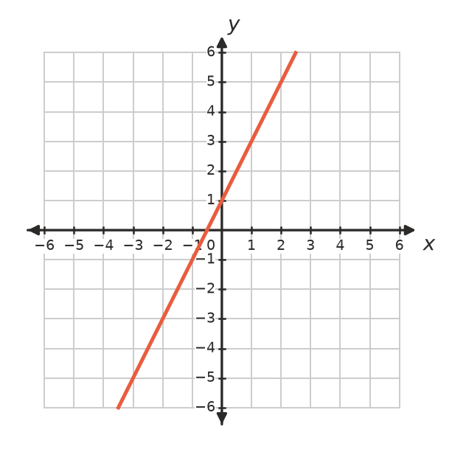
  - What is the $y$-intercept? ______________
  - When you move 1 unit right along the line, how far up do you go? This is the gradient. ______________
  - Write the equation of the line. ______________

 Fluency
- Write the equation of the line with:
  - gradient 4 and $y$-intercept 1 ______________
  - gradient −3 and $y$-intercept 2 ______________
  - gradient 1 and $y$-intercept −5 ______________
  - gradient $\frac{1}{2}$ and $y$-intercept 0 ______________
  - gradient 0 and $y$-intercept 6 ______________
- Write the equation of each line.
- 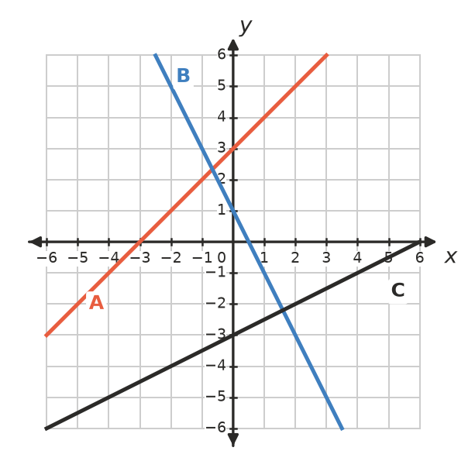
  - Line A ______________
  - Line B ______________
  - Line C ______________
- Rearrange each equation into the form $y=mx+c$.
  - $y−3x=5$ ______________
  - $y+2x=7$ ______________
  - $2y=6x+4$ ______________

 Reasoning
- Sam says the line $y=5−2x$ has gradient 5. Explain his mistake, and give the correct gradient and $y$-intercept.

- Look at these equations.
- $y=3x+1$, $y=2x+3$, $y=3x−5$, $y=1+3x$
  - Which lines have a gradient of 3? ______________
  - Which two equations describe exactly the same line? ______________

 Problem solving
- A taxi fare is given by $C=3d+4$, where $C$ is the cost in dollars and $d$ is the distance in km.
  - What does the 3 tell you? ______________
  - What does the 4 tell you? ______________
  - Find the cost of a 10 km trip. ______________
- A candle is 20 cm tall. It burns down 2 cm every hour.
  - Write an equation for its height, $h$ cm, after $t$ hours. ______________
  - What are the gradient and the $h$-intercept? ______________
  - After how many hours will the candle burn out? ______________
- Does the point (2, 7) lie on the line $y=3x+1$? Show your working. ______________

