4.04 Gradient-intercept form
Year 9 Maths · A5 question sheet · Level 2 · Core
This worksheet practises reading the gradient and $y$-intercept from an equation or a graph, rearranging equations into the form $y=mx+c$, and explaining what $m$ and $c$ mean in real situations. Tip: to rearrange, get the $y$ term on its own on one side, then divide every term by the number in front of $y$.

 Understanding
- Write the gradient and the $y$-intercept of each line.
Equation | Gradient, $m$
$y=−4x+9$
$y=\frac{2}{3}x−1$
$y=6−x$
$y=−7$
$y=\frac{x}{2}+3$

- Look at this line.
- 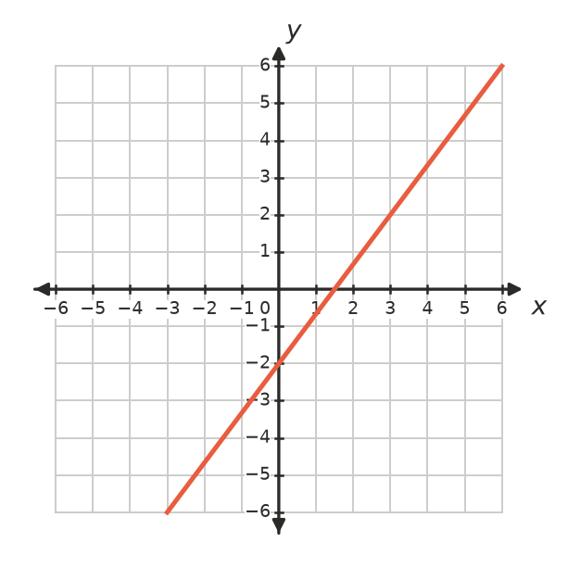
  - Write the $y$-intercept.
  - Find the gradient.
  - Write the equation of the line.

 Fluency
- Rearrange each equation into the form $y=mx+c$.
  - $y−4x=−3$
  - $3x+y=8$
  - $2y=5x−6$
  - $4x+2y=10$
  - $x−3y=6$
  - $3x+4y−12=0$
- Write the equation of each line.
- 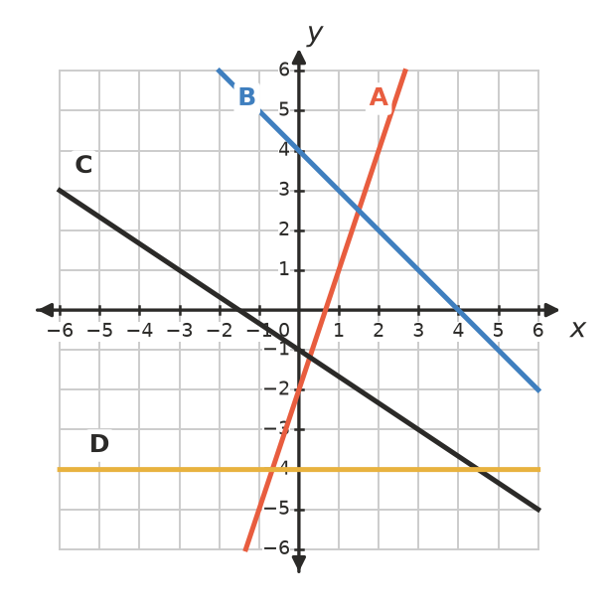
Line | A | B | C | D
Equation

- Write the equation of the line with:
  - gradient −2, passing through (0, 5)
  - gradient $\frac{3}{4}$ and $y$-intercept −1

 Reasoning
- Explain why $y=3x+2$ and $2y=6x+4$ are the same line.
- Jess rearranged $2x+y=6$ and got $y=2x+6$. Find her mistake and correct it.
- Which equation matches this graph?
- 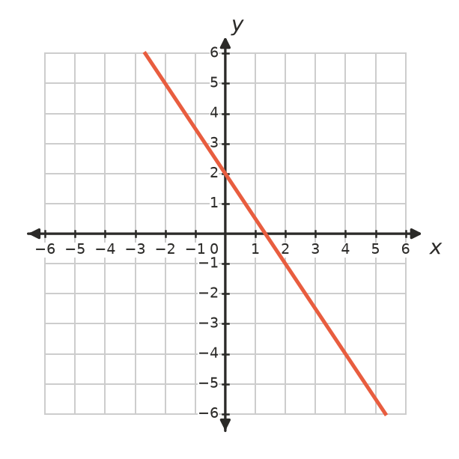
  - $y=\frac{3}{2}x+2$
  - $y=−\frac{2}{3}x+2$
  - $y=−\frac{3}{2}x+2$
  - $y=−\frac{3}{2}x−2$

 Problem solving
- A household’s electricity bill for three months is $C=0.32k+90$, where $C$ is the cost in dollars and $k$ is the number of kilowatt hours (kWh) used.
  - What does the 0.32 mean?
  - What does the 90 mean?
  - Find the bill when 850 kWh are used.
  - A bill was $474. How many kWh were used?
- The water in a tank is given by $W=4000−250t$, where $W$ is in litres and $t$ is in hours.
  - What are the gradient and the $W$-intercept? What do they mean?
  - When will the tank be empty?
- The line $y=mx+c$ passes through (0, −3) and (2, 5). Find $m$ and $c$.
- The line $y=2x+c$ passes through (3, 1). Find $c$.

