4.03 Distance between two points
Year 9 Maths · Worksheet · Level 3 · Challenge
Name: ____________________ Date: ______________
This worksheet practises the distance formula with surds and pronumerals, classifying shapes by their side lengths, and solving for unknown coordinates. Tip: to check for a right angle, compare the squares of the side lengths: if the two smaller squares add to the largest, the triangle is right-angled. You may use a calculator.

 Understanding
- Find the exact distance between each pair of points. Simplify any square roots.
  - (−3, 2) and (3, −1) ______________
  - $(2a,a)$ and $(5a,5a)$, where $a>0$ ______________
  - (−1.5, 4) and (2.5, −2) ______________
  - $(p,q)$ and $(p+5,q−12)$ ______________

 Fluency
- A triangle has corners A(−4, −1), B(2, 3) and C(4, 0).
  - Show that the triangle is right-angled.

  - Find the exact area of the triangle. ______________
- ABCD is drawn on the grid.
- 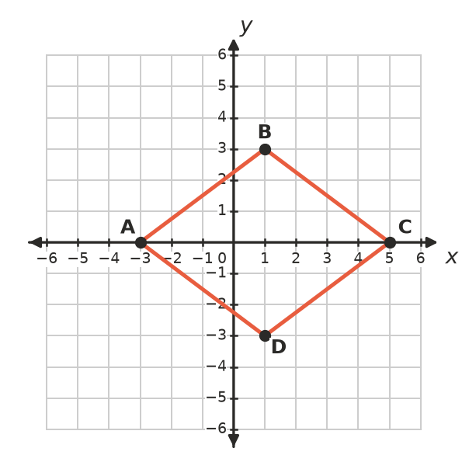
  - Show that ABCD is a rhombus.

  - Find the lengths of its diagonals and its area. ______________

 Reasoning
- The distance between ($k$, 3) and (2, −1) is $\sqrt{41}$. Find all possible values of $k$.

- Point P lies on the $y$-axis and is the same distance from A(2, 1) as from B(6, 5). Find the coordinates of P.

- A circle has its centre at (1, −2) and passes through (4, 2).
  - Find the radius of the circle. ______________
  - Which of these points also lie on the circle: (−3, 1), (6, −2), (−2, 3)? ______________
- Explain how the distance formula comes from Pythagoras’ theorem. Draw a sketch to help.

 Problem solving
- An orienteering course on a map (each unit is 100 m) starts at A(0, 0), goes to checkpoint B(6, 8), then to checkpoint C(18, 3), then straight back to A. How long is the course, in kilometres, correct to 2 decimal places? ______________

- An equilateral triangle has corners at (0, 0), (8, 0) and (4, $h$), where $h>0$. Find the exact value of $h$, and $h$ correct to 2 decimal places. ______________
- A right-angled triangle has corners O(0, 0), A(8, 0) and B(0, 6).
  - Find the midpoint M of the hypotenuse AB. ______________
  - Show that M is the same distance from O, A and B.

  - What does this tell you about the circle that passes through O, A and B? ______________

