4.03 Distance between two points
Year 9 Maths · A5 question sheet · Level 2 · Core
This worksheet practises the distance formula, exact answers with square roots, and using distances to solve problems. Tip: $d=\sqrt{(x_{2}−x_{1})^{2}+(y_{2}−y_{1})^{2}}$. Work out each difference first, in brackets, then square it. You may use a calculator.

 Understanding
- The interval AB is shown on the grid.
- 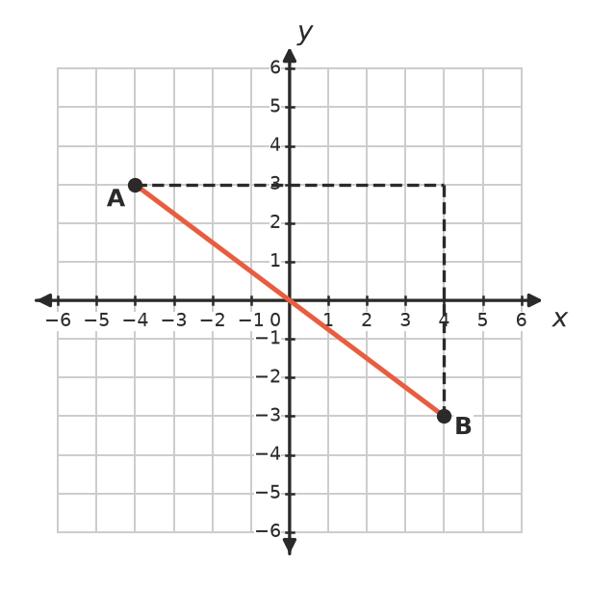
  - Find the horizontal and vertical distances from A to B.
  - Find the length of AB.
- In the distance formula, it doesn’t matter whether $x_{2}−x_{1}$ is positive or negative. Explain why.

 Fluency
- Find the distance between each pair of points.
  - (2, −1) and (7, 11)
  - (−3, 4) and (5, −2)
  - (−6, −5) and (2, 10)
- Find the distance between each pair of points. Give the exact answer as a square root, then round it to 2 decimal places.
  - (1, 2) and (4, 8)
  - (−2, −3) and (3, 1)
  - (−5, 4) and (2, −1)
- Triangle PQR is drawn on the grid.
- 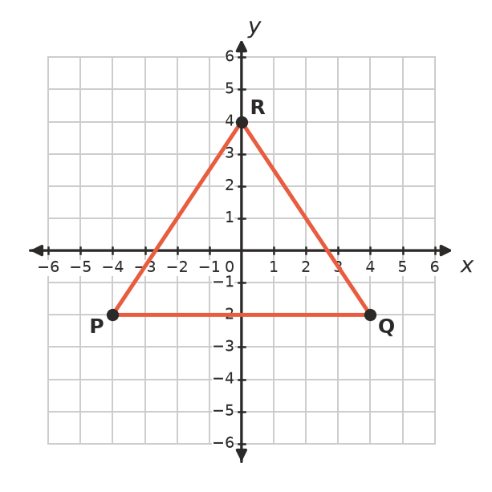
  - Find the lengths of PQ, PR and QR.
  - What type of triangle is PQR?
  - Find its perimeter, correct to 2 decimal places.

 Reasoning
- Tom found the distance between (−2, 3) and (4, −5) like this:
- $d=\sqrt{(4−2)^{2}+(−5−3)^{2}}=\sqrt{4+64}=\sqrt{68}$
- Find his mistake and give the correct distance.
- Show that the triangle with corners A(1, 1), B(5, 3) and C(3, 7) is right-angled. Which angle is the right angle?
- A circle has its centre at the origin and a radius of 5. Does each point lie on the circle?
  - (3, 4)
  - (4, −2)

 Problem solving
- At church camp, a treasure hunt starts at (−20, 15) and finishes at (40, −65), in metres on the camp map. How far apart are the start and the finish?
- A drone flies from its base at (0, 0) to (120, 50), then to (200, −10). All distances are in metres.
  - How far does it fly altogether?
  - How far is it from the base at the end, correct to 2 decimal places?
- The distance between (1, 2) and ($k$, 6) is 5. Find the two possible values of $k$.
- A phone tower at (3, −2) on a map grid (in km) reaches anything within 6 km. Which of these farms get phone coverage? Show your working.
  - Farm A at (7, 2)
  - Farm B at (−2, 2)
  - Farm C at (3, 4)

