4.03 Distance between two points
Year 9 Maths · A5 question sheet · Level 1 · Warm-up
This worksheet practises finding the length of an interval on the Cartesian plane. Tip: draw a right-angled triangle under the interval. Its two short sides are the horizontal and vertical distances, and Pythagoras’ theorem gives the length of the interval. You may use a calculator.

 Understanding
- Find the length of each interval by counting.
- 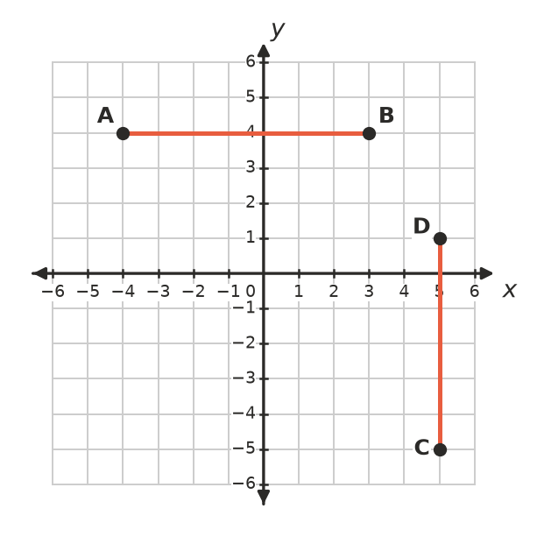
  - AB
  - CD
- The interval PQ is the longest side of a right-angled triangle.
- 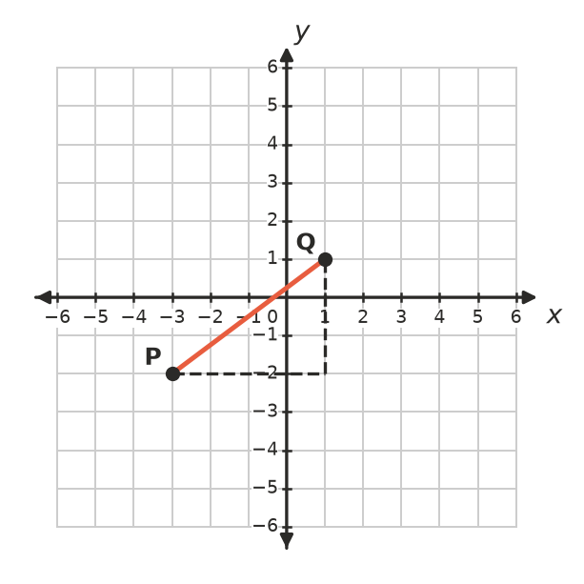
  - How long is the horizontal side?
  - How long is the vertical side?
  - Use Pythagoras’ theorem to find the length of PQ.

 Fluency
- Find the distance between each pair of points.
  - (2, 5) and (9, 5)
  - (−4, −1) and (6, −1)
  - (3, −2) and (3, 8)
- Use $d=\sqrt{(x_{2}−x_{1})^{2}+(y_{2}−y_{1})^{2}}$ to find the distance between each pair of points. Each answer is a whole number.
  - (0, 0) and (6, 8)
  - (1, 2) and (4, 6)
  - (−2, 1) and (3, 13)
  - (−1, −3) and (7, 3)
- Find the distance between each pair of points, correct to 1 decimal place.
  - (0, 0) and (2, 3)
  - (1, −1) and (4, 5)
  - (−2, 4) and (3, 1)

 Reasoning
- Ella says the distance between (1, 2) and (4, 6) is 3 + 4 = 7. What has she done wrong? What is the correct distance?
- Which point is closer to the origin, A(5, 1) or B(3, 4)? Show your working.

 Problem solving
- On a farm map where each unit is 1 km, the farmhouse is at (2, 1) and the shearing shed is at (8, 9).
  - How far is it in a straight line from the house to the shed?
  - The track goes 6 km east and then 8 km north. How much shorter is the straight line?
- A triangle has corners A(0, 0), B(4, 0) and C(4, 3). Find its perimeter.
- On a footy field grid in metres, a player kicks the ball from (10, 20) to (40, 60). How far did the ball travel?

