4.02 Gradient
Year 9 Maths · Worksheet · Level 2 · Core
Name: ____________________ Date: ______________
This worksheet practises finding the gradient of a line from a graph and from two points, and using gradient in real situations. Tip: the gradient formula is $m=\frac{y_{2}−y_{1}}{x_{2}−x_{1}}$. Keep the points in the same order on the top and the bottom.

 Understanding
- The line passes through P and Q.
- 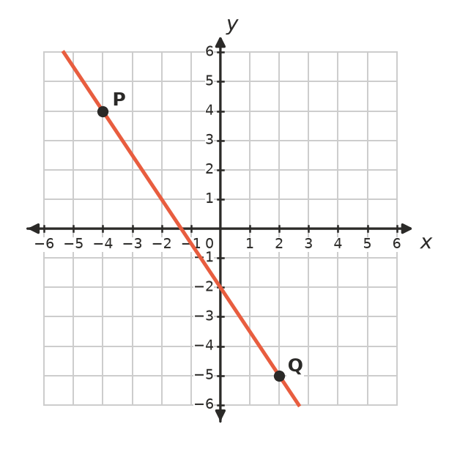
  - Find the rise and the run from P to Q. ______________
  - Find the gradient of the line. ______________
- Match each line with its gradient: 3, $\frac{1}{3}$, −1, −3.
- 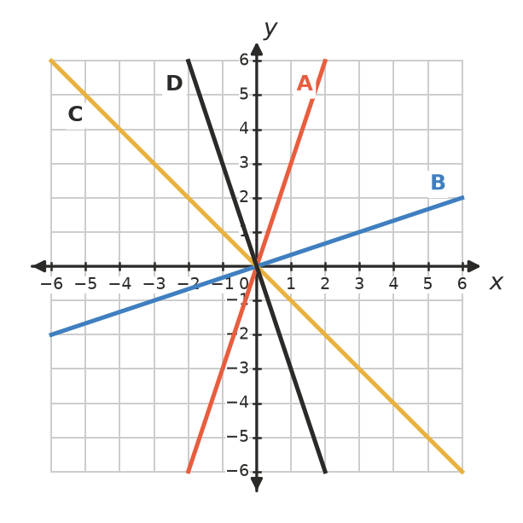
Line | A | B | C | D
Gradient

 Fluency
- Find the gradient of the line through each pair of points.
  - (2, 3) and (5, 12) ______________
  - (−1, 4) and (3, −4) ______________
  - (−6, −2) and (2, 4) ______________
  - (4, −3) and (−2, 1) ______________
  - (−5, 7) and (3, 7) ______________
  - (−2, −8) and (−2, 1) ______________
  - (0.5, 2) and (2.5, 7) ______________
- Find the value of $k$.
  - The line through (1, 2) and (4, $k$) has gradient 3. ______________
  - The line through (−2, 5) and ($k$, −3) has gradient −2. ______________
  - The line through (3, $k$) and (7, 1) has gradient $\frac{1}{2}$. ______________

 Reasoning
- Lila found the gradient of the line through (1, 5) and (4, −1) like this:
- $m=\frac{−1−5}{1−4}=\frac{−6}{−3}=2$
- Find her mistake and give the correct gradient.

- Do the points A(−2, −1), B(1, 5) and C(3, 9) lie on one straight line? Use gradients to explain.

- Explain why the gradient of a vertical line is undefined.

 Problem solving
- The Australian standard says a wheelchair ramp can have a gradient of at most 1 in 14 (it rises 1 m for every 14 m across). A ramp must rise 0.6 m to reach a doorway. What is the shortest run the ramp can have? ______________
- A road climbs steadily from a height of 120 m to a height of 168 m over a horizontal distance of 800 m.
  - Find the gradient of the road as a decimal. ______________
  - Road gradients are often written as a percentage. Write the gradient as a percentage. ______________
- The graph shows the water in a tank as it is drained.
- 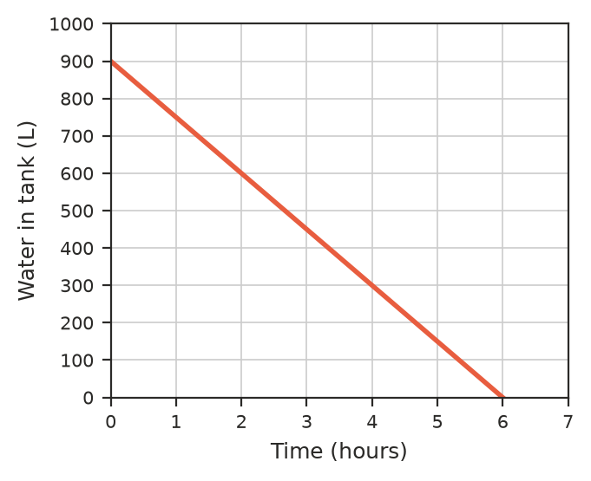
  - Find the gradient of the line. ______________
  - What does the gradient tell you about the tank? ______________
- A carport roof rises 0.9 m over a run of 3 m.
  - Find the gradient of the roof. ______________
  - A bigger carport has a roof with the same gradient and a run of 4.5 m. How much does its roof rise? ______________

