4.02 Gradient
Year 9 Maths · Worksheet · Level 1 · Warm-up
Name: ____________________ Date: ______________
This worksheet practises measuring how steep a line is. Tip: gradient = rise ÷ run. Always read from left to right: going up is a positive rise, going down is a negative rise.

 Understanding
- Is the gradient of each line positive, negative, zero or undefined?
- 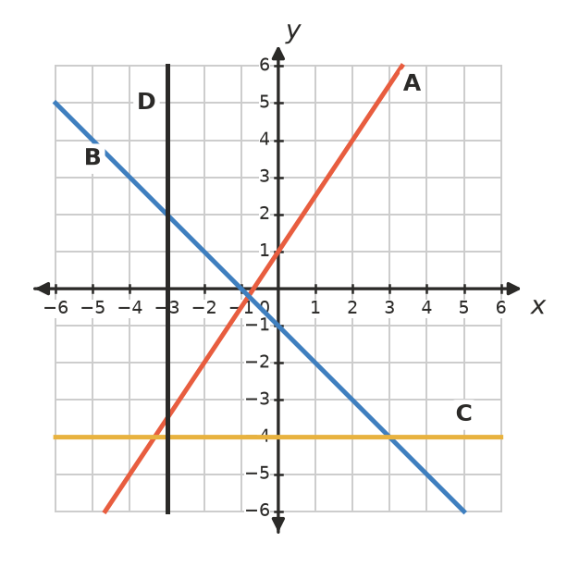
Line | A | B | C | D
Gradient

- The line passes through P and Q.
- 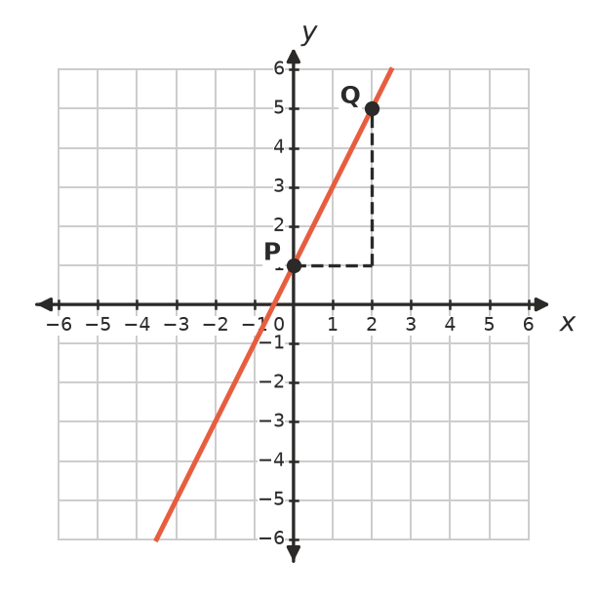
  - What is the rise from P to Q? ______________
  - What is the run from P to Q? ______________
  - Find the gradient of the line. ______________

 Fluency
- Find the gradient of each interval.
- 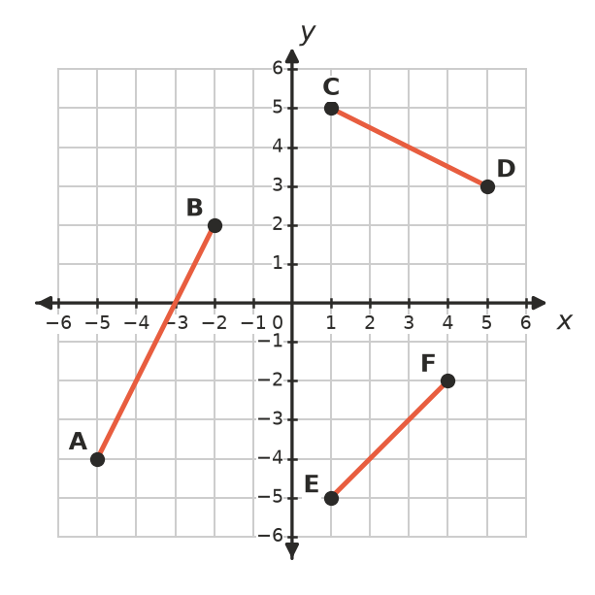
  - AB ______________
  - CD ______________
  - EF ______________
- Use $m=\frac{y_{2}−y_{1}}{x_{2}−x_{1}}$ to find the gradient of the line through each pair of points.
  - (1, 2) and (3, 8) ______________
  - (0, 4) and (2, 0) ______________
  - (2, 1) and (6, 3) ______________
  - (−1, 3) and (1, 7) ______________
  - (−2, 5) and (4, 5) ______________
  - (3, −1) and (3, 6) ______________

 Reasoning
- Kai says the gradient of the line through (1, 1) and (4, 7) is $\frac{1}{2}$ because the run is 3 and the rise is 6. What mistake has he made? What is the correct gradient?

- Without working it out, say whether the gradient of the line through each pair of points is positive, negative or zero.
  - (0, 0) and (3, 5) ______________
  - (−2, 4) and (3, −1) ______________
  - (1, 6) and (5, 6) ______________
- Which is steeper, a line with gradient 3 or a line with gradient $\frac{1}{2}$? Explain.

 Problem solving
- Two ramps lead up to a stage.
  - Ramp A rises 1 m over a run of 12 m. Find its gradient. ______________
  - Ramp B rises 0.5 m over a run of 4 m. Find its gradient. ______________
  - Which ramp is steeper? ______________
- A shed roof rises 3 m over a run of 4 m. Find the gradient of the roof as a fraction and as a decimal. ______________
- A road sign says the road rises 1 m for every 10 m it goes across. How much does the road rise over a horizontal distance of 250 m? ______________

