4.02 Gradient
Year 9 Maths · A5 question sheet · Level 3 · Challenge
This worksheet practises the gradient formula with fractions and pronumerals, finding unknowns from a gradient, and interpreting gradient as a rate. Tip: two intervals that share a point and have the same gradient lie on one straight line (the points are collinear).

 Understanding
- Find the gradient of the line through each pair of points.
  - (−3.5, 2) and (1.5, −8)
  - $\left(\frac{1}{2},3\right)$ and $\left(2,\frac{3}{4}\right)$
  - $(a,2b)$ and $(3a,8b)$
  - $(p,p^{2})$ and $(q,q^{2})$, simplified as far as possible
- Choose two points where the line crosses exactly at grid corners, and use them to find its gradient.
- 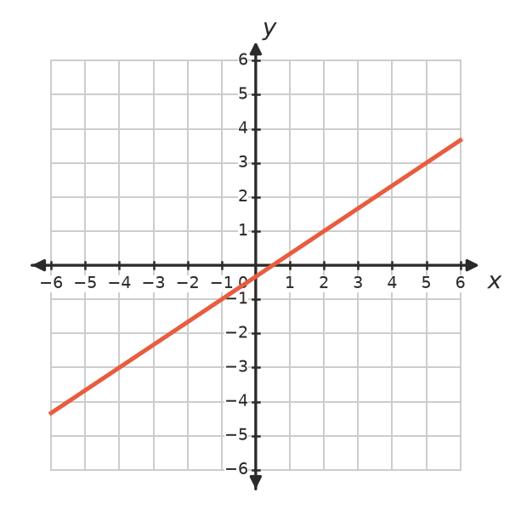

 Fluency
- Find the value of $k$.
  - The line through ($k$, 4) and (6, −2) has gradient $−\frac{3}{2}$.
  - The line through (2, $k$) and ($k$, 8) has gradient 2.
  - The line through (−1, 3) and (5, $k$) has the same gradient as the line through (0, 0) and (3, −2).

  - Show that the points (−3, 7), (1, 1) and (5, −5) are collinear.
  - Find $t$ so that (−3, 7), (1, 1) and ($t$, −8) are collinear.

 Reasoning
- Show that $\frac{y_{2}−y_{1}}{x_{2}−x_{1}}=\frac{y_{1}−y_{2}}{x_{1}−x_{2}}$. What does this tell you about the order you choose the two points in?
- A quadrilateral has corners A(−2, −1), B(4, 1), C(5, 5) and D(−1, 3). Use gradients to show that ABCD is a parallelogram.
- The steepness of a line depends on the size of its gradient, not its sign. Order these gradients from the least steep line to the steepest line.
- −4, 0.5, $−\frac{1}{3}$, 2, −1.5

 Problem solving
- A road sign warns of a 12% grade (the road rises 12 m for every 100 m across).
  - How much height does the road gain over a horizontal distance of 1.5 km?
  - A cyclist climbs 75 m over a horizontal distance of 2 km on another road. Is that road steeper than 12%?
- The Australian standard says a wheelchair ramp can have a gradient of at most 1 in 14. A ramp must reach a doorway 0.84 m above the ground, but there is only 10 m of flat space in front of the door.
  - Can a single straight ramp fit? Show your working.
  - Find the gradient of a ramp that uses all 10 m, and write it as “1 in ___” (to 1 decimal place).
- The graph shows a cyclist’s ride from home.
- 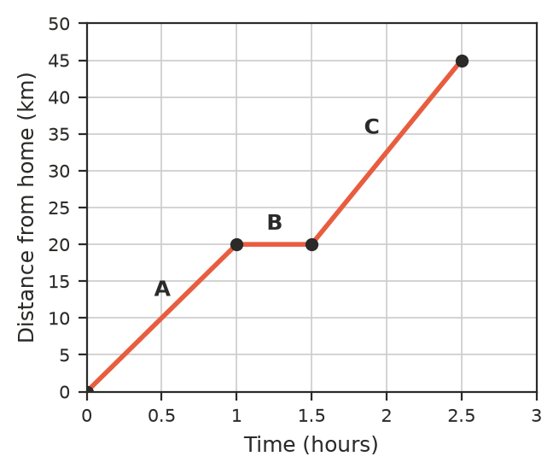
  - Find the gradient of each part, A, B and C.
  - What does the gradient tell you about the cyclist?
  - Describe what happened during part B.
- A safe ladder is placed so that its top is 4 times as high as the distance its foot is from the wall.
  - What is the gradient of a safe ladder?
  - The top of a ladder rests 5.6 m up a wall. How far from the wall should its foot be?

