4.01 Midpoint
Year 9 Maths · Worksheet · Level 2 · Core
Name: ____________________ Date: ______________
This worksheet practises finding the midpoint of an interval, and working backwards to find a missing endpoint. Tip: the midpoint of $(x_{1},y_{1})$ and $(x_{2},y_{2})$ is $\left(\frac{x_{1}+x_{2}}{2},\frac{y_{1}+y_{2}}{2}\right)$.

 Understanding
- The interval PQ is shown on the grid.
- 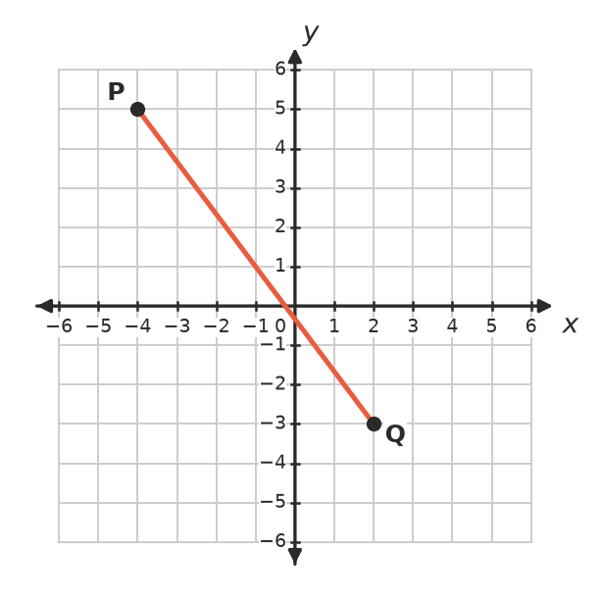
  - Write the coordinates of P and Q. ______________
  - Use the formula to find the midpoint M of PQ. ______________
  - Mark M on the grid. Does it look halfway along PQ? ______________
- Explain why we add the two $x$-coordinates and divide by 2 to find the $x$-coordinate of the midpoint.

 Fluency
- Find the midpoint of the interval joining each pair of points.
  - (3, 7) and (9, 1) ______________
  - (−4, 2) and (6, 8) ______________
  - (−5, −1) and (3, −7) ______________
  - (0, 9) and (−6, −3) ______________
  - (2, −3) and (7, 4) ______________
  - (−1.5, 4) and (3.5, −2) ______________
- A triangle has corners A(−2, 4), B(6, 2) and C(0, −4). Find the midpoint of each side.
  - AB ______________
  - BC ______________
  - CA ______________

 Reasoning
- M is the midpoint of AB. Find the coordinates of B.
  - A(1, 3), M(4, 5) ______________
  - A(−2, 6), M(1, 2) ______________
  - A(5, −1), M(0, 0) ______________
- Ben found the midpoint of (−6, 4) and (2, −8) like this:
- $\left(\frac{−6+2}{2},\frac{4+(−8)}{2}\right)=\left(\frac{−8}{2},\frac{−4}{2}\right)=(−4,−2)$
- Find his mistake and give the correct midpoint.

- Show that (3, 1) is the midpoint of the interval joining (−1, 4) and (7, −2).

 Problem solving
- The interval joining (−4, −1) and (6, 5) is a diameter of a circle. Find the centre of the circle. ______________
- On a map grid where each unit is 1 km, Ashford is at (12, 5) and Bellvale is at (−4, 17).
  - A rest stop is built halfway between the two towns. Where is it? ______________
  - A water tank is put halfway between the rest stop and Bellvale. Where is it? ______________
- ABCD has corners A(1, 1), B(7, 2), C(9, 6) and D(3, 5).
  - Find the midpoint of the diagonal AC. ______________
  - Find the midpoint of the diagonal BD. ______________
  - The diagonals of a parallelogram bisect each other. What does your answer suggest about ABCD? ______________
- M(2, −3) is the midpoint of PQ, where P is $(k,1)$ and Q is $(6,h)$. Find the values of $k$ and $h$.

- A(0, 0) and B(8, 12) are the ends of an interval. Find the three points that split AB into four equal parts. (Hint: find the midpoint M of AB first, then the midpoints of AM and MB.)

