4.01 Midpoint
Year 9 Maths · Worksheet · Level 1 · Warm-up
Name: ____________________ Date: ______________
This worksheet practises finding the point exactly halfway between two points. Tip: the midpoint’s $x$-coordinate is the average of the two $x$-coordinates, and its $y$-coordinate is the average of the two $y$-coordinates. Add them and halve.

 Understanding
- Find the number exactly halfway between each pair of numbers.
  - 2 and 8 ______________
  - −4 and 6 ______________
  - −7 and −1 ______________
  - 3 and 6 ______________
- Use the grid to find the midpoint of each interval.
- 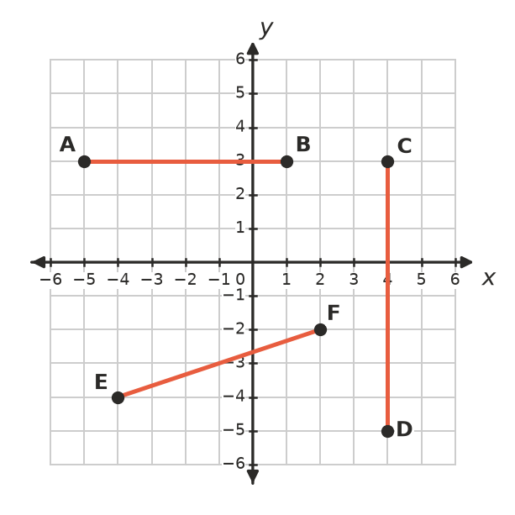
  - AB ______________
  - CD ______________
  - EF ______________

 Fluency
- Find the midpoint of the interval joining each pair of points.
  - (2, 4) and (6, 10) ______________
  - (1, 3) and (7, 5) ______________
  - (0, 0) and (8, −6) ______________
  - (−2, 5) and (4, 1) ______________
  - (−6, −3) and (−2, 7) ______________
  - (3, 2) and (6, 9) ______________

 Reasoning
- Mia found the midpoint of (2, 6) and (8, 4) like this:
- $\left(\frac{8−2}{2},\frac{6−4}{2}\right)=(3,1)$
- What mistake did she make? Find the correct midpoint.

- M(4, 3) is the midpoint of the interval AB. Point A is (1, 2).
  - How far right do you move to get from A to M? ______________
  - How far up do you move to get from A to M? ______________
  - Move the same amounts again from M to find point B. ______________
- Which point is the midpoint of (−2, 0) and (6, 4)? Answer: ______________
  - (4, 4)
  - (2, 2)
  - (2, 4)
  - (4, 2)

 Problem solving
- On a map grid, Sam’s house is at (2, 9) and his school is at (10, 3). Sam and a friend agree to meet halfway between the two. Where should they meet? ______________
- A footy oval is drawn on a grid where each unit is 1 metre. The two goals are at (10, 70) and (170, 70). The centre square goes exactly halfway between the goals. Where is it? ______________
- The interval joining (−3, 2) and (5, 2) is a diameter of a circle.
  - Find the centre of the circle. ______________
  - Find the radius of the circle. ______________
- A rectangle has corners A(0, 0), B(8, 0), C(8, 6) and D(0, 6).
  - Find the midpoint of the diagonal AC. ______________
  - Find the midpoint of the diagonal BD. ______________
  - What do you notice? ______________

